**Dear Zoo by** Rod Campbell

Focus Books

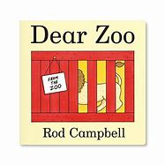

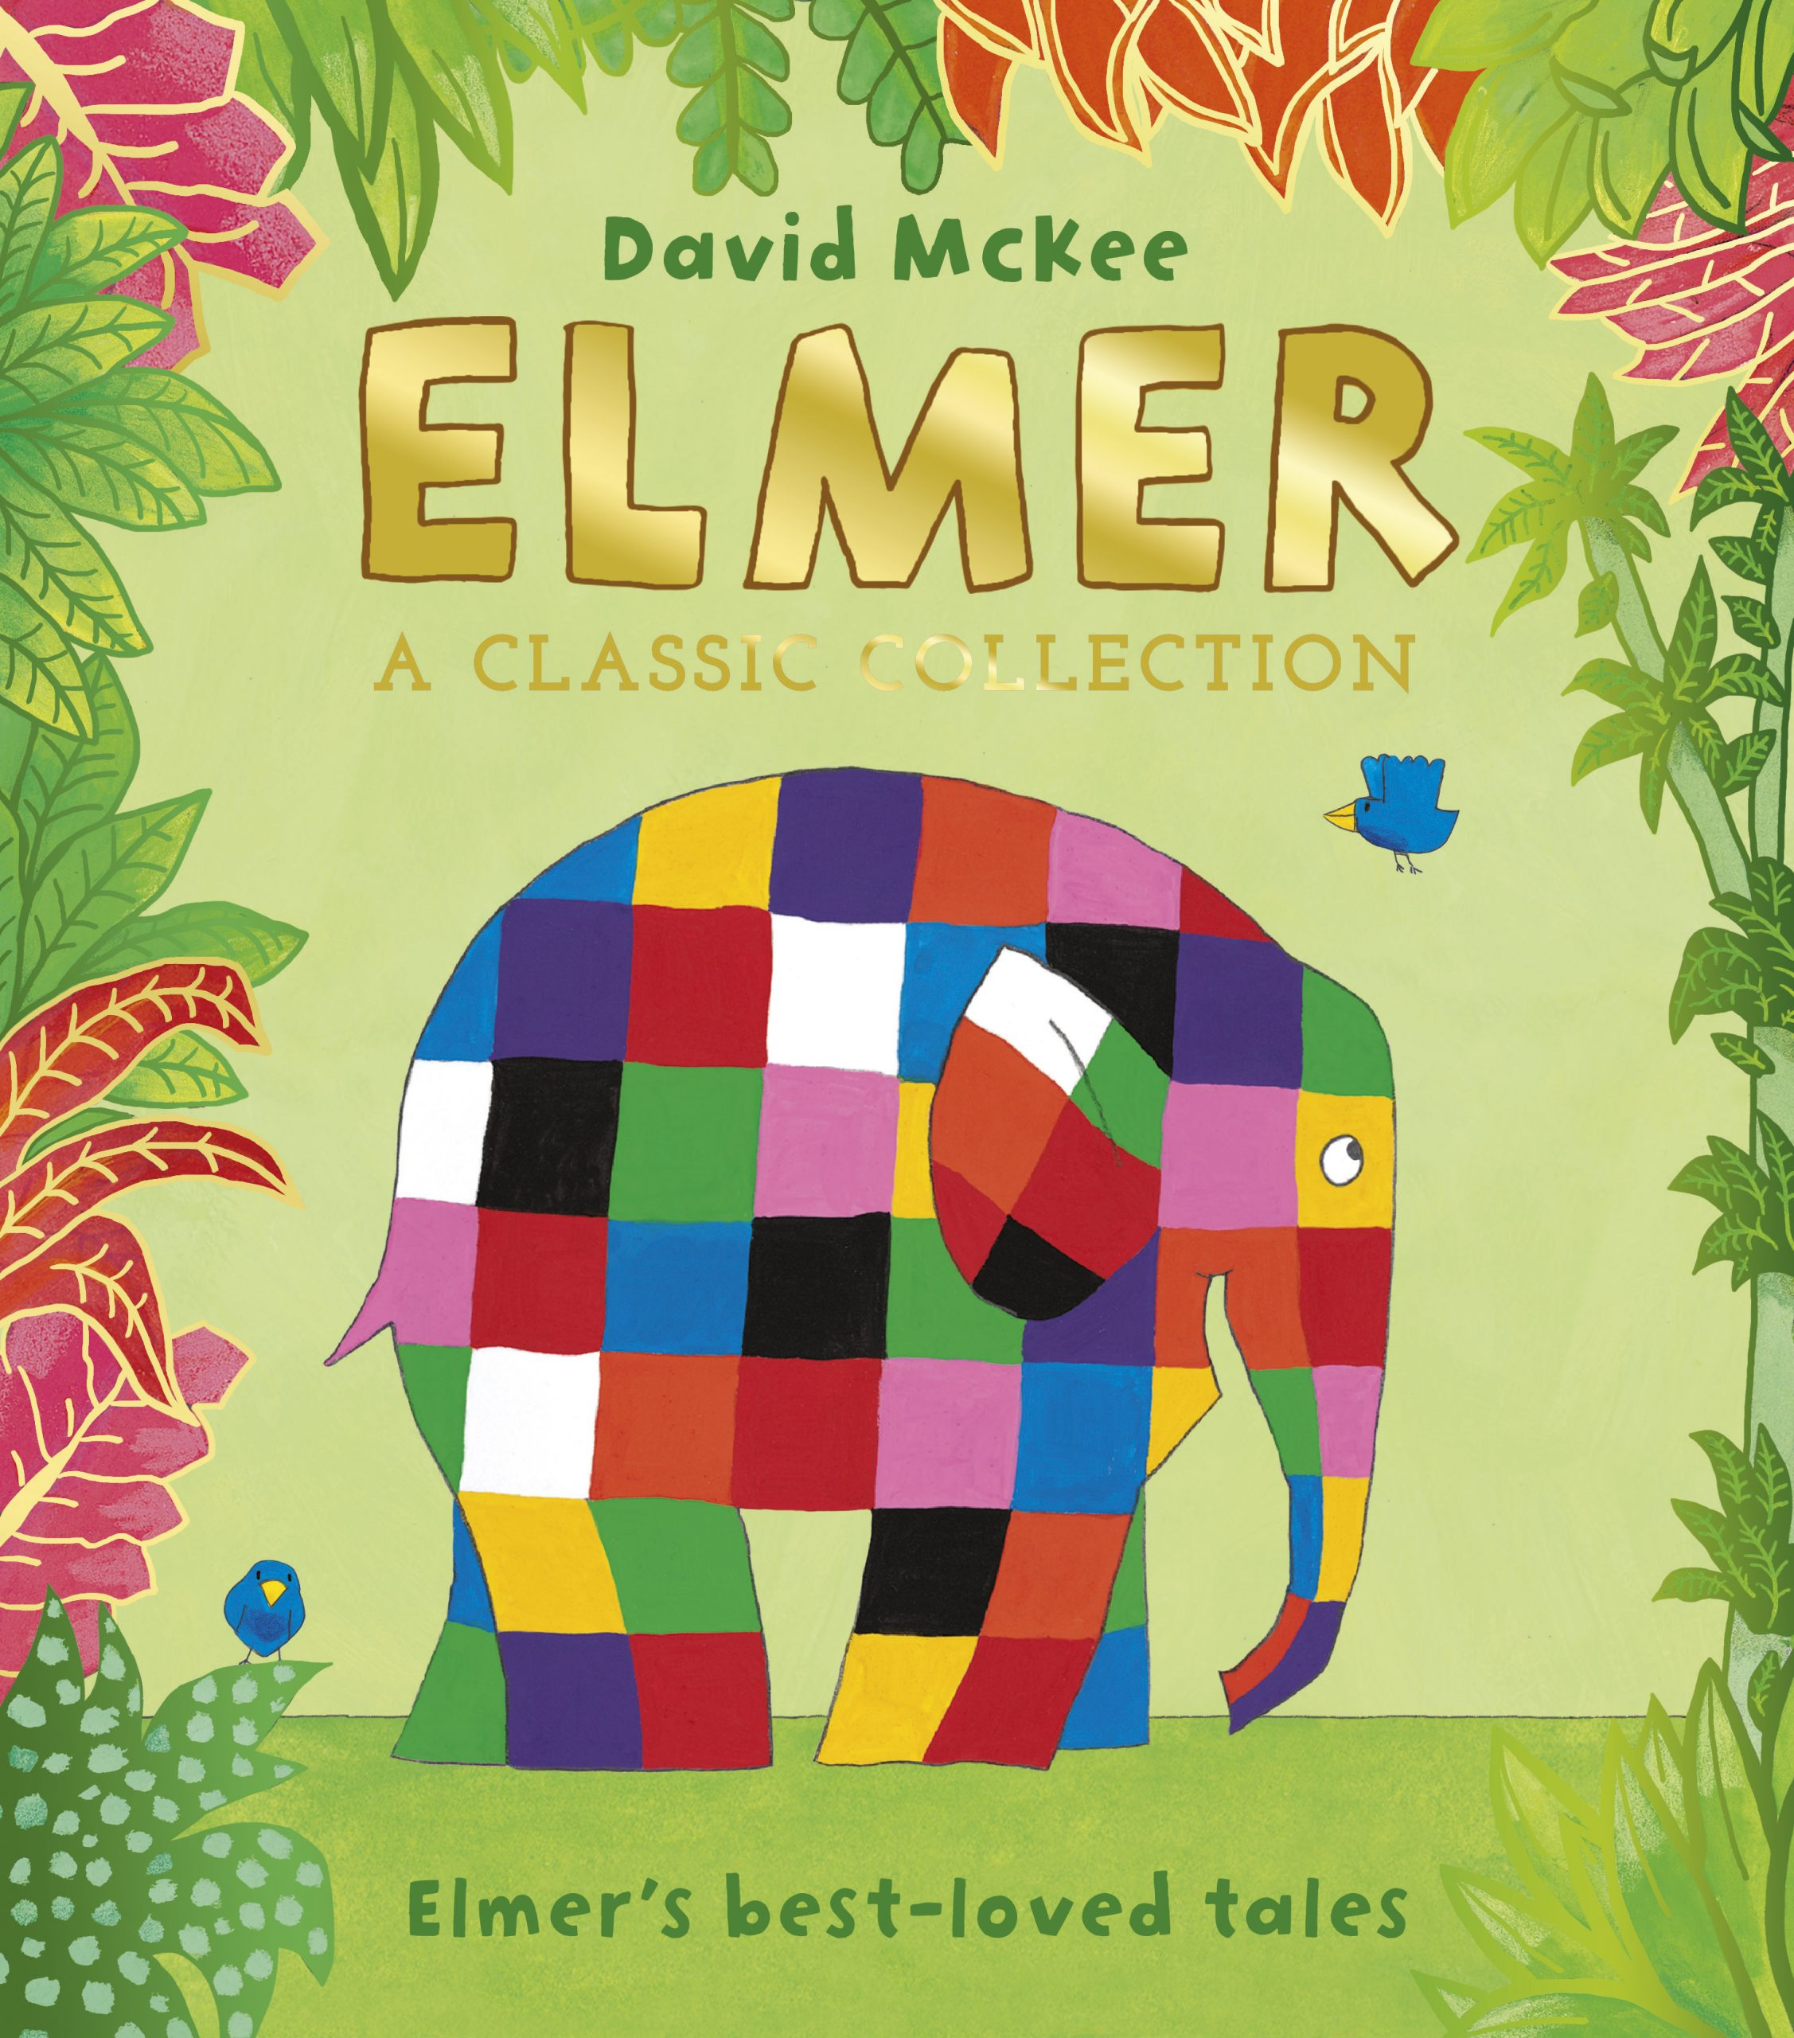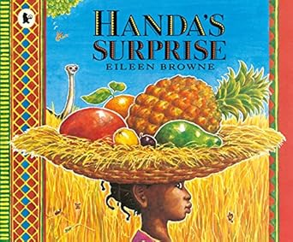

**Elmer** By David McKee

**Handa’s Surprise** By Eileen Browne

**Animals around the World** Summer One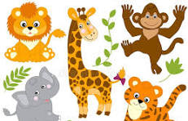

Parents as Partners

Share stories together and sing Nursery rhymes such as Sleeping Lions and 5 little ducks.

Discuss with your child the importance of making healthy eating choices. Encourage them to wash their hands after using the toilet and to drink water rather than juice.

Go on a Summer walk. Talk about the weather and discuss how we stay safe in the sun.

Key Questions

What is a Zoo?

Can I visit a Zoo?

What animals live at the Zoo?

Where do jungle animals live?

What do some jungle animals eat?

What is a country?

Activities

Learn to orally retell the story ‘Dear Zoo’ following a story map.

Draw a simple story map.

Name and describe animals from different countries.

Make a split pin moving animal.

Role-play the jungle.

Play long and short beats on musical instruments to create simple rhythms.

Key Vocabulary

Giraffe, elephant, frog, snake, lion, puppy, camel, monkey, fierce, grumpy, heavy, pride, lioness, mane, cub, eggs, Zoo, country