Boy going to school from MyCuteGraphics | Free clip art, School images, Clip  art[](https://www.google.co.uk/url?sa=i&rct=j&q=&esrc=s&source=images&cd=&ved=2ahUKEwj80pSw0a_kAhXLzYUKHRXWCR4QjRx6BAgBEAQ&url=http%3A%2F%2Fclipartmag.com%2Fpreschool-centers-clipart&psig=AOvVaw30zQvOkXEytxns9NjXRv2U&ust=1567427705904707)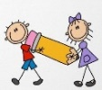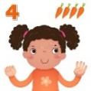[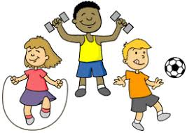](https://www.google.co.uk/url?sa=i&rct=j&q=&esrc=s&source=images&cd=&ved=2ahUKEwjIvuHY0K_kAhVHQBoKHf6eCosQjRx6BAgBEAQ&url=http%3A%2F%2Fclipart-library.com%2Fyouth-exercising-cliparts.html&psig=AOvVaw0FDByRGGT5n92YKwtE5L5C&ust=1567427488437358) 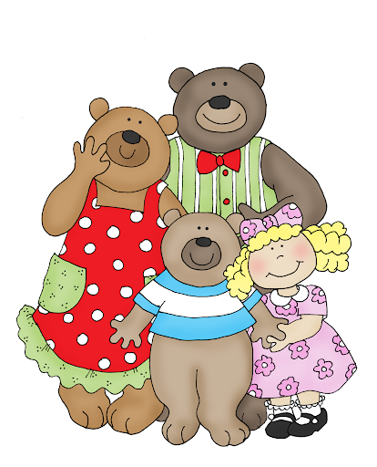

**PSED**

Learn to see themselves as valuable individuals, talk about their interests, their families

Build relationships with others in the class, share, take turns, listen to each other

Use story and talk to learn the importance of healthy eating, exercise, sleep, toothbrushing, and not too much ‘screen’ time.

Learn to manage our personal hygiene, wash hands before eating and after going to the toilet

**EXPRESSIVE ARTS AND DESIGN**

Role-Play House, Baby Clinic

Paint self-portraits

Draw pictures of our families

Act out the story of the Gingerbread Man

Design and make a Gingerbread Man

Explore steady beats, loud, soft, fast and slow sounds on the musical instruments and through movement

Paint to different moods of music

**Parents as Partners in Learning**

Read your child’s sharing book to your child every week. Discuss the characters and events and what their favourite part of the story and generally encourage a love of books and reading. Help your children with their reading book. Complete the Phonics Homework sheet every week.

**UNDERSTANDING THE WORLD**

Name and describe people in their families

Talk about different types of families

Find out what happens in a Baby Clinic

Explore similarities and differences between birthdays and toys past and present Learn how to bake a Gingerbread Man – what ingredients will we need?

Describe what we see, feel, hear and touch on an Autumn sensory walk

Plant bulbs for the Spring

St Paul’s CE Primary School **Reception Knowledge Organiser**

Topic: Ourselves

The Gingerbread Man

**Autumn One**

**PHYSICAL DEVELOPMENT**

Throw and catch a ball

Use ‘tummy time, activities and roll the tyres up and down the hill to develop core muscle strength

Develop good posture, sitting and standing up strong and straight

Use scissors effectively

Hold a pencil correctly

Do up a zip

Get dressed and undressed for PE independently

**COMMUNICATION AND LANGUAGE**

Express ideas through well-formed sentences when talking about class rules, favourite toys and how to be a good friend

Use’ talk for writing’ actions to assist retelling of The Gingerbread Man using story vocabulary

**LITERACY**

Write our names

Draw and label pictures of our families

Join in with repeated refrains in the story

‘The Gingerbread Man ‘using Talk for Writing

Draw a ‘ Gingerbread Man’ Story Mountain

Make a birthday card for the class puppet

Read and match labels to parts of the body

Label growing up pictures

Write a list of party foods

Begin to learn Phase 2 letter sounds in Phonics

**Key Vocabulary:** family, past, present, old, new, community, body, eyes, ears, nose, mouth, see, hear, taste, touch, smell, healthy, exercise, Doctor, Nurse, baby, toddler, child, teenager, adult. elderly person

**MATHS**

Match, sort and compare amounts using buttons, socks and natural objects, use language more/fewer

Compare size, mass and capacity using teddies, boxes, small world animals use language full/empty, tallest, shortest, longest.

Explore repeating patterns with colours, shapes, percussion

Represent 1, 2, 3 with dots. Numicon 1 – 3 shapes, cube 1 – 3 towers, look, count, subitise, show on fingers Sort objects/pictures into groups of ‘1, 2 and 3’ Match numerals 1 to 3 to the correct quantity. Count to 5 and back, 10 and back Sing counting songs, e.g. ‘1,2,3,4,5’ ‘5 Little Ducks’’ Learn names and properties of simple 2D shapes