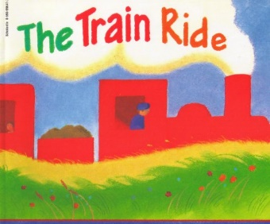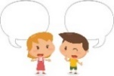[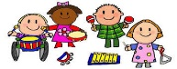](https://www.google.co.uk/url?sa=i&rct=j&q=&esrc=s&source=images&cd=&ved=2ahUKEwj80pSw0a_kAhXLzYUKHRXWCR4QjRx6BAgBEAQ&url=http%3A%2F%2Fclipartmag.com%2Fpreschool-centers-clipart&psig=AOvVaw30zQvOkXEytxns9NjXRv2U&ust=1567427705904707)[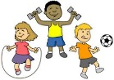](https://www.google.co.uk/url?sa=i&rct=j&q=&esrc=s&source=images&cd=&ved=2ahUKEwjIvuHY0K_kAhVHQBoKHf6eCosQjRx6BAgBEAQ&url=http%3A%2F%2Fclipart-library.com%2Fyouth-exercising-cliparts.html&psig=AOvVaw0FDByRGGT5n92YKwtE5L5C&ust=1567427488437358)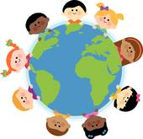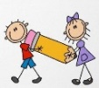

**PHYSICAL DEVELOPMENT**

Use our developing fine motor skills to draw and paint different types of transport with accuracy

Experiment with different ways of moving in our music and movement ‘transport’ lesson

**COMMUNICATION AND LANGUAGE**

Formulate questions using, who, what where, when and why sentence starters to ask our visiting Police Sergeant and Firefighters

**UNDERSTANDING THE WORLD**

Find out how we get around using different types of transport. Watch ‘Grace’s Amazing Machines’ and read non-fiction books.

Discover the features of a fire engine when the firefighters come to visit

Discover the features of a police car when the police sergeant visits.

Explore the forces ‘push and pull’ in our indoor and outdoor areas, using our outdoor equipment and toy cars. Create ramps covered in different texture materials and test how far a toy car can travel.

Create a large floor map of our local area, showing the routes, cars, buses and trains take. Use construction and workshop materials to create the key features of our town for the map.

Explore directional language using Bee Bots’ to move around a Street mat,

St Paul’s CE Primary School **Reception Knowledge Organiser**

Topic: Transport and Journeys

The Train Ride

Autumn Two

**Key Vocabulary:** car, boat, aeroplane, train, tram, helicopter, motorbike, bicycle, scooter, rocket, dinghy, canoe, skis, bus, yacht, force, push, pull, journey, transport, vehicle, fast, slow, speed, float

n

**Parents as Partners in Learning**

Look for different types of transport when out on a walk, shopping etc

Teach your children to fasten their coats and use a knife and fork at mealtimes

Hear your child read their book three times each week.

**EXPRESSIVE ARTS AND DESIGN**

Role-play buses and trains outdoors

Small World Transport Toys – cars, planes and trains,

Make boats from plastic pots/tubs to float in the water tray

Paint and draw different types of transport

Create pictures of vehicles with 2D shapes

Make a ‘racing car’ from cardboard tubes with split pin moving wheels

Sing journey and transport songs

Create and identify sounds of vehicles, using soundtracks, voices and instruments.

Make marks with toy car wheels, creating tracks for cars to travel on.

**Definitions:** **Transport/Transportation:** the movement of goods and persons from place to place and the various means by which such movement is accomplished. **Journey:** traveling from one place to another. **Force**: A **force** is a push or pull acting upon an object as a result of its interaction with another object..

**LITERACY**

Write captions and labels for pictures in our big book about ‘Transport’

Learn to recite the story ‘The Train Ride‘ using actions and supported by a story map

Write sentences about what we can see through the window on a train journey

Identify rhyming words in the book, ‘The Train Ride’

Read non-fiction books about transport