**Reception Maths Overview Summer Term**

10 frame subtraction. 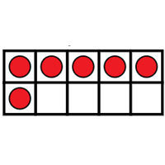

Numbers to 20.

Missing numbers.

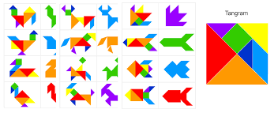Order numbers to 20

Bingo-numbers to 20.

Matching shapes.

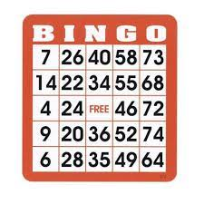Tangrams.

Consolidation.