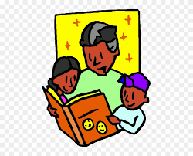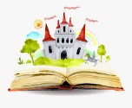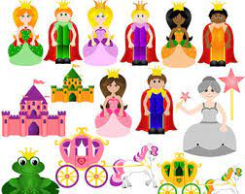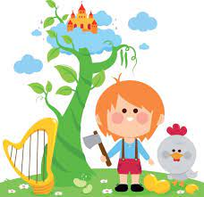

**Parents as Partners in Learning**

Take your children to the library and borrow some traditional fairy tales to share at home.

Which fairy tales did you enjoy when you were little? Discuss your favourite stories and characters with your children, read these stories together.

**PHYSICAL DEVELOPMENT**

**Fine Motor Skills**

* Make bean seeds from playdough and match to numerals on beanstalk leaves
* Use tweezers to pick up pom poms to use as bean seeds to match numerals on beanstalk leaves
* Make longs and short beanstalks and order by length
* Thread beads to make necklaces for Queens and Princesses
* Make castles and coaches from small construction’

**Gross Motor Skills**

* Paint giant beanstalks on the playground using paint rollers and chalk – number the leaves 1-20
* Pretend to be the Giant, balancing on stilts counting up and back down our giant beanstalks
* Build a carriage from large construction

**DEFINITIONS**

What is a Fairy Tale?

***Fairy tales are stories often intended for children, that feature wondrous characters, such as elves, goblins, wizards and even, but not necessarily, fairies. The term, ‘fairy’ tale seems to refer more to the fantastic and magical setting or magical influences within a story, rather than the presence of the other character of a fairy within that story, Fairy tales are often traditional, many were passed down from story teller to story teller before being recorded in books.***

**LITERACY**

Focus story- *Jack and the Beanstalk*

Learn to retell the story with talk for write actions

Sequence pictures depicting the beginning, middle and end of the story and write a simple sentence for each

Write a character description of the ‘Giant’

Share a range of Fairy tales at story time

**COMMUNICATION AND LANGUAGE**

* Memory Game, *I climbed up the Giant’s Beanstalk and I took his…* Children repeat the sentence, adding items to the list, and recalling all previous items
* Children will formulate questions to ask the Giant when teacher is in ‘role’

**PSED**

Discuss the rights and wrongs of Jack taking things that did not belong to him from the Giant

Discuss how the Giant might feel about this

Is Jack a good boy? Is the Giant bad?

**Understanding the World**

* Children will discuss different fairy tales and compile a list of all the fairy tales and characters they know
* Children will discover that Fairy tales have been around for many years, some 100s of years, and that their Grandparents will have heard and enjoyed many of the same stories as them

**EXPRESSIVE ARTS AND DESIGN**

* Paint fairy tale characters
* Make beanstalks and castles from junk materials
* Learn the songs, ‘*There was a Princess Long Ago’ ‘Jack climbed up the Beanstalk’ and accompany with musical instruments and actions.*
* Make playdough beanstalks from (Link to maths – can you make 2 beanstalks, one long, one short?)
* Drama activities:

Role-play fairy tales in the Role Play Castle

Hot seat as the Giant and Jack to find out more about their characters

Conscience Alley – children discuss and role-play the rights and wrongs of Jack taking the Giants Money

**Reception Planning**

**Spring Two**

**Knowledge Organiser**

**Fairy Tales**