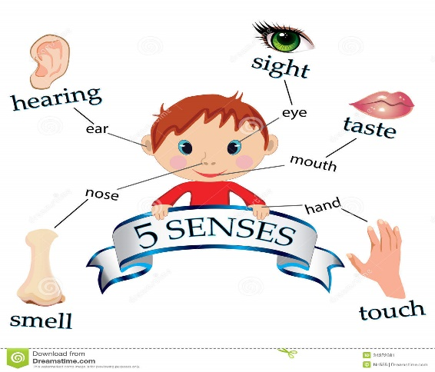

**St Paul’s CE Primary Knowledge Organiser Year Group: 1 Topic: Am I An Amazing Animal? Term: Autumn 1**

**What I already know**

* Names of simple body parts
* Facts about friends in my bubble
* Who I live with
* Some ideas about keeping myself clean
* How I am different/same as other people
* Able to select materials to create my own art work
* What some animals eat
* Animals can look different
* Names of common animals and pets

**Key Skills**

* Ask simple questions
* Recognise emotions
* Dealing with negative behaviour
* Know how to clean our hands
* Identifying different families
* Techniques in colour, texture and shape
* Awareness of online safety
* Working scientifically
* Ask simple questions
* Classifying
* Observing
* Describing and comparing
* Investigating- simple experiments and recording our findings
* Observe and describe seasonal weather

**Vocabulary**

* Head, neck, arms, elbows, legs, knees, face, ears, eyes, hair, mouth, teeth.
* Senses, hearing, seeing, touching, tasting and smelling
* Families, son, daughter, brother, sister, parent, grandparent, step parent
* Fish, amphibians, reptiles, birds, mammals
* Carnivore, Herbivore, Omnivore
* Season, Autumn, Winter, Summer Spring
* Weather, forecast, temperature, rain, fog, cloud, temperature, sun, wind, hail, snow

**New key learning**

* Identify, name, draw and label parts of the human body
* Name body parts associated with the senses
* Use drawing to share my ideas
* Develop art and design techniques in colour, texture and shape
* Classification of animals e.g. fish, reptiles, amphibians and mammals.
* Compare features of animals e.g. some have fur, some have scales.
* Sorting animals e.g. herbivore, carnivore and omnivore
* Observe seasonal changes
* Describe weather associated with the seasons

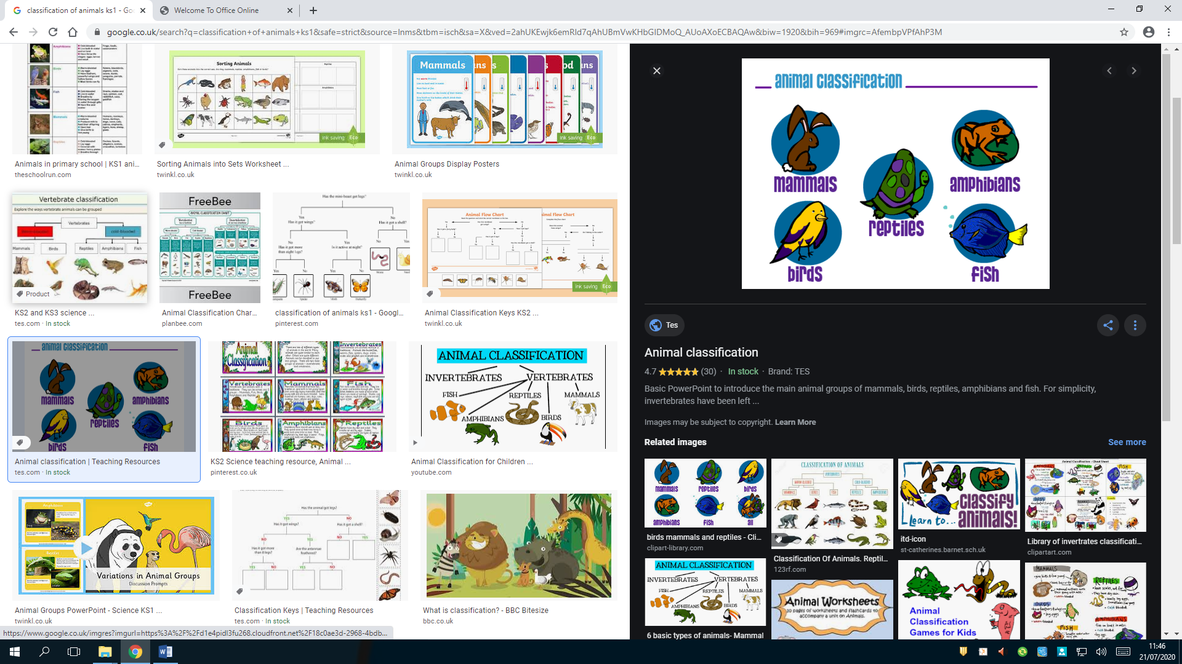

**Parents as partners**

Sing, Head, shoulders, knees and toes, possible visit to a Farm / Zoo/ Pet Shop, Watch the weather forecast on TV

Use the vocabulary, listed above, when talking to your child about their topic work

Use the vocabulary, listed above, when talking to your child about their school day and their school work

**Useful Websites: Senses:** <https://www.bbc.co.uk/bitesize/topics/z9yycdm/articles/zxy987h> **Seasons:** <https://www.bbc.co.uk/bitesize/articles/zk9mxyc>

**Human Body**: <https://www.bbc.co.uk/bitesize/topics/z9yycdm/articles/zqhbr82> **Animals:** <https://www.bbc.co.uk/bitesize/topics/z6882hv>