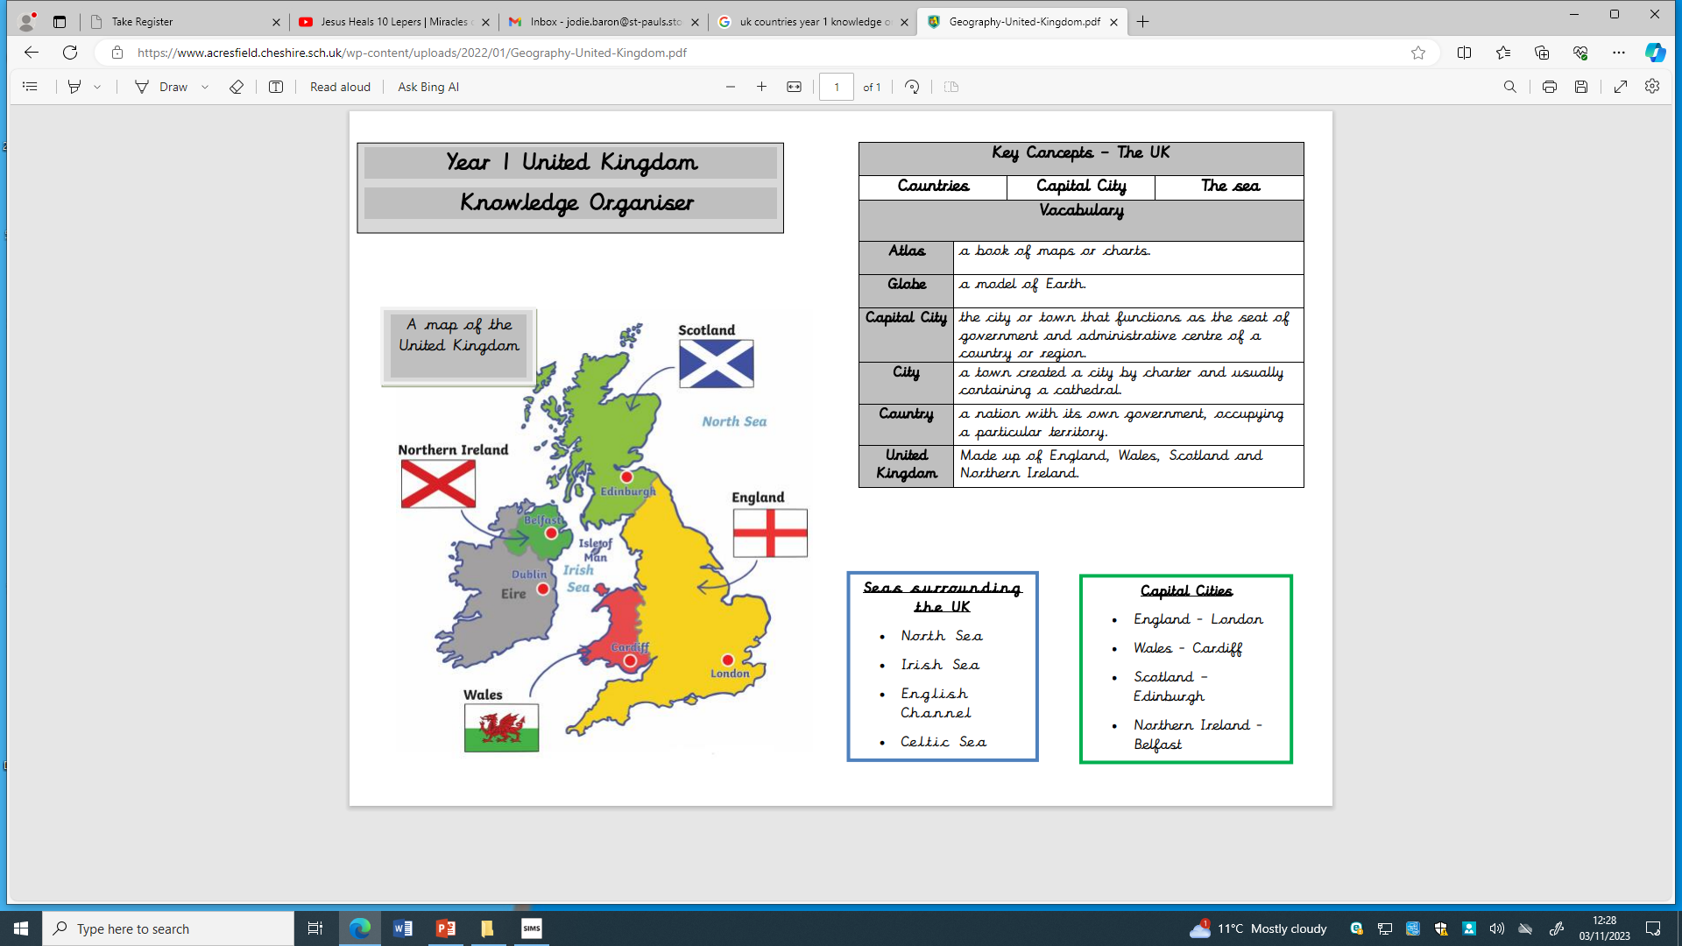

**Sea surrounding the UK**

* North Sea
* Irish Sea
* English Channel
* Celtic Sea

**Globe** – a model of the Earth

**Capital Cities** – Where the country’s government is located. There will be many businesses and people living in the area.

**City –** A place where many people live closely together and have lots of services including shops, businesses and transport. Cities usually contain a cathedral.

**Country –** an area controlled by its own government. They can be large or small.

**United Kingdom –** made up of England, Wales, Scotland and Northern Ireland. Its full name is the United Kingdom of Great Britain and Northern Ireland.

**Key concepts – The UK**

**Capital Cities**

* England – London
* Wales – Cardiff
* Scotland – Edinburgh
* Northern Ireland – Belfast

A map of the United Kingdom

Countries

**Vocabulary**

Capital City

The sea

Year 1 United Kingdom

Knowledge Organiser