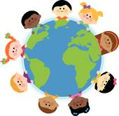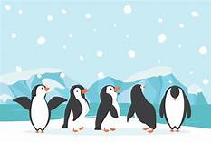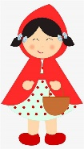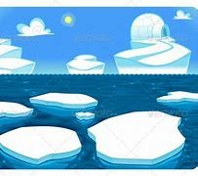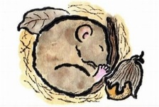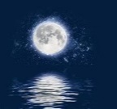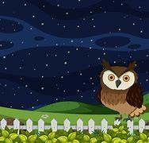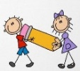[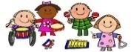](https://www.google.co.uk/url?sa=i&rct=j&q=&esrc=s&source=images&cd=&ved=2ahUKEwj80pSw0a_kAhXLzYUKHRXWCR4QjRx6BAgBEAQ&url=http%3A%2F%2Fclipartmag.com%2Fpreschool-centers-clipart&psig=AOvVaw30zQvOkXEytxns9NjXRv2U&ust=1567427705904707)[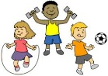](https://www.google.co.uk/url?sa=i&rct=j&q=&esrc=s&source=images&cd=&ved=2ahUKEwjIvuHY0K_kAhVHQBoKHf6eCosQjRx6BAgBEAQ&url=http%3A%2F%2Fclipart-library.com%2Fyouth-exercising-cliparts.html&psig=AOvVaw0FDByRGGT5n92YKwtE5L5C&ust=1567427488437358)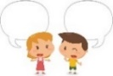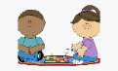

Arctic (North Pole) Antarctic (South Pole)

Reflection: Light travels towards a surface and bounces off it.

Hibernation: The state of being asleep during the winter.

Nocturnal: Being active at night rather than the day.

**EXPRESSIVE ARTS AND DESIGN**

Small world Polar Land play

Small world Woodland Animals play

Paint Polar animals

Make a clay model penguin

Paint a winter sky scene

Create cold colour collages

Create winter music and dance to Debussy, ‘Snow is Dancing’

Sing the Penguin Song

Role-play ‘Little Red Riding Hood’

Weave a basket for Grandma

Paint pictures of the characters from the story, Little Red Riding Hood.’

**Definitions:**

**Key Vocabulary:** light, dark, day, night, nocturnal, polar, Arctic, Antarctic, polar bear, penguin, seal, walrus, snowy owl, arctic fox, torch, snow, ice, frost, shiny, reflection, hail, storm, moonlight, Earth, sun, moon, stars, hibernate, hibernation.

**Parents as Partners in Learning**

Listen to your children read 2 or 3 times each week.

Share stories at bedtime.

Help your children learn to dress themselves, enabling independence.

Participate in the Learning with Parents activities and feedback to your teachers online.

Go on Winter Walks talk to your children about what they can see and hear around them, noticing the signs of winter in nature e.g., weather, plants, animals and birds.

**PHYSICAL DEVELOPMENT**

Manipulate clay to make Penguin models.

Use paint brushes with control to paint winter skies.

Weaving with paper to make a basket.

Experiment with different ways of moving in music and movement to Debussy’s ‘Snow is Dancing.’

St Paul’s CE Primary School **Reception Knowledge Organiser**

Topic: Winter and Polar Lands

Little Red Riding Hood

Spring One

**COMMUNICATION AND LANGUAGE**

Use new vocabulary from our topics and stories in correct contexts, e.g., small world and role-play and when retelling stories.

Articulate our ideas and thoughts in well-formed sentences in discussions and when writing

Retell our story, ‘Little Red Riding Hood’ with some exact repetition and some of our own words.

Act out our story and create story scenarios.

**PSED**

Learn about the value of ‘Thankfulness’’ using the Bible Story, The Thankful Leper

Discuss ‘Stranger Danger’ how to stay safe when out and about in our streets, parks and communities.

**UNDERSTANDING THE WORLD**

Share non-fiction books and power points to find out about the winter season, polar animals, animals that hibernate and animals that are nocturnal.

Investigate how ice melts

Explore the concepts of ‘light and dark’, using torches, mirrors, reflective jackets, colour paddles in the dark den.

Bake cakes for Little Red Riding Hood’s Grandma.

**LITERACY**

Write captions and labels about polar animals.

Draw pictures and write sentences to describe the setting, characters and events of the story Little Red Riding Hood.

Write character descriptions for Little Red Riding Hood, The Wolf, Grandma and the Hunter.