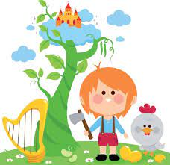


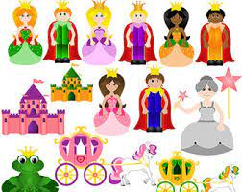
COMMUNICATION AND LANGUAGE
- Memory Game, I climbed up the Giant’s Beanstalk and I took his… Children repeat the sentence, adding items to the list, and recalling all previous items.
- Children will formulate questions to ask the Giant when teacher is in ‘role’.

EXPRESSIVE ARTS AND DESIGN
- Paint fairy tale characters and beanstalks.
- Draw castles using simple 2-D shapes.
- Make beanstalks and castles from junk materials.
- Learn the songs, ‘There was a Princess Long Ago’ ‘Jack climbed up the Beanstalk’ and accompany with musical instruments and actions.
- Make playdough beanstalks
- Role-play fairy tales in the Role Play Castle Area.
- Make up stories whilst playing with the small-world castle.

Nursery Planning
Spring Two
Knowledge Organiser
Fairy Tales

PSED
Discuss the rights and wrongs of Jack taking things that did not belong to him from the Giant.
Discuss how the Giant might feel about this
Is Jack a good boy? Is the Giant bad?

LITERACY
Focus story- Jack and the Beanstalk
Learn to retell the story with talk for write actions.
Discuss the character of the ‘Giant’.
Share a range of Fairy tales at story time.
Phonics. To learn phase 2 initial sound picture cards.
Continue to practice some if not all the letters in their name.

DEFINITIONS

What is a Fairy Tale?
Fairy tales are stories often intended for children, that feature wondrous characters, such as elves, goblins, wizards and even, but not necessarily, fairies. The term, ‘fairy’ tale seems to refer more to the fantastic and magical setting or magical influences within a story, rather than the presence of the other character of a fairy within that story, Fairy tales are often traditional, many were passed down from story teller to story teller before being recorded in books.

Parents as Partners in Learning
Take your children to the library and borrow some traditional fairy tales to share at home.
Which fairy tales did you enjoy when you were little? Discuss your favourite stories and characters with your children, read these stories together.
PHYSICAL DEVELOPMENT
Fine Motor Skills
- Make bean seeds from playdough and match to numerals on beanstalk leaves.
- Use tweezers to pick up pom poms to use as bean seeds to match numerals on beanstalk leaves.
- Make long and short beanstalks with the playdough.
- Thread beads and pasta to make necklaces for Queens and Princesses.
- Make paper castles drawing their own characters.
Gross Motor Skills
- Paint giant beanstalks on the playground using paint rollers and chalk – number the leaves 1-5.
- Pretend to be the Giant, balancing on stilts counting up and back down our giant beanstalks.
- Build castles from large construction.

Understanding the World
- Children will discuss different fairy tales and compile a list of all the fairy tales and characters they know.
- Children will discover that Fairy tales have been around for many years, some 100s of years, and that their Grandparents will have heard and enjoyed many of the same stories as them.

