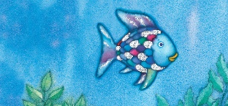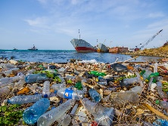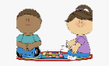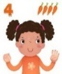[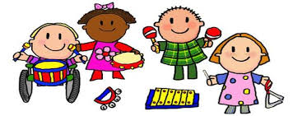](https://www.google.co.uk/url?sa=i&rct=j&q=&esrc=s&source=images&cd=&ved=2ahUKEwj80pSw0a_kAhXLzYUKHRXWCR4QjRx6BAgBEAQ&url=http%3A%2F%2Fclipartmag.com%2Fpreschool-centers-clipart&psig=AOvVaw30zQvOkXEytxns9NjXRv2U&ust=1567427705904707)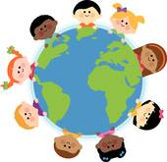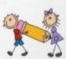

**LITERACY**

Read about sea creatures using non-fiction texts and PowerPoints.

Draw, label and write captions about our favourite sea creatures.

Read the story ‘Rainbow Fish’. Draw a story frame, depicting characters, setting and write simple sentences about the main events.

Read, learn, and recite some poems as a whole class from ‘Commotion in the Ocean’ poetry book

Take orders, write menus in the Seaside

Café role play

Design a ‘Save our Oceans’ poster

St Paul’s CE Primary School **Reception Knowledge Organiser**

Topic: Under the Sea

Summer Two

**COMMUNICATION AND LANGUAGE**

Engage in Non-Fiction Texts about sea creatures, and the season of Summer, developing new vocabulary

Ask how and why questions about sea creatures What do we already know? What do we want to know?

**DEFINITIONS**

Sea: The wide area of salt water that covers most of the earth's surface and surrounds the land.

Sea Pollution: Pollution is anything present or introduced into an environment which causes harm. In the sea there are many kinds of pollution such as rubbish, oil, chemical and even sewage from toilets!

**PSED**

Use the story ‘Rainbow Fish’ as a stimulus to discuss sharing and selfishness.

In Circle time, talk about what the children could share with a friend. Have there been times when they have been selfish?

**MATHS**

Create tally charts and pictogram to show our

favourite sea creatures

Solve addition and subtraction story problems using sea creatures as stimulus

Hide small world fish under a blue sea cloth, “Seven went in sea and 2 swam into the cave. I wonder how many are still in there?”

Use the counting/sorting fish to represent numbers in tens frames to help consolidate number bonds to 10, e.g., there are 7 fish, how many more would I need to make 10? I have 10 fish, take 4 away, how many will be left?

Count pennies correctly to pay for items in the seaside cafe

**Key Vocabulary:** sea creatures, sun, sea, ocean, sand, seaweed, pollution, plastic, recycle, fish, shark, whale, jelly fish, clown fish, angel fish, seahorse, sea turtle, crab, stingray, sun, heat,

**Parents as Partners in Learning**

Please read every week with your child and bring the reading book into school everyday

If you have any old shoe boxes, please can you donate for our Under the Sea craft activities

Practise recall of double facts 1 to 5 and bonds to 10. Count to 20 and back

**EXPRESSIVE ARTS AND DESIGN**

Paint and draw pictures of sea creatures

Paint and collage Rainbow Fish

Paper Plate Jellyfish

Create stories with the small world ocean and pirate ship

Make an Under the Sea small world in a box

Dance to the music ‘Aquarium’ by Saint Saens, using ribbons

and scarves and create the sounds of the sea musical instruments

Learn the song ‘Down there under the Sea’

Role-Play chefs and waiters in the Seaside Cafe

Role-Play Pirates on ‘Pirate Day’ and draw Treasure Maps

**PHYSICAL DEVELOPMENT**

Use stencils to create sea creature pictures

Use scissors to cut out drawn sea creatures for our Under the Sea boxes

Use our whole bodies, creatin sea dances to music

**UNDERSTANDING THE WORLD**

Use non-fiction books and the internet to find out about Sea Creatures

Discuss how we can keep our oceans clean and safe. Share the story ‘Billy’s Bottle’ as a stimulus. Discuss what happens to sea creatures when the ocean is polluted by oil and plastics. Set up a small world ocean that is clean and compare with one that is polluted. Which would the children rather have?

Discuss and read about the season of Summer

Discuss how to keep safe in the sun and how to keep safe on the beach.

Create stories based on going on holiday in our role-play seaside café and shop – what happens on a seaside holiday? What clothes do we need?