**Reception Maths Overview Spring Term**

Comparing height.

Comparing length.

Days of the week.

Looking at numbers 9 & 10.

Order numbers to 10.

Bingo-numbers to 10.

Counting backwards from 10.

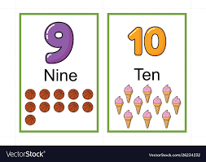Comparing within 10.

Making 10.

Patterns.

Consolidation.