<EMPTY>

**St Paul’s CE Primary Knowledge Organiser Year Groups: 3 Topic: We Are All God’s Creatures Term: Autumn**

**What I already know**

-I know that animals, including humans, have offspring which grow into adults.

-I know that animals, including humans, need food, air and water to survive.

-I know that exercise, eating the right types of food and personal hygiene are all important for humans to stay healthy.

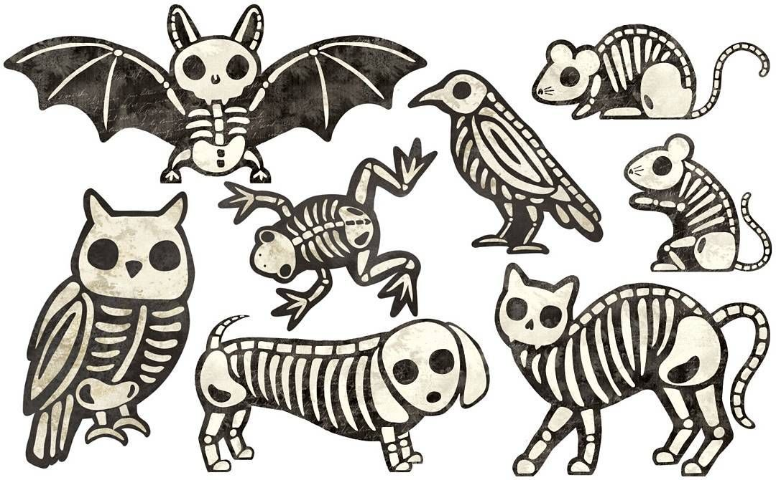

**Key Skills**

- Use reading, speaking and listening to find out new facts.

-Use text, the internet and pictures to find information.

-Use drawing and writing to record ideas about skeletons and muscles.

-Use scientific vocabulary to label skeletons and classify animals.

-Compare animals and skeletons using scientific vocabulary.

-Use practical tasks to investigate the purpose of the skeleton and use scientific vocab to explain observations..

-Set up and participate in simple scientific test.

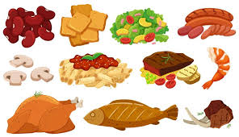

**Vocabulary**

nutrition healthy eating fruit and vegetables

protein carbohydrates fibre energy

protection support muscles joints

compare skeleton exoskeleton investigate

**Useful Websites Skeletons** [**https://www.bbc.co.uk/bitesize/clips/ztfnvcw**](https://www.bbc.co.uk/bitesize/clips/ztfnvcw)[**https://www.bbc.co.uk/bitesize/topics/z9339j6**](https://www.bbc.co.uk/bitesize/topics/z9339j6)

**Nutrition** [**https://www.nutrition.org.uk/**](https://www.nutrition.org.uk/)[**https://www.bbc.co.uk/bitesize/topics/z4d82hv/resources/1**](https://www.bbc.co.uk/bitesize/topics/z4d82hv/resources/1)

**Parents as partners**

Make a healthy meal using the 3 different food groups Try some food you have not tasted before Have a go at an exercise workout (E.g. Joe Wicks)

Use the internet to find out how many bones are in the human body Find out the scientific names for parts of our skeleton Find and take photos of insects with an exoskeleton

**New key learning**

* Identify that animals, including humans, need the right types and amount of nutrition.
* Identify that humans cannot make their own food; they get nutrition from what they eat.
* Identify that humans and some other animals have skeletons and muscles for support, protection and movement.
* Know that some other animals have exoskeletons and that these are on the outside of their body.
* Understand how muscles and bones work together to enable animals to move.
* Design, make and evaluate healthy food products.