<EMPTY>

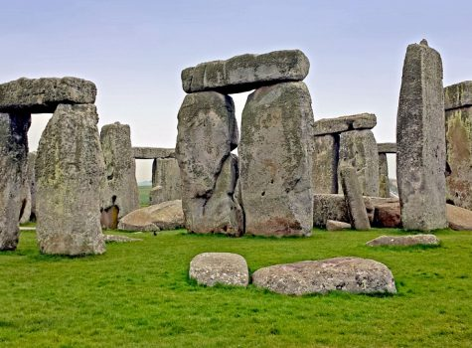

**Key Skills**

* Chronology and timelines.
* Know the difference between primary and secondary sources of information.
* Use primary and secondary sources to gather information.
* Understand the job of an archaeologist.
* Use art to interpret primary sources of evidence.

**New key learning**

* The Stone Age began approximately 700,000 years ago.
* The Stone Age ended 4200 years ago.
* There were life-style changes during and after the Stone Age.
* Order a timeline in chronological order.
* Understand about primary and secondary sources of information, which help us to find out about the past.
* Understand the daily life of the Stone Age people.

**What I already know**

* History included things that happen in the past – sometimes distant and sometimes close.
* An awareness of the past and passing of time.
* Understand that the Great Fire of London was a historical event.
* Identify similarities and differences in different periods of time.

**St Paul’s CE Primary Knowledge Organiser Year Group: 3 Topic: Stone Age Term: Spring 1**

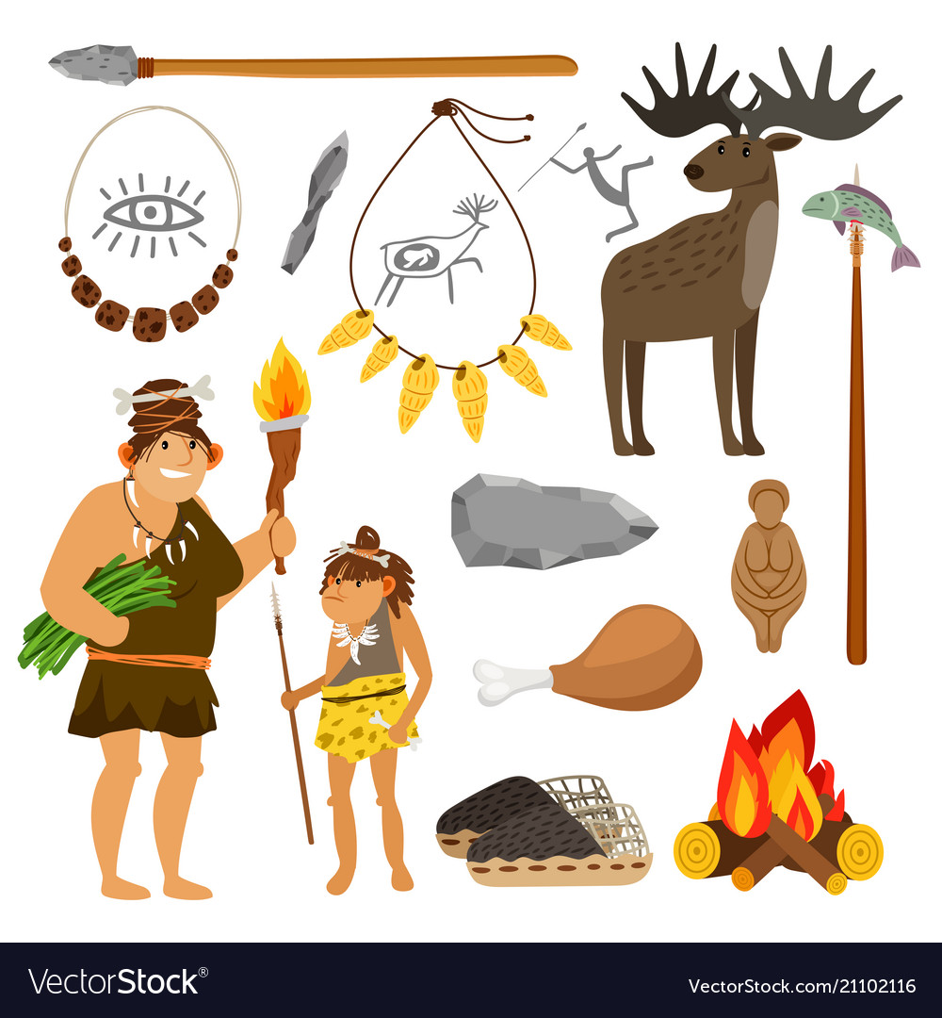

**Vocabulary**

Chronology, timeline, Stone Age, Bronze Age,

Iron Age, hunter, gatherer, winter solstice,

Summer solstice, Stone Henge, Skara Brae, site,

Settlement, artefact, archaeologist.

**Useful Websites**

[**https://www.theschoolrun.com/homework-help/the-stone-age**](https://www.theschoolrun.com/homework-help/the-stone-age)[**https://www.funkidslive.com/learn/top-10-facts/top-10-facts-**](https://www.funkidslive.com/learn/top-10-facts/top-10-facts-)

**about-the-stone-age/#**

**Parents as partners**

Research what Stone Age people would wear and draw a picture and write what the clothing would be made of. Find out about some of the animals that

lived in the Stone Age and draw pictures of them – Woolly Mammoth, Woolly Rhino and Sabre-Tooth Tiger.