What does Science at St Paul’s CofE Primary look like?



Curiosity ~ Aspiration ~ Resilience ~ Excellence

1. The Curriculum: What do we teach, when and how?

At St Paul’s we teach the National Curriculum for Science. We are supported by the PZAZ scheme of work and any other relevant resources that teachers select, to ensure full curriculum coverage as well children’s ‘build-up’ of knowledge and working scientifically skills.

In Reception, we develop children’s skills in ‘Understanding the World’ – looking closely at patterns, changes, differences; exploring materials and living things; talking about how things work; and becoming familiar with experimentation.
From Years 1 to 6, science is taught as a discrete subject with each class covering 4 to 5 units of work depending on their year group. The children begin each unit of work by sharing their prior learning and experience and knowledge, aided by the Knowledge Organiser for each unit in their books. Children’s questions and examples of work are displayed on the classroom’s working wall, serving as a permanent celebration of the wonder and curiosity that drives science lessons at St Paul’s.

2. What would you see in the classroom?

In order to ensure consistency for the children, every classroom at St Paul’s features a Science working wall where children’s questions and knowledge are displayed alongside key vocabulary alongside examples of their work.
In our discrete Science books, each unit of work begins with a Knowledge Organiser detailing prior knowledge and learning and what the children will be learning in the unit alongside key vocabulary and age appropriate definitions.
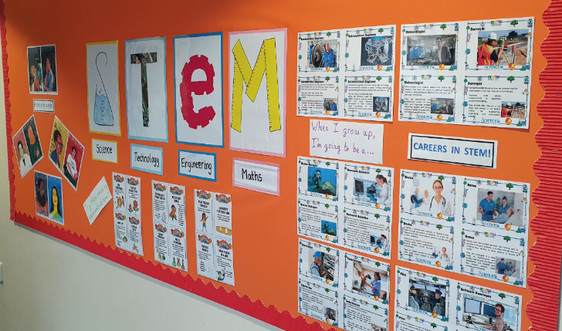
In addition to classroom displays, there are STEM displays in the KS1 and KS2 corridors promoting STEM and the work completed in classrooms each term.
Children are encouraged to ask questions regularly, and to share and explore these questions organically between themselves, as the skill of researching is developed.
In practical and creative work, children come across discoveries of their own and have their questions answered or generate further lines of enquiry. When working with equipment, safety precautions are modelled by the adults.
Most importantly, in the classroom you would see a healthy mix of success and failure. The children gain important experience and grow due to valuing the process of try – fail – learn – repeat. During lessons, there will be a range of independent and group activities where children engage with working scientifically and acquiring new knowledge. Teachers ensure, both throughout a unit of work and across the year, that the working scientifically strands are covered as well as knowledge.

3. SEND and Inclusion.

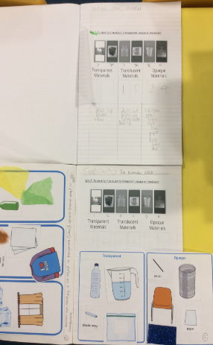
Inclusion for all children is something we pride ourselves in at St Paul’s. All teachers and members of staff ensure that all children will be able to access, enjoy and be challenged within Science lessons across school.
This is done through the well planned lessons with all children included, planned for and supported. Both Scientific Knowledge and Scientific Enquiry skills will be covered and planned for to build on prior learning before introducing new learning.
Any potential barriers will be thought of and removed to help learning. This could mean providing children with vocabulary scaffolds, supporting children’s speech and language targets or using images or DEAL to make conceptual connections. Children will have a range of additional support measures such as 1:1 work with an adult, group work and peer support to ensure that all children can access the well planned learning. In books, this will be recorded to show how children have been supported.
4. How do we know how children are doing? How do they know themselves?

During lessons, there is a lot of verbal discussion and live feedback from the teacher in order to maintain scientific accuracy around a concept, or keep an investigation on the right tracks.
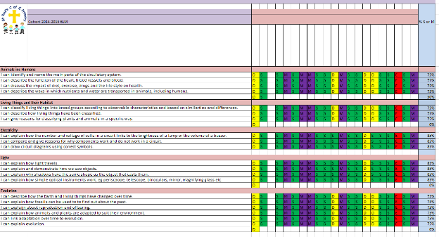
To track long term attainment and progress, teachers use our Marking Key for each WALT, the children are asked to self-assess using the traffic light system, and teachers then log developments against the knowledge and conceptual understanding statements on our cohort trackers.
This allows the Subject Lead and SLT to identify any gaps or areas of focus. It is also a tool for each new teacher of a cohort to easily see the children’s prior learning and aid with the planning and delivery of new units of work.
At the end of the year, teachers log children’s attainment in the knowledge and working scientifically skills on SIMS. This allows the Subject Lead and SLT to analyse in depth where children are with Science across the school and then identify any gaps or areas of concern that can then be addressed through support, CPD or any other relevant actions.

5. Challenge in the curriculum.

At St Paul’s we have a clear and well planned skills progression. Planning across all phases ensures full coverage of the National Curriculum for Working Scientifically and the acquisition of knowledge. This planning builds on prior learning and introduce new knowledge throughout the year groups.
In lessons, children are encouraged to question and discuss key concepts that drive their natural curiosity into the world around them and help with creative thinking and problem solving. There are high expectations clearly set out by all teachers both in terms of presentation, behaviour and involvement in Science lessons.
With the aid of detailed activities in our PZAZ scheme, we provide the children with a variety of activities to promote their love of Science and build their scientific skills. Teachers use a range of additional resources, such as Explorify or other ICT resources, to aid in the delivery of Science at St Paul’s.
6. Cross-curricular and enrichment.


At St Paul’s, we love to share effort and curiosity from the child with as big an audience as possible. We often take work to other teachers and SLT, share pieces in weekly assemblies and publish high quality work on the walls and on our website.
When relevant and appropriate, we make connections and links with other areas of the curriculum, particularly the STEM disciplines of maths, ICT and DT as well as geography.
In order to support the nationwide drive for more children, especially girls, taking up careers in science and engineering, our STEM displays reflect on women in science as well as encouraging diversity in STEM too.
In the past, children have been involved in British Science Week, Walk to School and the STEM Live lessons.
Our after school STEM club provides a platform for children to engage in STEM activities and where we aim to inspire our children further to pursue a career in STEM.
Our Eco-Advocates in Key Stage 2 provide a fantastic opportunity for children to exercise their voice and show courageous advocacy. We take part in the Stockport Climate Action initiative, successfully winning a debate and enacting changes both locally and within school.

