What does Geography at look like?
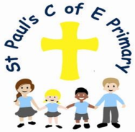

Curiosity ~ Aspiration ~ Resilience ~ Excellence

1. The Curriculum: What do we teach, when and how?

In EYFS the children will develop an understanding of the world around them. They will achieve this by going out into the local area, discovering the world around them. Teachers will constantly engage in conversation with the children to enhance their learning. They complete hands on learning as a group, focusing on the seasons, completing walks throughout the year to explore the world around them.

From Years 1-6, Geography is taught as a stand-alone subject, but links are made to other subjects where possible. Objectives are taken from the National Curriculum, split across all year groups, ensuring that all aspects of the curriculum are covered as well as allowing children to build on their learning. There are 4 key strands that run through the years which show how prior learning is built on in each year group and can be used as a support for teachers. Key vocabulary goes alongside these strands so teachers know what words the children should be using to support their learning.

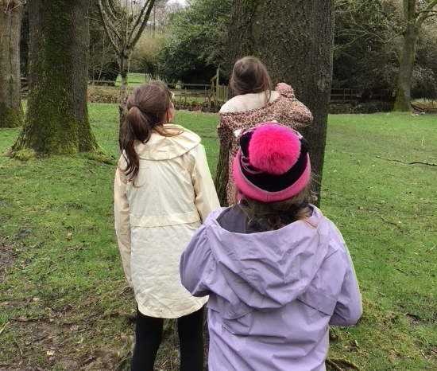
2. What would you see in the classroom?

Geography lessons should be hands-on and engaging lessons. Class teachers decide on the best groupings for their children so that they can all access the lessons as well as make progress. A variety of resources are used throughout lessons to create engaging lessons while also making further links for children. Prior learning will be built on, this might be through questioning at the beginning of lessons or building on skills from previous lessons or years. Geography learning will be recorded in their Geography books, this could be done in a variety of ways, and photographs can be used when practical learning is done by the children. Lessons won’t always be done in the classroom as children need to explore the world around them, developing skills in fieldwork.

Geography displays will be seen in learning areas, these should display children’s work as well as having resources on that will aid their learning. These displays will be clear and useful for the children. Knowledge organisers are stuck in children’s books, they will know how to use them to help with their learning and these can also be used by teachers, having key questions on them to assess children’s learning.

3. SEND and Inclusion.

Geography lends itself to learning through enquiry and lessons can be adapted to suit all learners enabling everyone to make progress and enjoy their learning. Children can be placed in mixed ability groups which will allow discussions to happen and all children to be involved, this can be through listening to other children’s ideas or having the opportunity to share their own where they feel comfortable. Children’s learning is assessed against the four stands which will allow children to show where their strengths are as this could be in certain areas of Geography. Lessons can be planned to explore outside of the classroom, taking their learning further, allowing all children to be involved, making links to the wider word, while taking the pressure of presenting their work.

Teachers model correct vocabulary which the children can use within their work, providing children with sentence starters or key word bands when competing activities so they can use correct geographical terminology. When presenting their learning, children will be given a variety of ways to do so, this could be through drawings, photos or writing where suitable. Adults can scribe for the children where necessary to allow them to show their understanding. During lessons, children will have access to a range of resources to aid them with their learning; maps, atlases, digital photographs and more. These resources can then be adapted further to support the children’s needs, this could be enlarging pictures or changing the colour to allow them to access them. During lessons, questioning can be used to check the children’s understanding, these questions can then be adapted further to allow all children to have a go at answering them.

4. How do we know how children are doing? How do they know themselves?

Assessment is done continuously throughout Geography teaching. At the beginning of Geography teaching, teachers gain an understanding of what children already know, this can be done through questioning or quizzes. Misconceptions can then be addressed and lessons can be adapted to suit the children’s level of understanding. Consistent questioning is done throughout lessons so the teacher can assess the children’s learning as well as the children being able to deepen their understanding. Through questioning the children will also gain an understanding of what they know and build confidence too.

Children are given knowledge organisers at the start of topics which are stuck in their books. These are used as an assessment tool as they involve key questions the teachers can use, as well as having the key learning the children should know by the end of the unit. Teachers use the 4 key strands to assess their children against, these strands which will allow staff to see where the strengths in Geography are.

Children who show signs of being mastery in Geography will show a deeper understanding of the topic. Teachers can use the ‘Mastery in Geography’ document to support their judgement when assessing these children.

5. Challenge in the curriculum.

Teaching Geography creatively, and offering a challenge for all children, means gaining an understanding of what the children know and adapting learning to create the challenge for all at their own level. During lessons children will be given the opportunity to take part in discussions, share their own ideas and opinions, while facing the challenge of what other children think. DEAL can be used to take the children’s learning further, giving them the opportunity to put themselves in real-world situations and having to adapt their way of thinking to suit the situation they are presented with. Constant questioning can be used to challenge children’s learning, requiring them to reason their choices as well as take their learning further. Teachers have high expectations throughout Geography, especially through the presentation of children’s work, achieving the curriculum value of excellence. Children have the opportunity to present their work in a variety of ways, taking responsibility for what they produce.

6. Cross-curricular and enrichment.

Cross curricular learning offers a creative way to develop children’s knowledge, skills and understanding of the world around them. Cross curricular links will allow children to experience situations that engage their imagination while also encouraging active enquiry. At St Paul’s we aim to make real links across subjects that the children understand, to make them effective within their learning. Geography provides plenty of opportunities for social development, providing opportunities to link topics to real world experiences and allow children the opportunity to share their opinions. Geography lends itself to speaking and listening development, children having plenty of chances to take part in discussions and presenting their work. It creates opportunities for children to present their work in a variety of ways, developing their writing skills, using geographical vocabulary within their work. One example of cross curricular learning in Year 4 is linking Geography and History learning through the study of the Mayas, locating where they were within the world while finding out why they were an important part in History.

