What does Design and Technology at St Pauls C of E

look like?

Curiosity ~ Aspiration ~ Resilience ~ Excellence

1. The Curriculum: What do we teach, when and how?

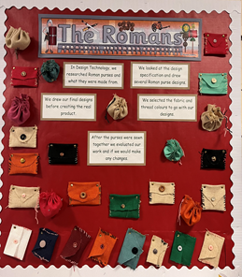
In Reception we develop children’s skills in Understanding the World and Expressive Arts and Design. The children have opportunities to explore cutting, joining, including elements of nature and different materials. They begin to become familiar with experimentation.

Throughout Years 1-6, Design and Technology is taught progressively enabling pupils to build on prior learning and skills to further develop their understanding. Children’s work is recorded in D & T books and often evidenced through display and model making.

To ensure consistency and progression Teachers follow the Projects on a Page scheme of work from Year 1 to Year 6. The scheme provides multiple opportunities for repeated encounters of key concepts, giving the children the opportunity to build upon and extend prior learning.

2. What would you see in the classroom?

Design and Technology lessons at St Paul’s include accurate vocabulary being used by both children and adults. You would see engaged children discussing, sharing, planning and adapting their ideas. Children understand that their ideas have to fit the principle of designing for a purpose. There is a clear distinction between D&T and Art, in that children are constantly aware of the end user and the purpose of their product. When they are evaluating their work, it is against the success criteria previously established at the very beginning of the design process.

To master the skills needed in order to physically make a product, teaching and support staff model, effectively, whilst empowering the children to be independent. Most importantly, in the classroom you would see a healthy mix of success and failure. The children gain important experience and are able to grow. Children have the opportunity to work in a range of ways matched to the activity such as, mixed ability pairs and groups, ability groups and individually. The resources provided are appropriate and enable the children to produce quality products.

3. SEND and Inclusion.

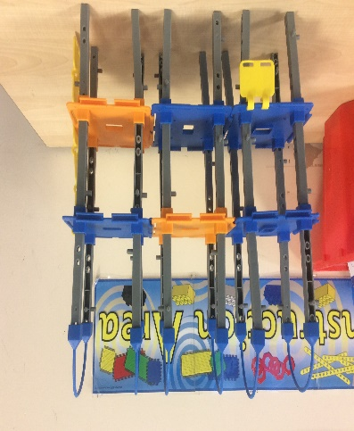
Our aim for Design Technology is to provide a purposeful and inclusive curriculum that enables all our pupils to develop a range of practical skills, knowledge and creative thinking abilities, irrespective of their needs. The Design and Technology curriculum meets the diverse range of needs and abilities of our SEND pupils. We carefully plan and adapt our teaching approaches and resources to ensure engagement and access for all learners. We adapt all of our lessons to make sure that children can meet their potential in the subject. Teachers consider factors that support each child’s needs and factors that may inhibit or prevent learning such as use of equipment, gaps in knowledge of vocabulary or processes. Teachers are mindful of how to balance adult support alongside opportunities for independent learning, ensuring that tasks are broken down and build incrementally. Scaffolds are used to facilitate the recording of work and additional support materials such as vocabulary mats, a range of scissors and other resources enable all the children to achieve their full potential.

4. How do we know how children are doing? How do they know themselves?

Within each lesson there will be live, purposeful discussion from the teacher in order to keep the children focused on the purpose of the product.

One of the strands of design skill we teach is evaluation. This develops the children’s independence and responsibility for their learning. When we explicitly teach how to evaluate, children are instantly able to recognise their steps for development and moments of success to celebrate.

To ensure long term progress teachers follow the Projects on a Page scheme, and projects are carefully planned into relevant terms and discussed between parallel classes and the following or previous Year group.

Data is collected each year and analysed to show how many children are working at each level. This can be extended to look at different and or vulnerable groups.

Marking in books is also used as is self-assessment. Learning more, remembering more strategies are also implemented.

5. Challenge in the curriculum.

Challenge lends itself easily to the core principles of Design and Technology in that the children have to create something brand new and that is fit for purpose. The scope for invention is vast and effectively limitless. In D&T projects, children have the freedom to explore the brief differently to other individuals and groups, allowing for real creativity and independent thinking.

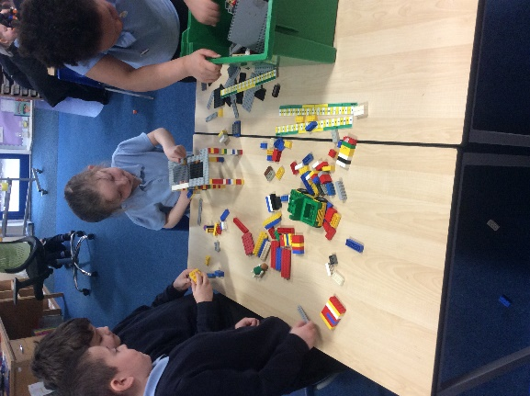
The challenge that comes from D&T at St Paul’s is two-fold. Firstly, the subject presents challenge for fine motor skills, for example when cutting, folding, joining, screwing and building. Secondly, D&T provides a level of emotional challenge within the cycle of development and evaluation of a project. The specific skills are referred to during these parts of lessons and praise for the process outweighs praise for the final product.

6. Cross-curricular and enrichment.

In order to support the drive for more children, especially girls, taking up careers in STEM we promote the subject by dedicating a week in school to STEM. During this time children are encouraged to see the links between subjects and are inspired to pursue their curiosity in this area of learning. The children have the opportunities to create and break things that take their interest and explore how they can be adapted. Design and Technology links to other subjects, when appropriate, for example linking to Maths and accurate measuring and Art, adding creative touches to the finished product.

