What does computing at St Paul’s CofE Primary look like?

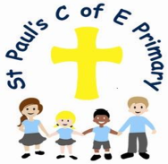

Curiosity ~ Aspiration ~ Resilience ~ Excellence

1. The Curriculum: What do we teach, when and how?
At St Paul's CofE Primary School, we want to use technology to improve learning outcomes and to get pupils ready for a world in which technology is a part of everyday life. We strive to achieve a cross curricular approach, teaching computing skills in a variety of ways. Our curriculum is designed to ensure pupils understand the importance of online safety. IPads and laptops are available to every year group to support their education.

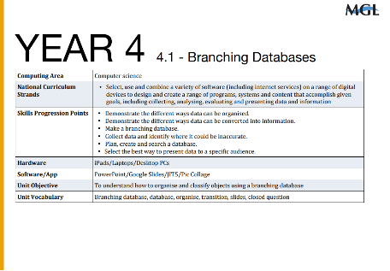
In EYFS there no requirements for computing to be taught however, computing is delivered cross every day during both adult directed and child initiated learning in a cross curricular way. In Year, groups 1-6, 6 units of specific Computing lessons are taught to teach the requirements outlined in the National Curriculum.

We use the MGL World framework, which is designed to prepare children for a digital future. Our computing curriculum is split into three aspects. These are:

Computer Science: This is the foundation of computing, which teaches pupils how digital systems operate and how to use that knowledge to write programmes.
2. Information Technology: this involves applying their understanding of computer science to the development of systems, software, and content.
3. Digital literacy: the ability to use and create ideas through IT; to understand computer networks, particularly the internet; and to use technology in a safe, courteous, and responsible manner.
2. What would you see in the classroom?
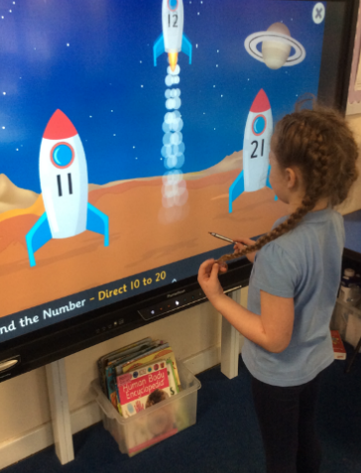

You will observe a variety of computing skills being applied on a daily basis in our classes. Whether it is pupils using computers in the classroom or using iPads and laptops to enhance their education.
Every classroom has an interactive whiteboard (IWB), which is used every day by both the teacher and the pupils. A lot of classrooms use computer displays that highlight the language and abilities that the pupils have learned throughout a unit of work. In order to prepare them for what they will learn, teachers introduce students to knowledge organisers for every unit. Both discrete and cross-curricular computing sessions are taught. Children utilise the laptops and iPads independently and in mixed-ability pairings.
Additionally, you will see the usage of the "parent app" to exchange messages, photos, and details on the children' schoolwork with their parents or carers.

3. SEND and Inclusion.
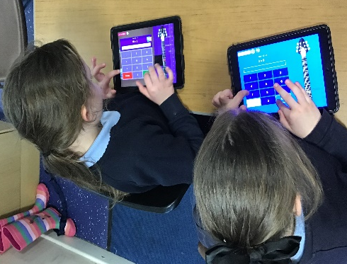
Every pupil, regardless of academic abilities, should be able to access the three computing strands taught in Primary Schools. Computing can be a lot of fun and offers pupils opportunities to achieve in ways that are not easily available in other areas of the National Curriculum.
Teachers strive to remove obstacles to learning in order to ensure that pupils learn computing skills throughout sessions. Every lesson starts with a review of prior learning and a clear introduction to new vocabulary. During sessions, adaptations are made to support pupils with SEND, such as assigning a confident reader peer to assist another pupil if reading presents a challenge. Children can better envisage solutions if hands-on, practical activities are presented such as the use of Ipads and laptops. Providing pupils with the chance to predict the actions of basic programmes can help them become more successful at solving problems across the curriculum. Teachers will make sure SEND pupils have the opportunity to understand and be introduced to the computing language prior to the start of a lesson. Pupil voice also allows pupils to have a say in how computing is taught in the future and how to ensure that it is a subject that all pupils can excel and achieve their full potential.
4. How do we know how children are doing? How do they know themselves?
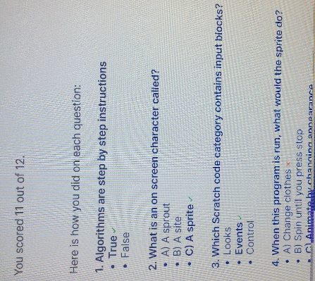
At St Paul's we follow the MGL scheme of work, each area of the computing curriculum has a quiz at the end of the unit. Children receive an instant score after each quiz, allowing them to see which questions they answered correctly. At the end of each quiz children have the opportunity to self-assess the skills they have learnt. This is then fed onto an assessment grid for teachers to access and to identify gaps in learning. An assessment grid that displays a general level of skill is made once the six units have been finished. Data allows teachers to know which children are working towards, working at or working above the expected standards.

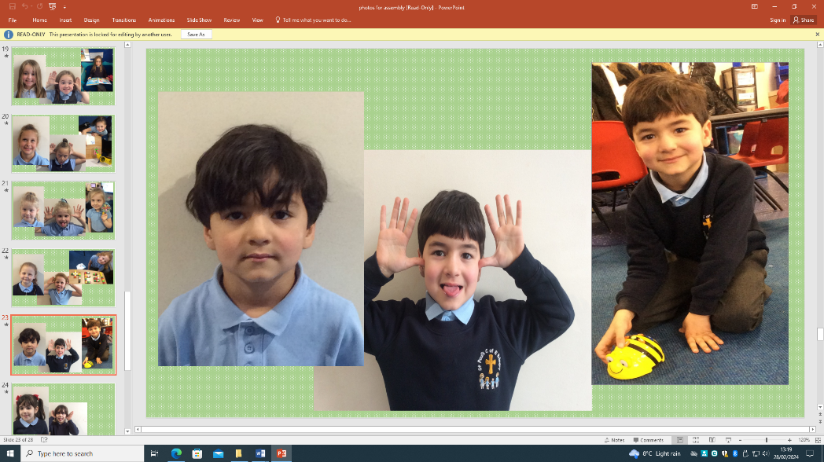
5. Challenge in the curriculum.
For year groups 1-6, the MGL scheme of work provides explicit skills, progression, and planning. The focus of almost every unit is a creative, often collaborative, task in which pupils can apply their own originality to challenging projects. Children develop resilience and the capacity to learn from mistakes throughout algorithm and coding instruction. Furthermore, it's necessary to build computational thinking abilities such as problem-solving.

6. Cross-curricular and enrichment.
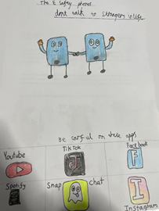
At St Paul's, we utilise technology on a daily basis and not just in our computer lessons. We use the well-known programme "Times Tables Rock Stars" on the iPads to encourage Maths. In Geography lessons, we travel the globe using Google Earth. We conduct research online and utilise Microsoft Office to make posters and presentations. We find that using technology as a part of our lessons makes them much more engaging for the children.
It is crucial to regularly teach children about online safety, also known as e-safety, so they feel comfortable using computers and the Internet and know what to do in the event that they encounter something improper or uncomfortable. Every February, St. Paul's celebrates Internet Safety Day in a variety of ways, including mascot competitions, videos, and posters. We also take part in STEM Week which offers the children the opportunity to investigate computing further alongside other subjects.

