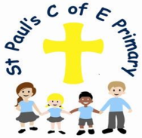
What does RE at St. Paul’s CE Primary School
look like?

Curiosity ~ Aspiration ~ Resilience ~ Excellence

1. The Curriculum: What do we teach, when and how?
The principal aim of RE is to engage pupils in systematic enquiry into significant human questions which religion and worldviews address, so that they can develop the understanding and skills needed to appreciate and appraise varied responses to these questions, as well as develop responses of their own. (Agreed Syllabus for Religious Education 2022- 2027)

RE at St Paul’s is about exploring big questions about life in order to promote deeper thinking. This will enable us to find out what people believe and what difference this makes to how we live, so that we can make sense of religion and world views and reflect on our own ideas and ways of living.

The RE curriculum delivered is based on the Manchester, Salford, Stockport, Tameside and Trafford Agreed Syllabus 2022-2027.


This is a curriculum of ambition and allows children to experience the significance of religious beliefs and worldviews within communities and the importance this understanding has on shaping their own minds. The curriculum allows children the freedom to explore their spiritual, moral, social and cultural development. Children develop knowledge and understanding of world faiths including Christianity, Judaism, Hinduism, Islam and Humanism in order to develop an acceptance of different beliefs. This prepares them for life in a diverse world where tolerance and cohesion within multi-cultural communities is key. By the end of KS2, we hope that the children are able to discuss, explain and be respectful to all faiths and their beliefs whilst maintaining an open-minded approach to new experiences.
The curriculum for RE aims to ensure that all pupils:
· Know about and understand a range of religious and non-religious worldviews.
· Express ideas and insights about the nature, significance and impact of religious and non-religious worldviews.
· Gain and deploy the skills needed to engage seriously with religious and non-religious worldviews.

Across KS1 and KS2, each year group will explore three to four Big Questions. In any one week, RE is usually taught discreetly in 1 hour lessons across KS2 and 45 minutes in KS1.

In Early Years, the children explore different faiths linked to our Christian values, focusing on Bible stories and major religious festivals through the year.

2. What would you see in the classroom?
All classrooms are different and each class studies different content. However there are still clear whole school consistencies throughout St Paul’s.
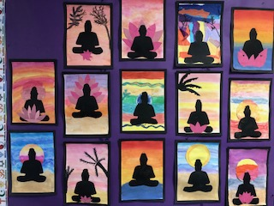
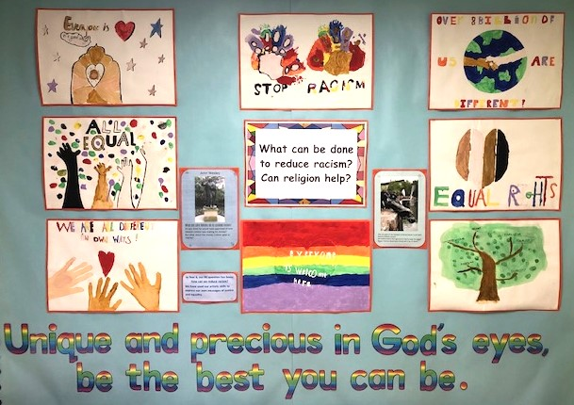
From Y1 through to Y6 each class follows three key themes that underpin planning and content – expressing, living and believing. All topics are started with key questions, clearly displayed on an RE display board, that encourage pupils to consider the different beliefs of others, how different people express themselves and how other faiths and communities live. Children work in groups, pairs, individually or as a whole class, depending on the task and the planned outcomes. RE exercise books are used to record much of the children’s learning. In addition, children’s responses are often displayed on the RE boards alongside the key question and key vocabulary, covering a huge range such as play scripts, quizzes, mind maps or reflective artwork. Boxes of artefacts support the children’s learning and help to broaden their understanding further.
During our Inter Faith week, the children focus on a contrasting religion through many creative mediums such as dance, drama, art and artefacts.

3. SEND and Inclusion.
RE is a subject that celebrates diversity within religious and non-religious worldviews. It encourages discussion about equality, human rights, justice and individuality. These inclusive ideas are affirming not only for the learner with SEND, but also for the whole class.
RE teaching and learning at St Paul’s strives to be fully inclusive and has many approaches to best supporting children with SEND. We ensure that the adaptations that are being made for children are specific to their individual needs and are most effective for them.

Where appropriate, pupils with special educational needs will follow the same RE curriculum as all other pupils. Where adaptations are appropriate, they may take the form of simpler language, matching activities, word mats, supported images and greater use of artefacts. Teaching assistants will work with individual pupils, where required, sometimes on a one-to-one or small group basis to pre teach vocabulary or to introduce new concepts with pictures or videos. It is the school’s policy not to withdraw pupils with special educational needs from RE to catch up on other National Curriculum subjects, as we believe that the understanding of other cultures and religions are of equal importance to and underpin academic achievement.
4. How do we know how children are doing? How do they know themselves?

Regular questioning and recaps at the start of lessons inform teachers as to how our children are learning. Written feedback in books inform the children how they are doing and next step suggestions can move their understanding on further. Written work also informs the teachers of misconceptions, which can then be followed up at the beginning of the next lesson. Multiple choice quizzes and mind maps are also given at the start and the end of units to gauge how much children know initially and what they have retained.
End of year judgements for each child are recorded by the class teacher under three judgements: meeting the expected standard, working towards or exceeding. These are analysed by the RE Lead to identify areas of strength, and where improvements need to be made. This data can also be analysed to look at different groups of children, to ensure all children are achieving equally.

5. Challenge in the curriculum.

At St Paul’s we have an expectation that the children will know more and remember more.

The RE syllabus provides many opportunities to challenge our children. There is clear progression planned into the curriculum and ample opportunities are given to pupils to express their learning, feelings, emotions and experiences in creative ways. During each RE topic covered, creative challenges are set. Some examples of these are poetry, songs or short drama performances as well as art. Children are challenged to think deeply from their own and others’ perspectives, to present their work to a high standard and to have the same expectations of the quality of their writing in RE as in English, reflecting our school curriculum values of curiosity, aspiration, resilience and excellence.

6. Cross-curricular and Enrichment activities

At St Paul’s, we seek carefully planned opportunities to draw links between RE and other curriculum subjects wherever possible to enhance children’s learning. In particular, RE can be linked to the following subjects:
- English – pupils can be given opportunities to use both fiction and non-fiction writing skills.
- Circles- Gives pupils the opportunity for discussion and listening to other people views and opinions.
- PSHE – gives pupils the opportunity to explore protected characteristics and inclusivity, mental wellbeing, family and self-care.
- Computing and ICT – opportunities to research other religions and virtual tours of places of worship.
- Art and DT – pupils can recreate their own RE inspired paintings, artefacts, drawings or models.
Enrichment
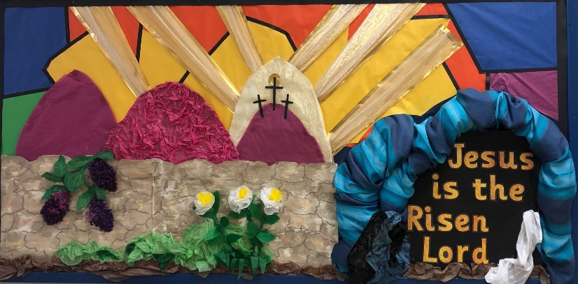
In addition to RE lessons we also have other whole school activities that support the RE curriculum. At St Paul’s, we actively take part in religious festivals and celebrations including
- Remembrance Day
- Harvest
- Christmas
- Easter
- Eid
- Ramadan
- Chinese New year
As well as following the RE syllabus, our school participates in whole school practical approaches such as prayers in assemblies, a half termly Christian Value focus, ‘Anti-bullying week’ ‘Inter Faith week’, and ‘Christmas nativity plays.’ As well as this we arrange school trips to places of worship such as our local church.

Our Ethos Group encourages some of our older children to be involved in planning and delivering assemblies, planning the Inter Faith week and running charity and fund-raising events for the school and the local community. They also get the opportunity to meet with other Ethos groups to develop their leadership skills.
We also have visitors in to support some areas of the RE curriculum such as Christians in Schools and a weekly assembly with one of our vicars from our local church, St Luke’s.



