What does Writing at St Paul’s CE Primary School look like?
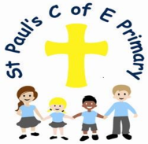

Curiosity ~ Aspiration ~ Resilience ~ Excellence

1. The Curriculum: What do we teach, when and how?
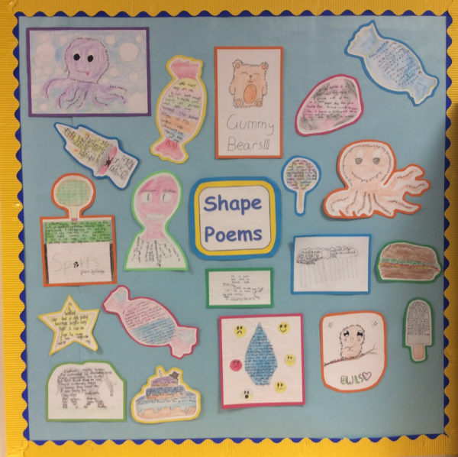
In EYFS, we teach writing alongside the daily Little Wandle Phonics Scheme. Once the children have basic knowledge of letters and sounds, we use a combination of guided and independent provision for them to develop their skills. Strategies which you will see regularly include story mapping, DEAL strategies, a writing area and lots of opportunity for gross and fine motor skill development.

All Writing across the school (from Reception to Year 6), is linked to a quality text which is the stimulus for the children’s writing. In Years 1-6, daily lessons will begin with the sharing of the text. During this time, there will be rich discussions about the genre, purpose and composition of the writing. Once the children are familiar with the text type, they use this as a scaffold for their own writing. A range of strategies are used to support the children in writing purposefully and successfully. Grammar is taught through the chosen text and children apply their grammar knowledge in their writing. Explicit Grammar lessons may also be taught in order to address misconceptions.

Handwriting and spelling are taught discreetly alongside this process following the Penpals for Handwriting and SCODE spelling schemes.

2. What would you see in the classroom?

A typical Writing lesson focuses on a key skill inspired by the text and its purpose. Teachers model and guide children to write creatively through a range of strategies. Initially, and with the help of constructed success criteria, children use their jotters or whiteboards to plan their ideas to begin the writing process. Children then have the opportunity to practise and develop their independent writing through drafting, editing and improving. During this process, children draw on a variety of scaffolded resources including sentence stems, word banks, writing frames, mixed ability groups or pairs and adult or peer support. Opportunities are given for children to share their work, and in response to this, you will see children engaged in the editing and redrafting process. Children receive verbal and written feedback alongside green and pink highlighting to identify areas of success and need for improvement.

Children then write a final copy, which showcases their learning and their hard work. These are displayed, shared with other staff members or celebrated in assemblies and the school newsletter to highlight their success.

Children have a handwriting book to regularly practise their joins and letter formations and are encouraged to apply this in all their writing.

3. SEND and Inclusion.

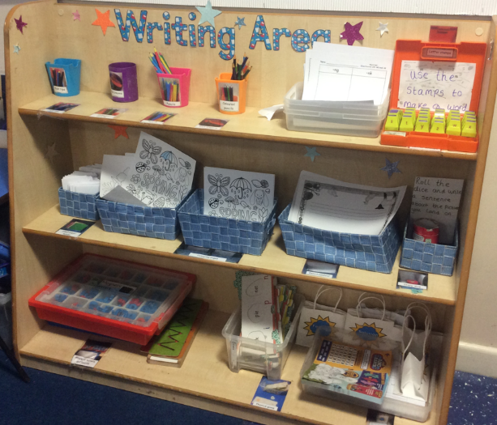
For our SEND pupils, each staff member carefully follows the guidance detailed in their Support Plans so we can best meet the individual needs of the child and address challenges such as handwriting, spelling, grammar and expression. We work closely with the inclusion team and speech and language therapist who further assist in supporting individuals. Scaffolds for these children might include simplified texts, phonics and spelling support, opportunities to orally retell stories, images to support, regular positive and constructive feedback, flexible grouping, DEAL strategies, multi-sensory opportunities including the outdoors and use of technology. Through use of these strategies we aim to empower all SEND pupils to develop proficiency and confidence in Writing.

4. How do we know how children are doing? How do they know themselves?

We record assessment of the children formally and on a termly basis using CAPITA. However, children also receive regular oral and written feedback which includes next steps on how to improve their work. Children know that successes are highlighted in green and areas for improvement in pink. Children are given time to respond to this feedback and make corrections or improvements. This feedback can also inform teacher’s planning if a common misconception arises. From Years 1-6 children are assessed using NFER grammar and spelling tests to track their progress.

5. Challenge in the curriculum.

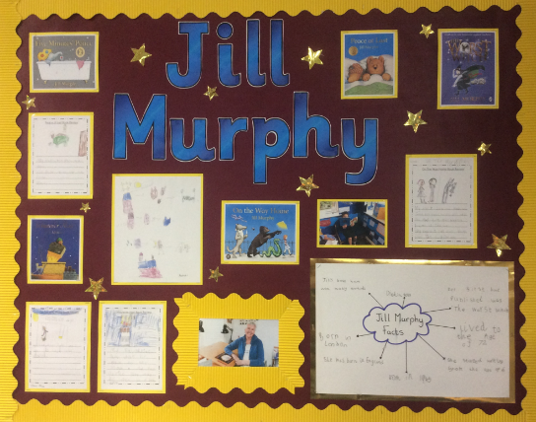
Children at St Paul’s C of E are inspired by high quality texts. Teachers are skilled in helping children to draw out what makes an effective text. Success criteria are developed with the children so that they know what needs to be included for their writing to be effective. Teachers plan units of writing building in the key writing skills specific to the genre of the chosen text. Teachers set high expectations and challenge children to reflect on whether their writing is purposeful and suited to the audience. We encourage children to take pride in their work and to strive for excellence.

6. Cross-curricular and enrichment.

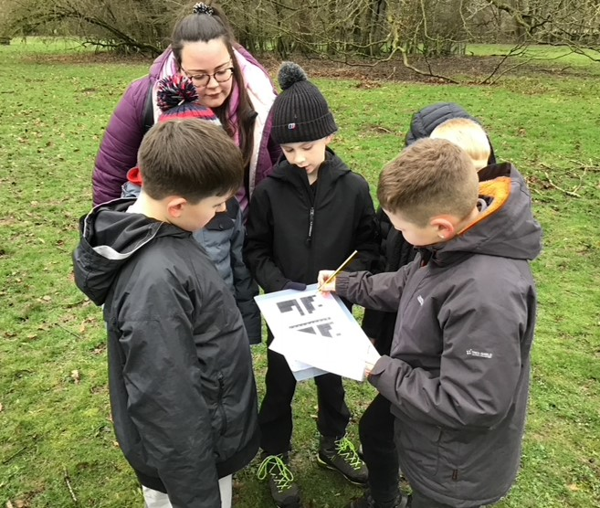
At St Paul’s C of E, writing is embedded throughout other curriculum areas and children are encouraged to apply their writing skills in a variety of different contexts. For example, in Year 2, children write a diary entry within their History topic about the Great Fire of London. In Year 5, children write a recipe within the context of their Design and Technology topic of Food. Year 4 and Year 6’s residential trips provide writing stimulus in their English lessons. Children write a range of non-fiction texts including recounts and persuasive leaflets about their experiences of the areas they have visited. As a school, we participate in World Book Day, Inter-Faith and STEM weeks, giving the children real experiences to write about in context.

