What does MFL look like at St Paul’s C of E Primary School?


Curiosity ~ Aspiration ~ Resilience ~ Excellence

1. The Curriculum: What do we teach, when and how?

Our Key Stage 2 children learn French in weekly lessons using our scheme. Lessons usually last 30 minutes. Children are introduced to French in fun, interactive lessons based around our scheme and using interactive resources.
Initially the emphasis is on speaking and listening. As the children progress they may record work on sheets or in a book.
Children learn to ask and answer questions; memorise words and understand basic grammar.
The pronunciation and phonology of French is taught alongside each module.

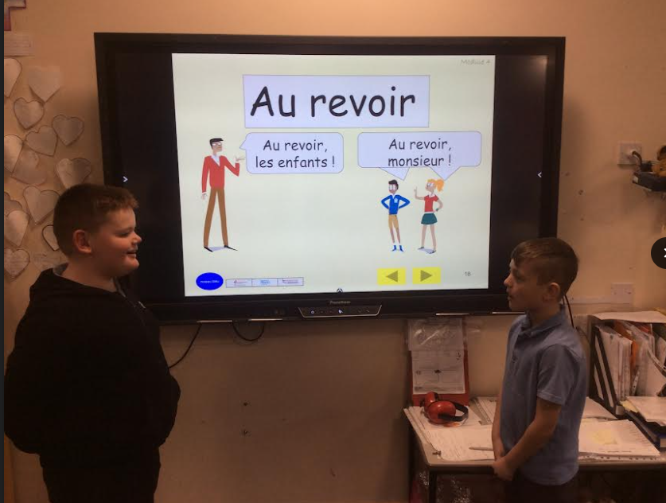

2. What would you see in the classroom?
Lessons follow a set format each week.
Children are encouraged to be active learners. They learn in pairs as a class and individually. Lessons provide opportunities for talking to the teacher and to one another.
Pronunciation is modelled by the teacher and on the interactive whiteboard, using our scheme resources.
Worksheets and exercise books provide the opportunity for reading and writing.
Sometimes we learn songs and listen to stories .Each class has French vocabulary displayed permanently.
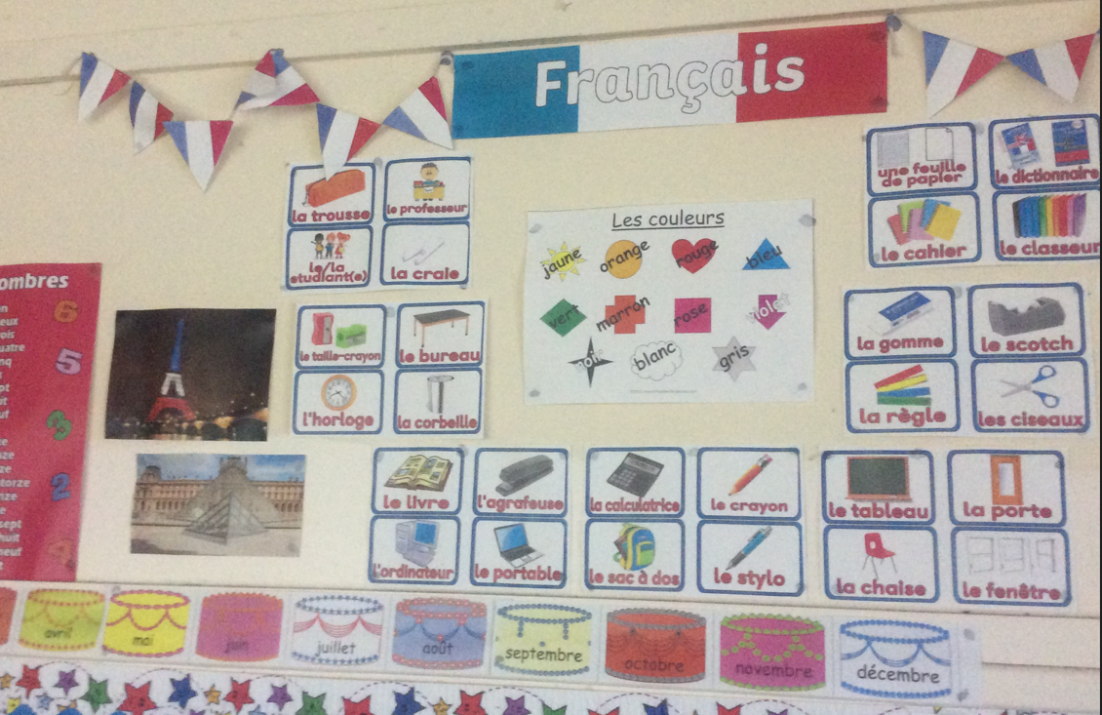
3. SEND and Inclusion.
We provide an inclusive environment where pupils feel safe to take risks and make mistakes. Children are not expected to speak in front of the whole class unless they so wish.
There is a lot of over-learning and repetition to reduce cognitive load.
Games and songs help to reduce anxiety and make learning fun and engaging..
Our scheme uses visuals and a multi-sensory approach to learning French. Teachers use non-verbal clues when speaking French.
Lessons follow a familiar and repetitive format across modules and from year to year.
SEND children may be supported by their peers or by staff. Adaptations are made in line with support plans and EHCPs.

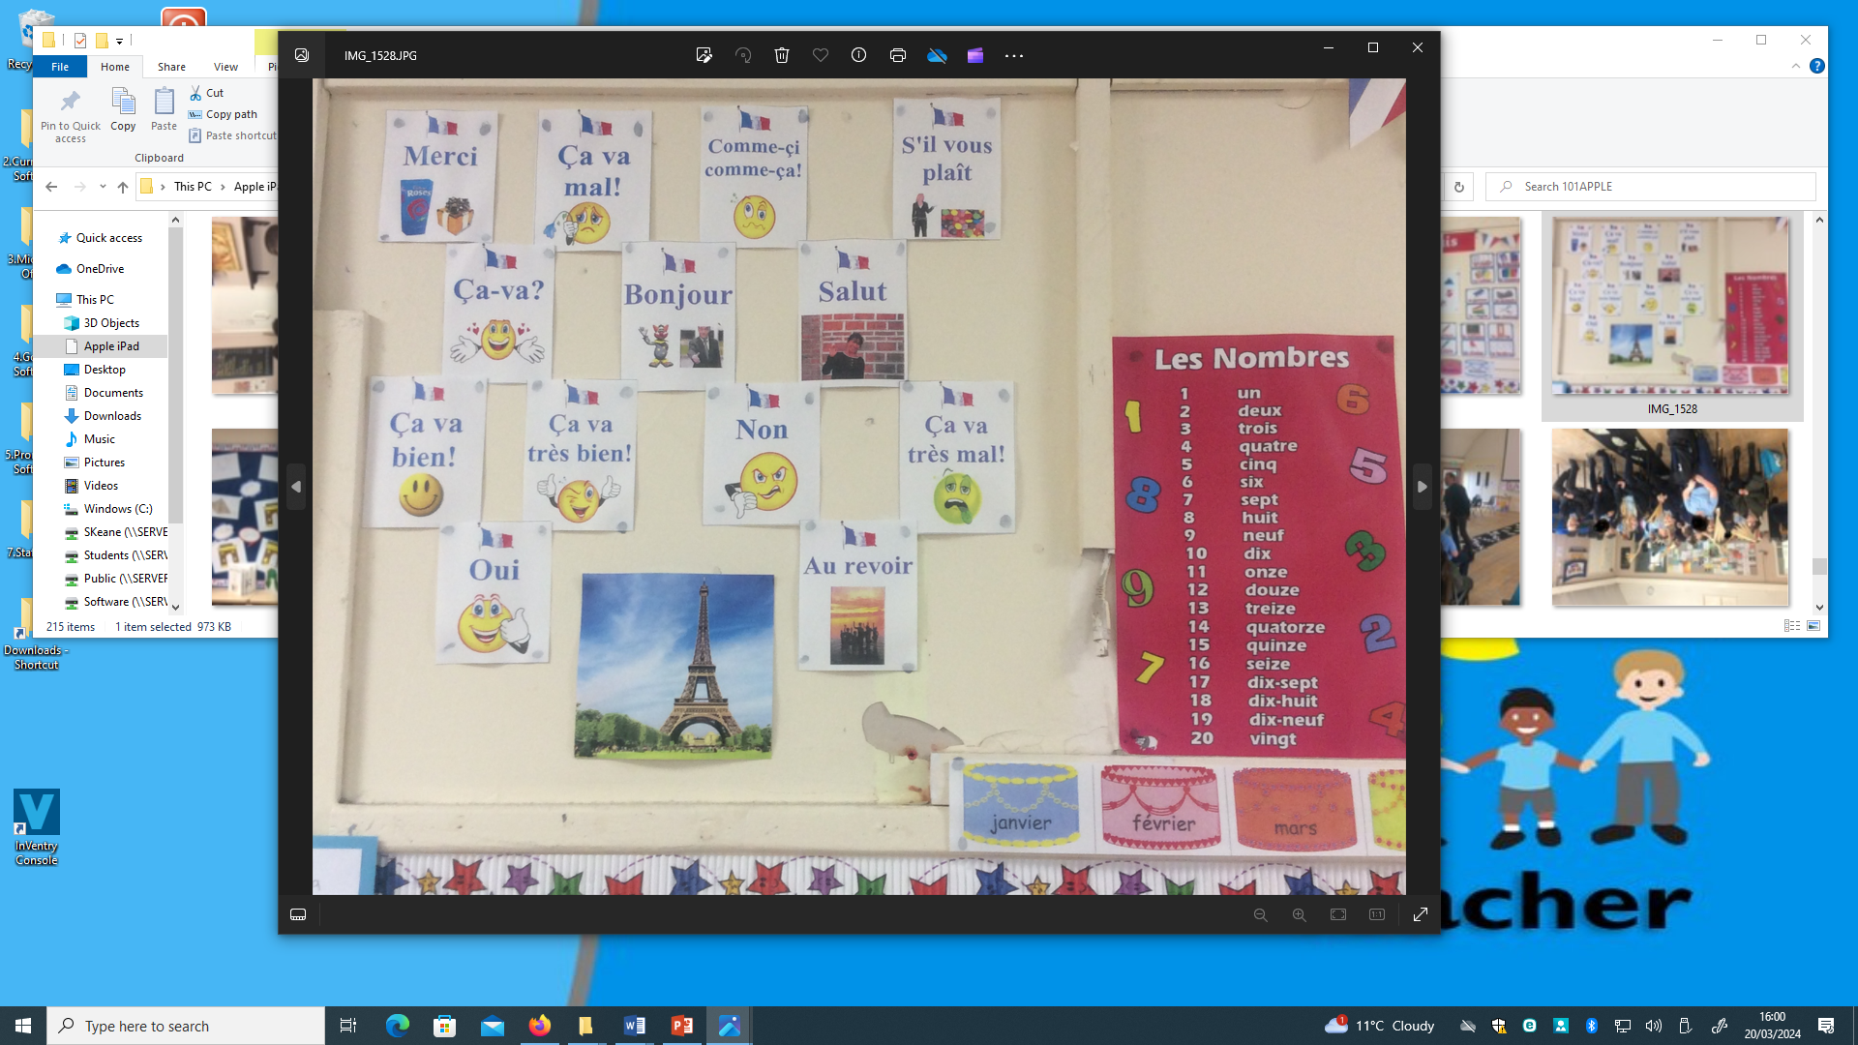

4. How do we know how children are doing? How do they know themselves?

Teachers will use ongoing AFL practice to continually asses their children.
Teachers will be observing and listening to children during lessons and they will be listening and speaking to each other.
As children progress they will have the opportunity to write in French and this will be recorded in books.
At the end of each module children are assessed before moving on.
End of year assessments are made, judging whether children are working below, at or above the expected standard. This helps to identify subject strengths and ensure all children are making progress.

5. Challenge in the curriculum.
We aim to encourage active learning and participation in lessons.
Children are encouraged to overcome any fear of speaking a new language and are encouraged to have a go and take risks.
They are introduced to aspects of French culture that will broaden their horizons.

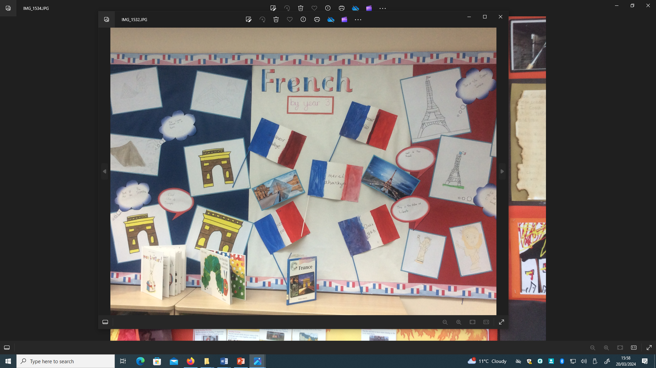

6. Cross-curricular and enrichment.
European Languages Day enables the whole school to be immersed in the culture and language of France and other countries through a variety of activities.

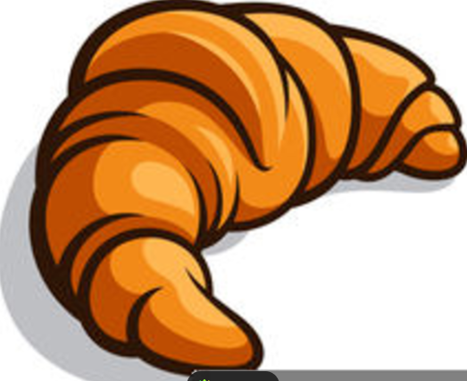

In EYFS
In years 1-6
Is it a discreet subject.
Number of units per year group?
Maths & Lit how often/daily
Discreet subject/some cross curricular links?
Use of a suitable and carefully chosen scheme? – adapted by teachers

2)
A photo/snap shot of ‘which skills will be delivered this lesson’ (ME still to look at this)
Do we use discreet exercise books?
Similarities, differences, consistencies across school?
Vocab?
Display?
Key skills/knowledge – how seen?
KOs where and use of.
Grouping of children?
Any indoor/outdoor provision
Any intervention?

3)
Inclusive – how? Remove barriers how?
Particular reference to subject specific skills where necessary.
Adaptations?
‘Flexible grouping’ - how, why and when this is used. (Use the term flexible grouping)
Examples of adaptations (vocab scaffolds, word banks, images, drama etc)

4)
No requirement to use photos of CAPITA or assessment documents.
Refer to specific feedback, questioning,
Use of marking policy and highlighting
Self and peer assessment? Evaluating (eg DT)
Discussions and picking up misconceptions.
Retrieval practise – mini quizzes etc in line with what we agree as a whole school
Use of particular assessments (NFER, Little Wandle, end of unit test MFL etc)

5)
Clear skills progression and planning.
Varied activities and groupings.
High expectations of everyone.
Reflect the curriculum values in lesson presentation, conduct and children’s work.
Expectation that the children will know more and remember more.

6)
Carefully planned cross-curricular links.
Where can the subject be seen to link?
How is the subject applied in other subjects so that it becomes further contextualised?
Extra-curricular groups (any research/targets that can be linked to this)
Additional activities (eg gardening links to Science/Eco Advocates etc)
Visitors or trips?
Special days/weeks celebrated in school.

