
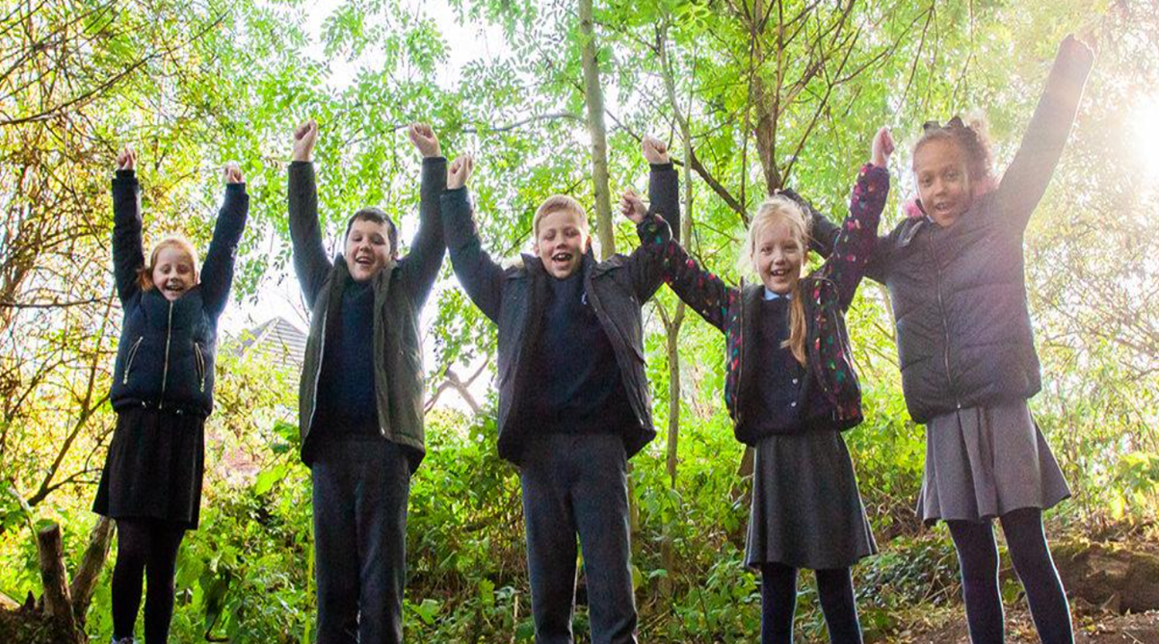

Science Curriculum Overview

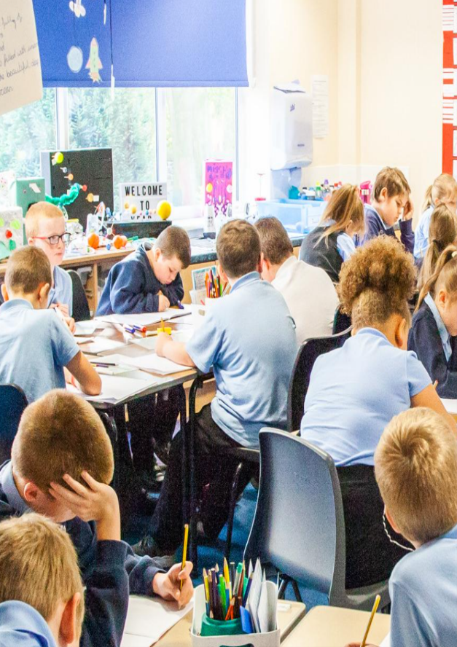
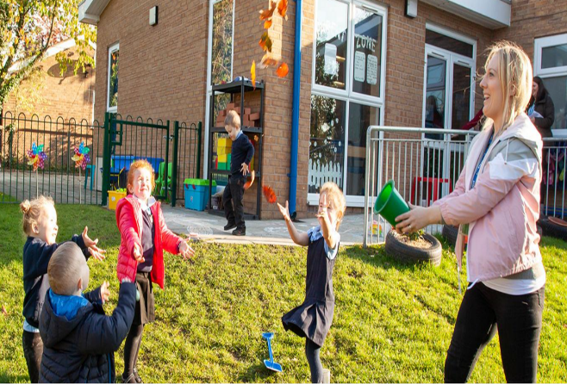
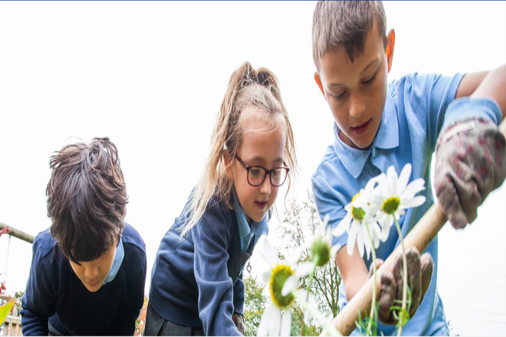
Our Approach
“Unique and precious in God’s eyes, be the best that you can be.”

We have used Kapow Science as the base for our cyclical curriculum, which weaves working scientifically through the 3 branches of Natural Sciences below. Our pupils revisit these aspects throughout their time in our school. The 5 elements of working scientifically are: observing over time, pattern seeking, identifying, classifying/grouping, comparative/fair testing and researching using secondary sources. Within each unit we have identified the working scientifically element that is the main focus. We have also ensured that working scientifically skills are embedded and built upon across each phase. Each time they revisit an aspect, it is with increasing complexity to build on their prior knowledge. In each year group starting in Y1, children learn about the work of 3 prominent scientists to build up an overview of different people and the impact of their work on society. Science is taught weekly for 1 hour from Y1-Y6. In each half term children will conduct a range of investigations/enquiries and have opportunities to apply the different strands of working scientifically. In EYFS children are immersed in enquiry through continuous provision and adult led activities to start to build the foundations of science knowledge and working scientifically elements, through the Knowledge and Understanding strand of the EYFS . From Reception to Y6 we have identified the key vocabulary that children will be introduced to and we use knowledge organisers from Y1-Y6,which contain all the essential knowledge our children should know and remember. We have also identified essential knowledge in bold on our one page overviews below. All classrooms have a science working wall, which displays key questions, our identified scientist, vocabulary, examples of pupils work and our working scientifically symbols.

Our Big Ideas

Our curriculum is designed to enable our children to work towards an understanding of the ‘big ideas’ in science taken from “Working with Big Ideas in Science Education” edited by Wayne Harlen 2015.

By the time a child reaches Y6 we expect them to know:

- All material in the Universe is made of very small particles.
- Objects can affect other objects at a distance.
- Changing the movement of an object requires a net force to be acting on it.
- The composition of the Earth and its atmosphere and the processes occurring within them shape the Earth’s surface and its climate.
- The solar system is a very small part of one of millions of galaxies in the Universe.
- Organisms are organised on a cellular basis.
- Organisms require a supply of energy and materials for which they are often dependent on or in competition with other organisms.
- Genetic information is passed down from one generation of organisms to another.
- The diversity of organisms, living and extinct, is the result of evolution.
This cumulative knowledge is developed over time to enable pupils to develop a secure understanding of the 3 core scientific disciplines and the themes within each as outlined in the National Curriculum. Pupils apply this substantive knowledge through the 5 working scientifically strands:

Observing Overtime  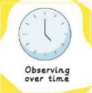 | Pattern Seeking  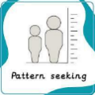 | 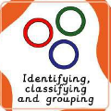  Identifying, Classifying & Grouping | Comparative/Fair Testing  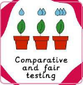 | 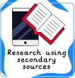  Researching Using Secondary Sources

Our Learning Cycles

Below is an overview of our unit titles for 2025-2026, which are colour coded to show the science discipline and the graphic icons highlight the core working scientifically aspect focused on within each taught unit. The last unit in each year group from Y1 onwards is a “connect” unit which consolidates all prior knowledge and skills from across the year through a key investigation question. The current sequence is based on adjustments due to mixed age classes.

 | AUTUMN |  | SPRING |  | SUMMER
EYFS | Animal Adventures & seasons  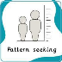  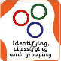  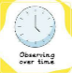 |  | I am a scientist & seasons  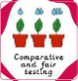 |  | Our beautiful planet & seasons
Y1 | Seasonal Changes  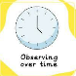 | Everyday Materials  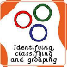 | Sensitive Bodies  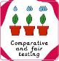 | Comparing Animals | Introduction to Plants  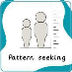 | Investigating science through stories
Y2 | Everyday Materials | Seasonal Changes | 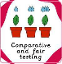  Sensitive Bodies | Comparing Animals | Introduction to Plants | Plant based materials
Y3 | Electricity | States of Matter  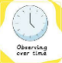 | Seed Dispersal  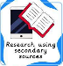 | Sound and vibrations  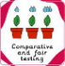 | Movement, nutrition & muscle fatigue | How does hand span affect grip strength?
Y4 | Electricity | States of Matter | Seed Dispersal | Sound and vibrations | Movement, nutrition & muscle fatigue | How does the flow of liquids compare?
Y5 | Mixtures and separation  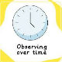 | Properties and changes  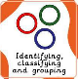 | Earth and space | Lifecycles and reproduction | Unbalanced forces | Human timeline
Y6 | Classifying big and small | Light and reflection  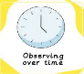 | Evolution and inheritance | Circuits, batteries and switches | Circulation and health   | Are some sunglasses safer than others?

 | YR |  | Autumn |  |  |  |  |  | Spring |  |  |  |  |  |  |  |  |  | Summer
 | Knowledge & Skills |  | Animal adventures & seasons  - The names of familiar animals (e.g. farm animals, pets and animals seen in storybooks.)  - The main body parts of common animals (number of legs, wings, fur and tail).  - Animals, including humans, use their senses to explore the world.  - Animals need food.  - Animals and plants move, grow and feed.  - The difference between things that are living and things that are non-living.  - Plants and animals live in a range of different places (land, sea, air).  - Some different places where animals live on the school site.  - Some trees change in the four seasons.  - Some signs of each season (leaves on the ground, cold weather, daffodils growing and sunny weather).  - The weather changes throughout the year.  - And compare weather types (rain, sun, snow and wind).  - With support, asking questions about the natural world.  - Commenting on what they see and hear in the natural world.  - Drawing and labelling pictures of plants and animals.  - With support, grouping objects, plants and animals. |  |  |  |  |  | I am a scientist & seasons  - Some objects move when pushed or pulled.  - Some objects freeze or melt.  - Objects float or sink.  - Day is light because the sun is in the sky.  - Night is dark because the sun is not in the sky.  - Shadows happen when something blocks the light.  - About differences in sound.  - Some trees change in the four seasons.  - Some signs of each season (leaves on the ground, cold weather, daffodils growing and sunny weather).  - Some animals hibernate or store food in winter.  - The weather changes throughout the year.  - And compare weather types (rain, sun, snow and wind).  - Asking questions about the natural world with support.  - Beginning to share ideas and suggestions when working practically.  - Beginning to make guesses about what might happen.  - Commenting on what they see and hear in the natural world.  - Grouping objects, plants and animals with support.  - Describing their discoveries when working practically. |  |  |  |  |  |  |  |  |  | Our beautiful planet & seasons  - Some objects found in nature are natural, e.g. plants and animals.  - Names for the basic plant parts (leaves, flowers, stem and roots.)  - Some familiar flowering plants (e.g. daisy, rose, sunflower or daffodil).  - Plants and animals live in a range of different places.  - Some different places where animals live on the school site.  - Plants are alive.  - Seeds need water to grow.  - Seeds grow into plants if taken care of.  - Animals and plants move, grow and feed.  - The difference between things that are living and things that are non-living.  - How to help care for the planet.  - Commenting on what they see and hear in the natural world.  - Recognising that information can be found online and in books.  - Drawing and labelling pictures of plants and animals.  - Some trees change in the four seasons.  - Some signs of each season (leaves on the ground, cold weather, daffodils growing and sunny weather).  - Some animals hibernate or store food in winter.  - The weather changes throughout the year.  - And compare weather types (rain, sun, snow and wind).
 | Vocab |  | Alive, desert, group, home, move, ocean, sort, zoo, compare, farm, grow, minibeast, non-living, polar, woodland, autumn, season, weather |  |  |  |  |  | Dark, daytime, float, freeze, light, loud, melt, nighttime, pull, push, quiet, sink, volume, winter, spring, season, weather |  |  |  |  |  |  |  |  |  | Care, earth, flower, grow, human made, leaf, natural, plant, roots, seed, stem, summer, weather, season
 | Continuous Provision |  | Continuous Provision Enhancements  - A range of books linked to areas focus on different places, cultural identity/awareness and environmental impact, plants, animals and the human body.  - Small world enhancement focus to apply skill learnt and explore seasonal/daily weather patterns.  - Access to habitats within the school groups and creation of bug hotels/bird feeders.  - Access to cameras, clipboards and recording media to capture observations of the natural world in and around the school grounds.  - Use of senses to articulate what they see, hear, feel, smell and touch in the world around them
Y1 |  |  | Autumn |  |  |  |  |  | Spring |  |  |  |  |  |  |  |  |  | Summer
Knowledge & Skills |  |  | Forces, Earth & Space Seasonal Changes  - The name and order of the four seasons: spring, summer, autumn and winter.  - That it is unsafe to look directly at the Sun.  - The weather associated with the four seasons and how it changes (in the UK).  - That day length varies across the four seasons, with fewer daylight hours in the winter and more in the summer.  - Exploring the world around them and raising their own simple questions.  - Suggesting what might happen, often justifying with personal experience.  - Using their senses to describe, in simple terms, what they notice or what has changed.  - Gathering specific information from one simplified, specified source.  - Using a prepared table to record tally frequency.  - Representing data using pictograms.  - Using their results to answer simple questions. |  | Everyday Materials  - Objects are items or things.  - A material is what an object is made from.  - A variety of everyday materials, including wood, plastic, glass, metal, water and rock.  - Property refers to how a material can be described.  - Materials can be grouped based on their physical properties.  - Beginning to recognise whether a planned test is fair.  - Suggesting what might happen, often justifying with personal experience.  - Using their senses to describe, in simple terms, what they notice or what has changed.  - Using a prepared table to record results including simple observations.  - Grouping based on visible characteristics.  - Using their results to answer simple questions.  - Begin to recognise when results or observations do not match their predictions. |  |  |  | Animals including humans Sensitive Bodies  - The key parts of the human body (including head, neck, arms, elbows, legs, knees, face, ears, eyes, hair, mouth and teeth).  - The five main senses: sight, smell, hearing, taste and touch.  - The skin is used for touch, the tongue is used for taste, the nose is used for smell, the eyes are used for sight and the ears are used for hearing.  - Recognising there are different types of enquiry (ways to answer a question).  - Using their senses to describe, in simple terms, what they notice or what has changed.  - Using non-standard units to measure and compare.  - Drawing and labelling simple diagrams.  - Using a prepared table to record results including numbers and simple observations.  - Grouping based on visible characteristics.  - Using their results to answer simple questions. |  |  |  | Animals including humans Comparing Animals  - A variety of common animals (including fish, amphibians, reptiles, birds and mammals).  - The main body parts of common animals (arms, legs, wings, tails, fins, head, trunk, horns, tusks & shell).  - A carnivore is an animal that eats other animals and to give examples.  - A herbivore is an animal that eats only plants and to give some examples.  - An omnivore is an animal that eats both animals and plants and to give some examples.  - Recognising there are different types of enquiry and responding to suggestions on how to answer.  - Deciding if suggested observations are suitable, with support.  - Gathering specific information from one simplified, specified source.  - Drawing and labelling simple diagrams.  - Grouping based on visible characteristics.  - Representing data using pictograms and block charts. |  |  |  |  |  | Introduction to Plants  - A variety of common plants and how they differ.  - That deciduous trees lose their leaves seasonally but evergreen trees do not.  - The basic structure, including leaves, flowers (blossom), petals, fruit, roots, bulb, seed, trunk, branches and stem, of a variety of common plants, including flowering plants and trees.  - To begin to understand how plants grow and change over time.  - Ordering a simple method.  - Suggesting what might happen, often justifying with personal experience.  - Using non-standard units to measure and compare.  - Drawing and labelling simple diagrams.  - Using a prepared table to record results including: numbers; simple observations.  - Beginning to recognise when results or observations do not match their predictions. |  |  |  | Investigating science through stories  - The basic structure, including leaves, flowers (blossom), fruit, roots, bulb, seed, trunk, branches and stem, of a variety of common plants, including flowering plants and trees.  - How plants grow and change over time.  - A variety of common animals (including fish, amphibians, reptiles, birds and mammals).  - The main body parts of common animals (arms, legs, wings, tails, fins, head, trunk, horns/tusks and shell).  - The diets of carnivores, herbivores and omnivores and give examples.  - A variety of everyday materials, including wood, plastic, glass, metal, water and rock.  - Property refers to how a material can be described.  - The physical properties of a variety of everyday materials.  - The name and order of the four seasons: spring, summer, autumn and winter.  - The weather associated with the four seasons and how it changes.
WS |  |  | Observing overtime |  | Identifying, classifying and grouping |  |  |  | Comparative/fair testing |  |  |  | Identifying, classifying and grouping |  |  |  |  |  | Pattern seeking |  |  |  | Connects learning across all units
Vocab |  |  | Deciduous tree, evergreen tree, season, weather |  | Absorbent, fabric, glass, group, material, metal, metal, object, plastic, rock, tough, waterproof, wood |  |  |  | Compare, group, hearing pattern, sense(s), sight, smell, taste, touch |  |  |  | Amphibian, carnivore, diet, fish, herbivore, observe, reptile, similarity, bird, compare, difference, group, mammal, omnivore, scientist |  |  |  |  |  | Bulb, diagram, flower, garden plants, growth, measure, roots, stem, wild plants, deciduous, evergreen, fruit, group, leaf, observe, seed, trunk |  |  |  | Amphibian, carnivore, diet, fish, herbivore, material, omnivore, reptile, similarity, bird, compare, difference, group, mammal, object, pattern, season, trunk, waterproof, weather
 |  |  | Alfred Wegener |  |  |  |  |  | Carl Linnaeus |  |  |  |  |  |  |  |  |  | Jeanne Baret
Y2 |  | Autumn |  |  |  |  |  |  |  | Spring |  |  |  |  |  |  |  | Summer
Knowledge & Skills |  | Living things  Habitats  - Some life processes, including movement, reproduction, sensitivity, growth,  - The difference between things that are living, dead, and things that have never been alive.  - A variety of plants and animals and describe some differences.  - A variety of habitats, including woodland, ocean, rainforest and coastal.  - A habitat is the environment where an animal or plant lives/grows because it provides what Living things depend upon each other.  - A food chain can be used to show how animals obtain food from eating either plants and/or other animals.  - Recognising there are different types of enquiry (ways to answer a question).  - Gathering specific information from one simplified, specified source.  - Using a prepared table to record results, including simple observations.  - Grouping based on visible characteristics. |  | Living things  Microhabitats  - A variety of plants and animals and describe some differences.  - A habitat is the environment where an animal or plant lives/grows because it provides what they need to survive.  - A microhabitat is a very small habitat (e.g. under stones, logs and leaf litter).  - That living things depend upon each other (e.g. for food or shelter).  - Responding to suggestions on how to answer questions.  - With support, deciding if suggested observations are suitable.  - Ordering a simple method.  - Suggesting what might happen, often justifying with personal experience.  - Using their senses to describe, in simple terms, what they notice or what has changed  - Recording results using simple observations and tally frequency.  - Organising questions to create a simple classification key.  - Beginning to recognise when results or observations do not match their predictions. |  |  |  |  |  | Uses of everyday materials  - Objects are made from materials that suit their uses.  - One material can be used for a range of purposes.  - Different materials can be used for the same purpose.  - A push or pull must be applied to change the shape of a solid object.  - Solid objects can be stretched, twisted, bent or stretched.  - Different solid objects may take different amounts of force to change shape.  - Recognising there are different types of enquiry (ways to answer a question).  - Using non-standard units to measure and compare.  - Using a prepared table to record results, including numbers.  - Grouping based on visible characteristics.  - Representing data using pictograms and block graphs.  - Analysing and drawing conclusions  - Using their results to answer simple questions. |  |  |  | Animals including humans  Lifecycles and health  - Baby, toddler, child, teenager and adult are human life cycle stages.  - There are differences in the life cycles of different animals.  - Humans grow as they age.  - The basic survival needs of animals are air, water and food.  - Personal hygiene prevents the spread of germs.  - Washing our hands and changing our clothes keep us clean.  - Exercise can improve performance and well-being.  - The five food groups are carbohydrates, fruits and vegetables, dairy and alternatives, protein/oils/spreads.  - Humans require a balanced diet to stay healthy.  - Beginning to use simple measuring equipment to make approximate measurements.  - Gathering specific information from one simplified, specified source.  - Using a prepared table to record results, including numbers.  - Analysing and drawing conclusions |  |  |  | Plant growth  - Seeds and bulbs grow into seedlings by producing roots and shoots.  - Seedlings grow into mature plants by developing parts such as roots, stems, leaves and flowers.  - Seeds need water and warmth to germinate.  - Plants need water, light and a suitable temperature for growth and health.  - Beginning to recognise whether a planned test is fair.  - Suggesting what might happen, often justifying it with personal experience.  - Using their senses to describe, in simple terms, what they notice or what has changed.  - Beginning to use standard units and read simple scales to measure and compare.  - Beginning to use simple measuring equipment to make approximate measurements.  - Drawing and labelling simple diagrams.  - Using a prepared table to record results including: numbers; simple observations.  - Using their results to answer simple questions.  - Beginning to recognise when results or observations do not match their predictions. |  |  |  |  |  |  |  | Plant based materials  - Seeds and bulbs grow into seedlings by producing roots and shoots.  - Seeds need water and warmth to germinate.  - Plants need water, light and a suitable temperature for growth and health.  - the life processes, including movement, reproduction, sensitivity, growth, excretion and nutrition.  - The difference between things that are living, dead and things that have never been alive, using some of the life processes.  - Why objects are made from particular materials and to give examples of their suitability.  - One material can be used for a range of purposes.  - Different materials can be used for the same purpose (and to give examples.)  - Why certain materials are unsuitable for particular objects.  - Solid objects can be squashed, bent, twisted or stretched.
WS |  | Researching using secondary sources |  | Identifying, classifying and grouping |  |  |  |  |  | Comparative/fair testing |  |  |  | Pattern seeking |  |  |  | Observing overtime |  |  |  |  |  |  |  | Connects learning across all units
Vocab |  | Alive, dead, diet, food chain, habitat, life processes, omnivore, prey, sort, carnivore, depend, energy, growth, herbivore, mammal, predator, shelter |  | Food chain, microhabitat, minibeast, research, results, test |  |  |  |  |  | Elastic, fabric, flexible, glass, material, metal, object, plastic, property, rock, suitable, wood |  |  |  | Basic needs, egg, health, hygiene, life cycle, live young, pupa, spawn, survive, teenager, toddler, tadpole |  |  |  | Bulb, diagram, energy, flower, germinate, growth, leaf, life cycle, measure, nutrient, observe, seed, shoot, stem |  |  |  |  |  |  |  | Alive, fabric, germinate, invention, material, property, seed, test, wood, dead, flexible, growth, life processes, plastic, results, suitable, waterproof,
 |  | Al Jahiz |  |  |  |  |  |  |  | Steve Irwin |  |  |  |  |  |  |  | Barbara McClintock
Y3A |  | Autumn |  |  |  |  |  |  |  |  | Spring |  |  |  |  |  |  |  |  | Summer
Knowledge & Skills |  | Animals including humans  Movement and nutrition  - Animals can be grouped based on the presence of a skeleton.  - The skeleton in humans and some animals is used for movement, protection and support.  - The muscular system in humans and some animals works with the skeleton for movement.  - The main bones in the body.  - Animals, including humans, need the right types and amount of nutrition.  - Humans cannot make their own food; therefore, they eat to get the nutrition needed.  - There are nutrient groups (carbohydrates, protein, fats, fibre, vitamins, minerals and water) with their own functions.  - A balanced diet should include all nutrient groups.  - Animals have different diets.  - Reading scales with unmarked intervals between numbers.  - Writing a conclusion to summarise findings using simple scientific vocabulary. |  |  |  | Forces, Earth & Space  Forces and magnets  - Examples of contact and non-contact forces.  - Some forces are a result of contact between two surfaces but some forces can act at a distance (e.g. magnetism).  - Magnets have a north/south pole.  - Some examples of magnetic materials, including iron and nickel, and how they react to a magnet and each other.  - Some different examples of magnets, including bar, horseshoe, button and ring.  - Some uses of magnets.  - Beginning to select from options which variables will be changed, measured and controlled.  - Suggesting what observations to make and how long to make them.  - Beginning to draw more scientific diagrams by labelling with more scientific vocabulary and use arrows.  - Representing data using bar charts.  - Beginning to suggest how one variable may have affected another.  - Beginning to quote results as evidence of relationships. |  |  |  |  | Materials  Rocks and soils  - Rocks can be grouped based on appearance or properties.  - Rocks may contain grains, crystals or fossils.  - Grains and crystals appear differently and can be used to classify rocks.  - Soils are made from rocks and dead matter.  - The relationship between the properties of rocks and their uses.  - Fossils can form from the remains of living things.  - Beginning to draw more scientific diagrams by: drawing in 2D to produce simple line diagrams and labelling with more scientific vocabulary.  - Grouping based on visible characteristics and measurable properties.  - Representing data using bar charts.  - Beginning to suggest how one variable may have affected another.  - Beginning to quote results as evidence of relationships.  - Beginning to use identified patterns to predict new values or trends. |  |  |  | Forces, Earth & Space  Lights and shadows  - Light travels from a source  - Light is needed to see things and that dark is the absence of light.  - Light from the Sun can be dangerous and how to protect their eyes.  - Shadows form when the light from a light source is blocked by an opaque object.  - Shadows change as a result of changing the position of the light source and changing the distances between the light source, object and surface.  - Shadows change position and length throughout the day as the Sun changes position in the sky.  - Beginning to raise further questions during the enquiry process.  - Beginning to suggest how one variable may have affected another.  - Identifying data that does not fit a pattern (anomalous data).  - Recognising when results or observations do not match their predictions.  - Beginning to identify steps in the method that need changing and suggest improvements. |  |  |  |  | Plant reproduction  - The functions of the basic parts of a plant and the relationship between structure and function.  - Water is transported within a plant from the root, through the stem and to the leaves.  - Plants need water, light, air, nutrients and a suitable temperature for growth/health.  - The needs for growth and health vary from plant to plant.  - The life cycle of a plant from seed to mature plant.  - Flowers are the reproductive organs of a plant.  - Pollination is the transfer of pollen to the female (part of the) flower.  - The process of seed formation is the growth of a seed after pollination.  - Different methods of seed dispersal and their benefits.  - Writing a conclusion to summarise findings using simple scientific vocabulary.  - Identifying data that does not fit a pattern (anomalous data).  - Beginning to identify steps in the method that need changing and suggest improvements. |  | How does hand span affect grip strength?  - The muscular system in humans and some animals works with the skeleton for movement.  - The main food groups (carbohydrates, protein, fats and oils, fibre, vitamins, minerals and water) and their simple functions.  - Friction is a contact force that acts between two surfaces to slow an object down.  - Rougher surfaces have more friction between them than smoother surfaces.  - To understand the relationship between the properties of rocks and their uses.  - To know that shadows are formed when the light from a light source is blocked by an opaque object.  - Flowers are the reproductive organs of a plant.  - The process of pollination is the transfer of pollen to the female (part of the) flower.  - The process of seed formation is the growth of a seed after pollination.
WS |  | Pattern seeking |  |  |  | Comparative/fair testing |  |  |  |  | Pattern seeking |  |  |  | Comparative/fair testing |  |  |  |  | Researching using secondary sources |  | Connects learning across all units
Vocab |  | Balanced diet, carbohydrate, fat, invertebrate, measure, movement, nutrient, protein, research, support, vitamin, bone, conclusion, fibre, joint, mineral, muscle, protection, record, skeleton, vertebrate |  |  |  | Attract, conclusion, diagram, friction, magnet, magnetism, non-contact force, plan, record, bar chart, contact force, force, investigation, magnetic material, method, north pole, results, repel, variable, record, south pole |  |  |  |  | Bar chart, crystal, fossil, group, hardness, predict, research, sediment, sedimentation, conclusion, diagram, grain, hard, observe, record, rock, sedimentary rock, soft, soil, sedimentation |  |  |  | Bar chart, conclusion, investigation, luminous, mirror, observe, mirror, predict, record, cast, group, light source, measure, non-luminous, opaque, pattern, prove, reflect, reflection, results table, the sun, transparent, variable, reflective, shadow, translucent, trustworthy |  |  |  |  | Bar chart, female, male, pollen, predict, reproduction, seed dispersal, variable, conclusion, flowering plant, pattern, pollination, record, results table, transport |  | Bar chart, carbohydrate, fat, joint, muscle, predict, shadow, variable, bone, conclusion, friction, light source, opaque, protein, trustworthy
 |  | Marie Curie |  |  |  |  |  |  |  |  | Mary Anning |  |  |  |  |  |  |  |  | Joseph Banks
Y4B |  | Autumn |  |  |  |  |  |  |  |  |  | Spring |  |  |  |  |  |  |  |  | Summer
Knowledge & Skills |  | Animals including humans  Digestion and food  - The main organs of the human digestive system are the mouth, teeth, tongue, oesophagus, stomach, small and large intestines and each has a different function.  - The different types of human teeth are incisors, canines, premolars and molars and each has a different function.  - Teeth can be damaged by sugary and acidic food, for example.  - It is important to brush teeth twice a day, make good food choices and visit the dentist.  - The teeth of carnivores and herbivores are different for a reason.  - Beginning to select from options which variables will be changed, measured and controlled.  - Beginning to suggest how one variable may have affected another.  - Beginning to identify steps in the method that need changing and suggest improvements.  - Commenting on the degree of trust by reflecting on the quality of results. |  |  |  |  | Forces, Earth & Space  Electricity and circuits  - All electrical appliances need a power source, including batteries or mains electricity.  - An electrical circuit needs a complete path for the electrical charge to flow through.  - The main components in a series circuit.  - There are precautions for working safely with electricity.  - Some materials allow electric charge to pass through them quickly and these are known as electrical conductors (e.g. metals).  - Some materials do not allow electrical charge to pass through them easily and these are known as electrical insulators (e.g. wood and plastic).  - Metals are used for cables and wires because they are good conductors of electricity.  - Plastic is used to cover cables and wires because it is a good insulator.  - Planning a simple method, verbally and in writing with numbered steps.  - Selecting and beginning to decide what simple equipment might be used to aid observations and measurements.  - Making predictions about what they think will happen by predicting a trend. |  |  |  |  | Materials  States of matter  - All substances around us can exist as solids, liquids and gases.  - A property of a solid is that it keeps its shape unless a force is applied.  - A property of a liquid is that it can flow freely and take on the shape of a container.  - A property of a gas is that it does not have a fixed shape and can escape from an unsealed container.  - Heating causes solids to turn into liquids (melting) and liquids to turn into gases (evaporating).  - Cooling causes gases to turn into liquids (condensing) and liquids to turn into solids (freezing).  - Water can exist as a solid/liquid/gas.  - The melting point of water is zero degrees Celsius and the boiling point of water is 100 degrees Celsius.  - Water flows around the world in a continuous process-the water cycle.  - In the water cycle, evaporation is when bodies of water are heated and turn into water vapor.  - In the water cycle, condensation is the process of water vapour cooling to form water droplets in clouds, which can result in precipitation.  - The rate of evaporation increases as the temperature rises. |  |  |  | Forces, Earth & Space  Sound and vibrations  - Sound is a result of vibrations.  - Vibrations from sounds travel through mediums to the ear.  - An insulating material reduces the amount of vibrations that pass through it and can be used to protect the ears from damaging sounds.  - Different materials provide different amounts of insulation against sound.  - A variety of ways to change the pitch or volume of a sound.  - Quicker vibrations cause higher-pitched sounds and slower vibrations cause lower-pitched sounds.  - To suggest what observations to make and how long to make them for.  - To observe closely how different instruments create a sound.  - To research how cetaceans communicate underwater.  - To present results using a bar chart.  - To design simple results tables.  - To identify when results or observations do not match predictions. |  |  |  |  | Living things  Classification and changing habitats  - A classification key is used to group/ identify plants/animals.  - Living things can be grouped in different ways.  - Vertebrates are animals that have a backbone and invertebrates are animals that do not have a backbone.  - Plants can be grouped into flowering or non-flowering varieties.  - Flowering plants include grasses and non-flowering plants include ferns and mosses.  - There are five main vertebrate groups: birds, mammals, reptiles, amphibians and fish.  - Invertebrate groups include snails, slugs, worms, spiders and insects.  - Habitats can change throughout the year, which can be dangerous for living things.  - Humans can have both a positive and negative impact on the environment.  - Recording data in Carroll and Venn diagrams.  - Grouping based on visible characteristics.  - Populating a preprepared branching/number key. |  |  | How does the flow of liquids compare?  - How to compare/ group materials together, according to whether they are solids, liquids or gases.  - The part played by evaporation and condensation in the water cycle and associate the rate of evaporation with temperature.  - And use classification keys to help group, identify and name a variety of living things in their local and wider environment.  - Environments can change and that this can sometimes pose dangers to living things.  - A switch opens and closes a circuit and associate this with whether or not a lamp lights in a simple series circuit.  - Some common conductors and insulators, and associate metals with being good conductors.  - Sound and vibrations  - How sounds are made, associating some of them with something vibrating.  - Vibrations from sounds travel through a medium to the ear.  - To know the simple functions of the basic parts of the digestive system in humans.
WS |  | Researching using secondary sources |  |  |  |  | Comparative/fair testing |  |  |  |  | Observing overtime |  |  |  | Comparative/fair testing |  |  |  |  | Identifying, classifying and grouping |  |  | Connects learning across all units
Vocab |  | Canine, control variable, digest, ethics, fair test, incisor, molar, oesophagus, plan, producer, record, saliva, stomach, variable, conclusion, diagram, digestive system, faeces, group, large intestine, mouth, pattern, premolar, proof, results table, small intestine, trustworthy |  |  |  |  | Appliance, bulb, circuit, electrical conductor, electricity, method, pattern, predict, results table, wire, battery, cell, buzzer, conclusion, electrical insulator, mains, motor, power source, property, switch, variable |  |  |  |  | Boiling, condensing, diagram, evaporation rate, gas, measure, precipitation, rate, solid, stop watch, thermometer, conclusion, degrees Celsius, evaporating, freezing, liquid, melting, predict, research, steam, temperature, water cycle |  |  |  | Air, eardrum, observe, plan, proof, research, sound, vibrations, bar chart, insulator, pitch, predict, record, results table, trustworthy, volume |  |  |  |  | Classification key, conservation, endangered, group, nature reserve, observe, research, snail, worm, classify, deforestation, flowering plants, insect, non flowering plants, pollution, slug, spider |  |  | Bar chart, condensing, evaporating, insect, motor, predict, switch, the water cycle, variable, battery/cell, conclusion, gas, liquid, precipitation, solid, temperature, trustworthy
 |  | Leonardo Da Vinci |  |  |  |  |  |  |  |  |  | Galileo Galilei |  |  |  |  |  |  |  |  | Maria Sibylla Merian
Y5A |  | Autumn |  |  |  |  |  |  |  |  |  | Spring |  |  |  |  |  |  |  |  | Summer
Knowledge & Skills |  | Materials  Mixtures and separation  - Some substances will dissolve in a liquid to form a solution.  - The factors that affect the time taken to dissolve, including temperature and stirring.  - Some liquids and solids can be separated using sieving, filtering and evaporation and to describe these processes.  - Gathering answers to open-ended questions from a variety of sources.  - Labelling with a broader range of scientific vocabulary.  - Annotating diagrams to explain concepts and convey opinions.  - Selecting the most appropriate enquiry method to answer questions and give justification.  - Using their senses to describe, in detail and with a broader range of scientific vocabulary, what they notice or what has changed.  - Suggesting which variables will be changed, measured and controlled.  - Making and explaining decisions about what observations to make and how long to make them for. |  |  |  |  |  | Materials  Properties and changes  - To describe a broader range of materials and their properties, including hardness, solubility, transparency, conductivity and response to magnets.  - Dissolving, mixing and changes of state are reversible changes.  - Some changes result in the formation of new materials, which are usually irreversible (e.g. burning, rusting, the action of acid on bicarbonate of soda).  - Writing a method including detail about how to ensure control variables are kept the same.  - Making increasingly scientific predictions by: using previous scientific knowledge and evidence to inform their predictions;  - Using standard units to measure and compare with increasing precision (decimals).  - Suggesting headings to tables, including units.  - Designing results tables with increasing independence with consideration of variables where applicable.  - Writing a conclusion to summarise findings using increasingly complex scientific vocabulary. |  |  |  | Forces, Earth & Space  Earth and space  - The Sun is a star at the centre of our Solar System.  - The Sun, Earth and Moon are approximately spherical bodies.  - The names, order and relative positions of the planets and other main celestial bodies.  - A moon is a celestial body that orbits a planet and give examples of moons that orbit other planets.  - The Earth and other planets orbit around the Sun.  - The tilt of the Earth and its orbit around the Sun causes the seasons.  - The Moon orbits around the Earth.  - How the Earth’s rotation causes day and night and the apparent movement of the Sun across the sky.  - Drawing scientific diagrams by: using a wider range of standard symbols; drawing with increasing accuracy; labelling with a broader range of scientific vocabulary; annotating diagrams to explain concepts and convey opinions.  - Suggesting headings to tables, including units.  - Designing results tables with increasing independence with consideration of variables where applicable.  - Using identified patterns to predict new values or trends. |  |  |  | Living things  Lifecycles and reproduction  - A life cycle shows the changes an animal or plant goes through until the reproduction of a new generation when the cycle restarts.  - All living things must reproduce for the species to survive.  - Sexual reproduction requires two parents whereas asexual reproduction only requires one.  - There are different processes plants and animals use to reproduce (asexual and sexual reproduction).  - Raising questions throughout the enquiry process.  - Identifying testable questions.  - Suggesting which variables will be changed, measured and controlled.  - Using standard units to measure and compare with increasing precision (decimals).  - Gathering answers to open-ended questions from a variety of sources.  - Representing data by using line graphs and scatter graphs with greater accuracy.  - Reading the value of plotted points with greater accuracy.  - Quoting relevant data as evidence of relationships. |  |  |  |  | Forces, Earth & Space  Unbalanced forces  - Gravity is a non-contact force that pulls objects together.  - Air resistance and water resistance are both types of friction.  - Unsupported objects fall towards the Earth because of gravity.  - Friction, air resistance and water resistance act in the opposite direction of a moving object.  - When forces are unbalanced, the speed, shape or direction of an object changes.  - When forces are balanced, the speed, shape or direction of an object stays the same.  - Some mechanisms, including levers, pulleys and gears, allow a smaller force to have a greater effect.  - Rougher surfaces have more friction between them than smoother surfaces and how that may affect movement.  - The larger the surface area of an object, the greater the air or water resistance it creates.  - Suggest which variables will be changed, measured and controlled.  - Write a method that considers reliability planning. |  |  |  | Human timeline & Does the size of an asteroid affect the diameter of its impact crater?  - How to describe the human life cycle, including the stages of growth and development (baby, toddler, child, teenager, adult, elderly).  - How to describe changes that occur during puberty (in boys and girls).  - Gestation periods vary across mammals.  - Representing data by using line graphs and scatter graphs.  - Plotting points with greater accuracy.  - Reading the value of plotted points with greater accuracy.  - Analysing and drawing conclusions  - Writing a conclusion to summarise findings using increasingly complex scientific vocabulary.  - Suggesting with increasing independence how one variable may have affected another.  - Quoting relevant data as evidence of relationships.
WS |  | Observing overtime |  |  |  |  |  | Identifying, classifying and grouping |  |  |  | Pattern seeking |  |  |  | Researching using secondary sources |  |  |  |  | Comparative/fair testing |  |  |  | Connects learning across all units
Vocab |  | Control variable, dissolve, filtering, insoluble, mixture, sieving, soluble, solution, stop watch, variable |  |  |  |  |  | Burning, conductor, hazard, irreversible change, reversible change, rusting, thermal conductivity, trustworthy, control variable, electrical conductivity, insulator, method, rust, safety, transparency, variable |  |  |  | Celestial bodies, day/daytime, discovery, evidence, Jupiter, line of best fit, Mercury, Moon, night, nighttime, data, degrees Celsius, earth, gravity, line graph, Mars, model, Neptune, orbit, planet, Saturn, spherical, temperature, Uranus, year, testable, Pluto, solar system, star, Venus |  |  |  | Adolescence, characteristic, estimate, germination, gills, line graph, lungs, metamorphosis, ovule, asexual reproduction, data fertilisation, gestation, line of best fit, mating, offspring, pollen, pollination, sexual reproduction, reproduction, testable |  |  |  |  | Air resistance, balanced, data, gravity, line graph, mean average, pulley, reliable, trustworthy, anomaly, control variable, gear, lever, line of best fit, pivot, relationship, surface area, unbalanced, variable, water resistance |  |  |  | Anomaly, evidence, foetus, gestation period, hormones, life cycle, line graph, period, puberty, rate, relationship, air , gravity, predict, spherical, reliable, variable, trustworthy, resistance, celestial bodies, conclusion, evaluate, fair test
 |  | Amedeo Avogadro |  |  |  |  |  |  |  |  |  | John Tyler Bonner |  |  |  |  |  |  |  |  | Stephen Hawking
Y6B |  | Autumn |  |  |  |  |  |  |  |  |  | Spring |  |  |  |  |  |  |  |  | Summer
Knowledge & Skills |  | Living things  Classifying big and small  - To know that ‘organism’ is a term used to refer to an individual living thing.  - To know that micro-organisms are incredibly small and cannot usually be seen by the naked eye.  - To know the characteristics of the different groups of vertebrates and commonly found invertebrates.  - Grouping in a broader range of contexts.  - Organising the layout of number and branching keys.  - Formulating appropriate questions for classification keys. |  |  |  |  |  | Forces, Earth & Space  Light and reflection  - Light travels in a straight line from a light source.  - Luminous objects are seen as a result of light directly entering the eye, whereas non-luminous objects reflect light into the eye.  - Shiny surfaces reflect light uniformly.  - When light is reflected off a surface, its direction changes.  - Mirrors and periscopes work using reflection of light on smooth surfaces.  - Shadows have the same shape as the objects that cast them as a result of light travelling in straight lines.  - There are relationships between light sources, objects and shadows.  - The distance between the object and the screen affects the size of the shadow.  - The angle of a reflected ray is affected by the angle of the incoming ray on a smooth surface.  - Identifying testable questions.  - Using standard units to measure and compare with increasing precision.  - Reading a wider variety of scales with unmarked intervals between numbers.  - Annotating diagrams to explain concepts and convey opinions. |  |  |  | Animals including humans  Evolution and inheritance  - Living things have changed over time.  - Fossils provide information about living things that inhabited the Earth millions of years ago.  - Characteristics are passed from parents to their offspring but all offspring vary from their parents.  - Over time, variation in offspring can affect animals’ chances of survival in particular environments.  - Animals and plants have adapted to suit their environment over many millions of years and this process can be called evolution.  - Calculating the mean average.  - Grouping in a broader range of contexts.  - Suggesting with increasing independence how one variable may have affected another.  - Quoting relevant data as evidence of relationships.  - Identifying anomalies in repeat data and excluding results where appropriate.  - Comparing individual, class and/or model data to the prediction and recognising when they do not match. |  |  |  |  | Forces, Earth & Space  Circuits, batteries and switches  - A variety of components in a series circuit (including buzzer and motor).  - Conventions are used to draw circuit diagrams, including the recognised symbols for common components and using straight lines.  - The voltage of a circuit can be changed and this affects bulb brightness (or buzzer volume).  - Suggesting which variables will be changed, measured and controlled.  - Writing a method, including details about ensuring control variables are kept the same.  - Writing a method that considers reliability by planning repeated readings.  - Identifying anomalies in repeat data and excluding results where appropriate.  - Using identified patterns to predict new values or trends.  - Identifying steps in the method that need changing and suggesting improvements. |  |  |  | Animals including humans  Circulation and health  - The main parts of the human circulatory system (heart, blood vessels and blood).  - The heart pumps blood around the body.  - Blood vessels transport blood around the body.  - Blood transports vital substances around the body, including oxygen and nutrients.  - The relationships between different organ systems.  - The impact of diet, exercise, drugs and lifestyle on the way a body functions.  - The heart rate is the number of beats per minute.  - Exercise increases heart rate.  - Making increasingly scientific predictions by using previous scientific knowledge and evidence to inform their predictions, using scientific language to describe a potential outcome or explain why they think something will happen and making links between topics to evidence a prediction.  - Gathering answers to questions from a variety of sources. |  |  |  |  |  | Are some sunglasses safer than others?  - To know the characteristics of the different groups of vertebrates and commonly found invertebrates.  - When light is reflected off a surface, its direction changes.  - Luminous objects are seen as a result of light directly entering the eye.  - Characteristics are passed from parents to their offspring, but all offspring vary from their parents.  - Animals and plants have adapted to suit their environment over many millions of years- evolution.  - Over time, variation in offspring can affect animals’ chances of survival in particular environments.  - A variety of components in a series circuit.  - Conventions are used to draw circuit diagrams, including the recognised symbols for common components and using straight lines.  - To know the impact of diet, exercise, drugs and lifestyle on the way a body functions
WS |  | Identifying, classifying and grouping |  |  |  |  |  | Observing overtime |  |  |  | Pattern seeking |  |  |  |  | Comparative/fair testing |  |  |  | Researching using secondary sources |  |  |  |  |  | Connects learning across all units
Vocab |  | Classification key, classify, cold-blooded, conifer, exoskeleton, fern, life processes, micro0organism, moss, organism, warm-blooded |  |  |  |  |  | Anomaly, control variable, evidence, light ray, line of best fit, pupil, reflective, reliable, testable, conclusion, evaluate, fair test, line graph, mean average, ray diagram, relationship, scale, units |  |  |  | Adaption, competition, environment, evaluate, evolution, fossil, inherit, mean average, natural selection, anomaly, control variable, environmental, evidence, extinct, gene, inheritance, model, parent, reliable, survival of the fittest, variable, population, selective breeding, theory, variation |  |  |  |  | Anomaly, cell, circuit diagram, control variable, current, evaluate, fair test, mean average, relationship, safety, variable, data, evidence, hazard, model, resistance, units, voltage |  |  |  | Anomaly, bloodstream, carbon dioxide, control variable, drug, evidence, heart, line graph, model, blood, blood vessels, circulatory system, data, evaluate, fair test, heart rate, mean average, model, pulse, relationship, secondary source, variable, oxygen, rate, reliable |  |  |  |  |  | Adaptation, bar chart, circuit diagram, classify, conclusion, evaluate, inherit, predict, trustworthy, variable
 |  | James Clark Maxwell |  |  |  |  |  |  |  |  |  | Charles Darwin |  |  |  |  |  |  |  |  | Marie Curie
Our Working Scientifically Progression

Key Area | EYFS | Y1 | Y2 | Y3 | Y4 | Y5 | Y6
Observing Overtime | Know that observation is a key skill of a  scientist.  Know that comparisons can be made through observation. | Know that  observations can be made using simple  equipment.  Know that changes can be recorded through observation. | Know that equipment can be selected to observe change over time.  Know that observations can be measured. | Know that observations need to be careful and systematic. | Know that choices can be made on what to observe and how to measure it.  Know that standard units of time in minutes and seconds can be used when accurately observing. | Know that observations can be made on a variety  of scientific activities.  Know that times of observation will vary according to the requirements each experiment. | Know that observations require: identifying the  measurements required, selecting the equipment  needed and taking precise readings.  Know that the interval and range can be taken from a set of observations.
Pattern Seeking | Know that patterns exist within scientific phenomena. | Know that patterns can be identified within scientific phenomena. | Know that relationships can be identified within scientific phenomena. | Know that patterns can be naturally occurring.  Know that conclusions can be formed based on findings.  Know that a range of bar charts, tables and pictograms are used to show measurements. | Know that patterns can be identified in results.  Know that patterns can be identified through data collection. | Know that causal relationships can be identified.  Know that data can be interpreted to find patterns.  Know that data can be gathered, recorded, classified and presented in a variety of ways which include scientific diagrams, labels, keys, graphs and tables. | Know that patterns can be found in the natural environment.  Know that evidence can support / refute causal relationships.
Identifying, Classifying and Grouping | Know that living and non-living things can be classified. | Know that living and non-living things can be classified and compared. | Know that living and non-living things can be classified and compared through methods of sorting and grouping. | Know that  identified criteria will determine how living and non-living things are classified.  Know that keys can be used when grouping, sorting and classifying. | Know that scientific ideas and  processes determine how living and non- living things are classified and sorted. | Know that scientific ideas and  processes determine how living and non- living things are classified and sorted. | Know that own classification methods can be chosen and developed in order to sort living and non - living things.
Comparative/Fair Testing | Know that we can investigate different areas of science practically.  Know that objects, materials and living things can be explored scientifically.  Know that simple predictions can be made. | Know that patterns can be found in the natural environment.  Know that evidence can support / refute causal relationships. | Know that explanations can be made based on what has happened during an investigation.  Know that simple tests can be carried out independently. | Know that an investigation includes simple, practical enquiries.  Know that measurements can be taken using a range of equipment.  Know that comparative tests can be carried out. | Know that there is more than one variable.  Know that fair tests can be carried out. | Know that some variables need to be controlled.  Know that results can lead to further prediction and the design of further comparative tests.  Know that methods can be improved. | Know that there are explanations behind needing to control variables.  Know that there are reasons for improving methods.  Know that the correct units must be used when measuring accurately and precisely.
Researching Using Secondary Sources | Know that questions can be asked to find answers. | Know that simple secondary sources can be used to find answers. | Know that questions can be researched to find answers. | Know that questions can be researched to find answers using secondary sources | Know that answers to questions using secondary sources can be reported in different ways. | Know that repeated and precise recordings must be taken.  Know that research can be presented in different formats. | Know that research can be presented using different formats, selecting the best format for the information being shared.
End Points | A Reception child working at the expected standard can:  Explore the natural world around them, making observations and drawing pictures of animals and plants.  Know some similarities and differences between the natural world around them and contrasting environments, drawing on their experiences and what has been read in class.  Understand some important processes and changes in the natural world around them, including the seasons and changing states of matter.  (ELG’s:  Understanding the World) | A Year 1 child working at the expected standard can ask simple questions. They can observe closely, using simple equipment performing simple tests. They can identify and classify using their observations and ideas to suggest answers to questions. They can gather and record data to help in answering questions. | A Year 2 child working at the expected standard can ask questions and recognise that they can be answered in different ways. They can observe closely, using simple equipment performing simple tests. They can identify and classify using their observations and ideas to suggest answers to questions. They can gather and record data to help in answering questions. | A Year 3 child working at the expected standard can ask relevant questions and use different types of scientific enquiries to answer them.  They can set up simple practical enquiries.  They can set up fair tests making systematic and careful observations and, where appropriate, taking accurate measurements using standard units.  They can use a range of equipment, including thermometers. They can gather, record, classify and present data in a variety of ways to help in answering questions. They can record findings using simple scientific language, drawings, labelled diagrams, bar charts, and tables. They can report on findings from enquiries, including oral and written explanations. They can use results to draw simple conclusions, make predictions, suggest improvements, and raise further questions. | A Year 4 child working at the expected standard can: ask relevant questions and use different types of scientific enquiries to answer them.  They can set up simple practical enquiries. They can set up comparative and fair tests making systematic and careful observations and, where appropriate, taking accurate measurements using standard units.  They can use a range of equipment, including thermometers, gathering, recording, classifying and presenting data in a variety of ways to help in answering questions.  They can record findings using simple scientific language, drawings, labelled diagrams, keys, bar charts, and tables. They can report on findings from enquiries, including oral and written explanations, displays or presentations of results.  They can use results to draw simple conclusions, make predictions, suggest improvements, and raise further questions. They can identify differences, similarities or changes related to simple scientific ideas and processes using straightforward scientific evidence to answer questions or to support  their findings. | A Year 5 child working at the expected standard can plan different types of scientific enquiries to answer questions, including recognising and controlling variables where necessary. They can take measurements, using a range of scientific equipment, taking repeat readings when appropriate. They can record data and results using scientific diagrams and labels, classification keys, tables, scatter graphs, bar and line graphs. They can use test results to make predictions to set up further comparative and fair tests. They can report and present findings from enquiries, including conclusions and explanations of results.  They can present results in oral and written forms such as displays and other presentations. They can identify scientific evidence that has been used to support or refute ideas or arguments. | A Year 6 child working at the expected standard can plan different types of scientific enquiries to answer questions, including recognising and controlling variables where necessary.  They can take measurements, using a range of scientific equipment, with increasing accuracy and precision, taking repeat readings when appropriate.  They can record data and results (of increasing complexity) using scientific diagrams and labels, classification keys, tables, scatter graphs, bar and line graphs. They can use test results to make predictions to set up further comparative and fair tests.  They can report and present findings from enquiries, including conclusions, causal relationships and explanations of and degree of trust in results. They can present results in oral and written forms such as displays and other presentations. They can identify scientific evidence that has been used to support or refute ideas or arguments.

