St Paul’s C of E Primary School Reception Literacy and Topic Curriculum Overview
 | Autumn One | Autumn Two | Spring One | Spring Two | Summer One | Summer Two
Topic | Me and my Family | Our School Our Community | British Woodland Animals | Fantasy and Adventure! | The Prehistoric Animal Brigade | We can be Heroes!
Pathways to Literacy Texts | Peace at Last by Jill Murphy  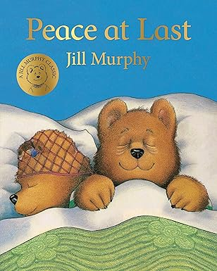  Outcomes - oral retelling, draw a story mountain and label events and characters | The Three Little Pigs by Mara Alperin  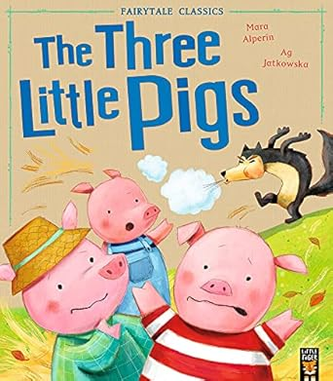  Outcomes – name and write a description of a character. Draw and label a story map and retell story orally | A Walk in the Woods by Flora Martyn  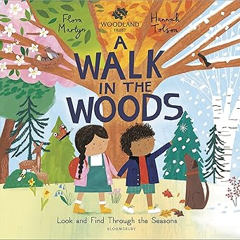  Outcome – write sentences for a non-fiction information seasons book. | The Pirates Are Coming! by John Condon  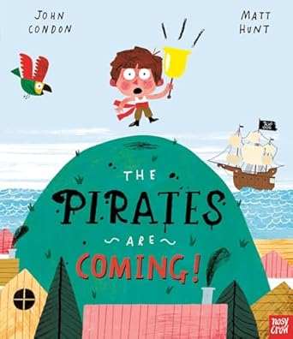  Outcomes – draw and label a treasure map, write character descriptions, label features and write sentences about pirate ships. | Giganotosaurus by Jonny Duddle  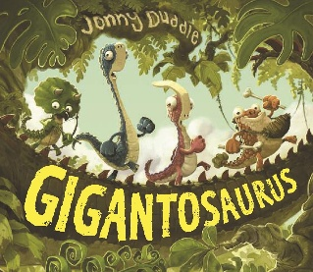  Outcomes– identify rhyming and onomatopoeia words, non-fiction information writing about dinosaurs and orally retell/ rewrite the story | Supertato by Sue Hendra  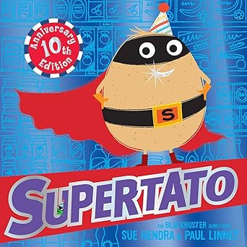  Outcome – draw and label a wanted poster and write a detailed character description
Additional and Supportive Texts | Featured Author: Jill Murphy  Just one of those days  Whatever Next?  The Large Family stories  The Family Book by Todd Parr  So Much! By Trish Cooke  Home by Carson Ellis | Mog and the Vet by Judith Kerr  You can’t call an Elephant to an Emergency! By Patricia Cleveland-Peck  In Every House on Every Street by Jess Hitchman  Six Dinner Sid by Janet Perry Non-Fiction about people who help us in our communities. | Owl Babies by Martin Waddell  Percy the Park-Keeper stories by Nick Butterworth  Non-Fiction British Animals Texts | Here come the Aliens! By Colin Mc Naughton  Where the Wild Things Are by Maurice Sendak  The Snail and the Whale by Julia Donaldson  Zoom Rocket Zoom by Margaret Mayo  Fairy Tales | Mad about Dinosaurs by Giles Andrea  Harry and the Dinosaurs by Ian Hybrow  Dinosaur Stomp by  Non-fiction books about Dinosaurs | Charlie’s Superhero Underpants by Paul Bright  Superhero ABC by  Super Daisy and the Peril of Planet Pea by Kes Gray  & Nick Sharratt  Superworm by Julia Donaldson  Superkid by Claire Freedman  & Sarah McIntyre
Understanding the World  History | My Life Timeline  Family Tree  Birthdays past and present  Toys past and present  Homes and Families past and present  History Texts  My Two Grandads by Floella Benjamin Toys in the Past by Elizabeth Moore.  Peepo by Janet and Allan Ahlberg. | Our school in the past  Local History (Brinnington Hall) |  | Wearing the Crown  Recognise that kings and queens are powerful people.  History Texts  Winne the Pooh meets the King by Jane Riordan Look Inside a Castle by Conrad Mason & Barry Ablett. |  | My Achievements!  Recognise special achievements  History Texts  Marcus Rashford and Taylor Swift ‘Little People Big Dreams’  Coming to England by Baroness Floella Benjamin
Understanding the World  Geography/Science | My body | Our school from above  Let’s Build a Map!  Road Safety  Exploring Seasons - Autumn  Exploring Weather (Wind)  Geography Texts  We’re Going on a Leaf Hunt by Steve Metzger. | Journey Sticks  Describe a journey using found objects as prompts.  Exploring Seasons  Winter  Exploring Weather (Snow)  Research British Birds and Woodland Animals  Cook winter vegetable soup  Make Bird Feeders | Pirate Map Bingo  Find and name familiar features on maps.  Exploring Seasons – Spring planting vegetables and flowers in the garden  Exploring Weather  (Rain)  Nature Catchers  Explore natural objects using senses  Floating and Sinking  (Making Pirate Ships from construction kits and junk materials)  Geography Texts  Martha Maps It Out by Leigh Hodgkinson  The Tiny Seed’ by Eric Carle. | Around the World  Explore diverse global environments, comparing them to local ones, enhancing understanding of geography and cultural differences.  Exploring how fossils are made (Make salt-dough fossils)  Geography Texts  Cleo the Completely Fine Camel by Wendy Meddour Antarctica: A Continent of Wonder’ by Mario Cuesta Hernando | Exploring Seasons – Summer  Exploring Weather  (Sun - shadows)  Dress the Teddy
PSED | Routines and Feelings | Friendships and Relationships | Considering their feelings and others | Staying Safe | Managing care needs and Keeping Healthy | Independence and Resilience
Expressive Arts and Design  Art | Access to Art  Pastel Self-Portraits  Painting to Music | Access to Art  Autumn Textile Art  Leaf rubbings and prints | Access to Art Clay Owls  Winter Skies Exploring and blending pastel shades | Access to Art Observational drawings of sea shells using pencil, charcoal and watercolours  Watercolour paintings of spring flowers | Access to Art  Imaginary Landscapes  Collages of Dinosaur Worlds | Access to Art  Plasticine Potato Heads
Expressive Arts and Design  DT | Textiles  Weaving and Threading | Cooking  Make Vegetable Soup  Split pin Santas |  | Joining  Book Making  Create Fairytale character books, joining with range of materials | Structures  Junk Model Dinosaurs
Expressive Arts and Design  Role-Play | Bear Family House  Birthday House  Baby Clinic | The Three Little Pigs House  People Who Help Us | Percy the Park Keeper’s Hut  Small World British Woodland Animals | Fairy Tale Castle  Small World Castle and Fairy Tale Characters | Dinosaur Museum | Fruit and Veg Shop
Expressive Arts and Design  Music and Movement | Body Percussion and Instrument Percussion  Dynamics: Loud/quiet  Tempo: Fast/slow  Play a steady beat  Action Songs and Nursery Rhymes  Singing Circle Games | Nativity Songs  Accompany with steady beats and simple rhythms on  percussion instruments | Songs  Jack Frost  Wintertime (Singing Sherlock) | Songs  Jack and the Beanstalk (Singing Sherlock)  Spring Chicken  Plant a Little Seed  There was a Princess long ago | The Prehistoric Animal Brigade Learn song and accompany with actions and percussion instruments | Under the Sea Music and Movement  Free movement dance with scarves and streamers to ‘Aquarium’ by Saint Saens  Sounds of the Sea Percussion and Vocal sounds
WOW! | WOW! Visit from a baby! | WOW! Trip to local library Visits from Police, Fire service etc, | WOW!  Visit from Birds of Prey | WOW! Fairy Tale Character Dress-up day!

