
Year 1 St Paul’s CE Primary Long Term Year Group Overview

 | Autumn 1 | Autumn 2 | Spring 1 | Spring 2 | Summer 1 | Summer 2
RE Unit | Who is a Christian? | What makes places sacred? | How and why do we celebrate sacred times? | How and why do we celebrate sacred times? |  | What does it mean to belong to a faith community?
English | Meesha makes friends  (Fiction)  Outcome: Recount – diary entry | Katie in London  (Non-chronological report)  Outcome: Non-chronological report | Grandpa’s Gift  (Fiction)  Outcome: Journey story | Beegu  (Fiction)  Outcome:  Fiction Writing | Somebody Swallowed Stanley  (Non-chronological report)  Outcome: Fact files | A Midsummer Night Dream  (Fiction)  Outcome:  Character description
English texts | 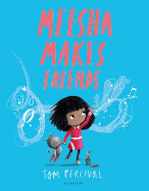 | 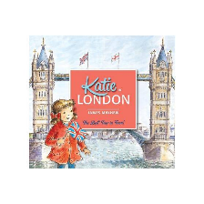 | 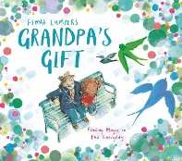 | 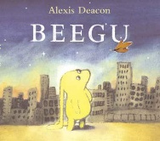 | 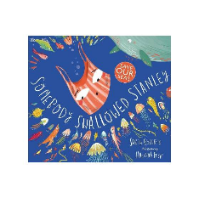 | 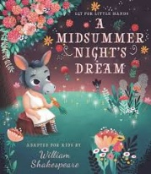
Reading | Practise Read | Practise Read | Practise Read | Practise Read | Practise Read | Practise Read
Maths Units | Place Value  Add & Subtract | Add & Subtract  Shape  Money | Multiplication  and division  Length and height | Length and height  Mass capacity temp | Fractions  Time | Statistics  Position and Direction  Consolidation
 | Please see White Rose and the Calculation Strategy for further details on the Maths page.
Science Kapow Unit | Forces and space: seasonal changes | Materials: everyday materials | Animals: sensitive bodies | Comparing Animals | Introduction to plants | Investigating science through stories
Key people | Alfred Wegener | Alfred Wegener | Carl Linnaeus | Carl Linnaeus | Jeanne Beret | Jeanne Beret
Computing Unit | Basic skills. | Using words and other programmes to process and format text and images. | Unplugged algorithms understanding and building a basic algorithm. | Programming, coding and robotics | Digital painting | Producing digital material
DT Projects on a Page Unit |  | Sliders and Mechanisms  Moving Xmas cards. |  | Cooking & Nutrition -  Preparing fruit and vegetables. |  | Textiles – Puppet.
Key People |  | Rod Campbell/  David A Carter |  | Nadia Hussain |  | Jim Henson
History KPOW Unit |  | How am I making history? |  | How have toys changed over time? |  | How have explorers changed the world?
Key People |  | Own family members. |  | Ole Kirk Christiensen |  | Matthew Henson, Mary Kingsley, Christopher Columbus and Dame Ellen MacArthur
Geography KPOW  Unit | What is it like here? |  | What is the weather like in the UK? |  | What is it like to live in Shanghai?
Key Places | Classroom and school grounds |  | Weather station in school grounds |  | Virtual tour of Shanghai
PSHE | Family and Relationships  Families look after us.  Personal information.  Stereotyping.  Feelings.  Caring for others. | Health and Wellbeing  Good hand hygiene.  Food allergies.  Sleep  Sun Safety  Personal qualities.  Managing feelings. | Family and Relationships  Positive friendships.  Overcoming friendship difficulties.  What is bullying?  Working with others. | Safety and the changing Body  Hazards at home  Emergencies – safe and unsafe  Contacting emergency services.  Appropriate contact.  Being lost | Citizenship  School Rules.  Reasons for ruls.  Voting.  We are all different.  Younger children’s needs.  Pet’s needs | Economic Wellbeing  Money in everyday life.  Uses of money and keeping it safe.  Stealing.  Banks.  Jobs.
Music  Charanga  Unit | Hey you! | Rhythm in the way we walk and banana rap | In the grove | Round and round | Your imagination | Reflect rewind replay.
Art ‘Access Art’ Unit & Key Artist | Drawing - Spirals |  | Simple Printing – Inspired by Flora and fauna |  | Sculpture & 3D - Playful making
Key Artists | Molly Haslund |  | Eric Carle |  | Faith Bebbington
PE Getset4PE  unit | Gymnastics  Sports Coach:Ball skills | Yoga  Sports Coach:Ball skills | Dance  Sports Coach:  Sending and receiving | Fitness  Sports Coach:  Target games | Target Games  Sports Coach: Sending and receiving | Athletics  Sports Coach:  Striking and fielding.
Trips, visitors and enrichment experiences.

