
Year 2 St Paul’s CE Primary Long Term Year Group Overview

 | Autumn 1 | Autumn 2 | Spring 1 | Spring 2 | Summer 1 | Summer 2
RE Unit | Who is a Christian? | What makes some places sacred? | How and why do we celebrate special and sacred times? | What does it mean to belong to a faith community? | What does it mean to belong to a faith community? | Learning about faith through art.
English | Troll Swap  (Fiction)  Outcome:  Story | The Owl who was Afraid of the Dark  (Fiction)  Outcome: Fact sheet | The lion inside  (Fable)  Outcome: Story | Major Glad, Major Dizzy  (Photographic picture story book)  Outcome: Recount-Diary | The Last Wolf  (Humorous Fable)  Outcome: Letter | Grandad’s Secret Giant  (Fiction)  Outcome: Story with a moral focus
English texts | 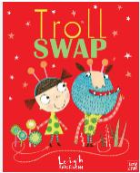 | 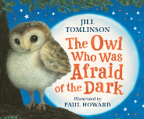 | 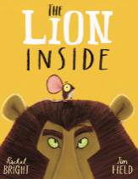 | 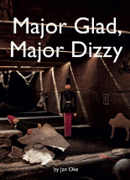 | 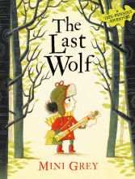 | 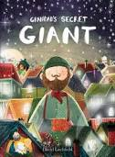
Reading | Troll  By Julia Donaldson | Above and Below  By Clulow and Hegarty | Dragon Sitter  By John Lacey | Owen and the Soldier  By L Thompson | Fantastic Mr Fox  By Roald Dahl | Illustrated Grimm’s Fairy Tales  By R Brocklehurst
Maths Units Year 2 | Place Value  Add & Subtract | Add & Subtract  Shape  Money | Multiplication  and division  Length and height | Length and height  Mass capacity temp | Fractions  Time | Statistics  Position and Direction  Consolidation
 | Please see White Rose and the Calculation Strategy for further details on the Maths page.
Science Kapow Unit | Everyday Materials | Seasonal Changes | Sensitive bodies | Comparing animals | Introduction to plants | Plant Based Materials
Key People | Al Jahiz | Al Jahiz | Steve Irwin | Steve Irwin | Barbara McClintock | Barbara McClintock
Computing Unit | What is a computer | Coding  Algorithms. | Programming with Scratch | Data collection and representation | Modifying text and images | Staying safe on line
DT Projects on a Page Unit |  | Food and Nutrition-Perfect Pizzas |  | Structures-Playground equipment |  | Mechanisms-exploring axles and vehicles
Key People |  | Auguste Escoffier and his food revolution |  | Gustav Eiffel and his incredible structures |  | Henry Ford and the mass manufacture of cars
History KPOW Unit |  | Living Memory-How am I making History? |  | Living memory and beyond – How have toys changed? |  | Beyond living memory-How have explorers changed the world?
Key People |  | Own family members |  | Ole Kirk Christiansen |  | Matthew Henson, Mary Kingsley, Dame Ellen MacArthur & Christopher Columbus
Geography KPOW  Unit | Why is our world wonderful? |  | Would you prefer to live in a hot or cold place? |  | What is it like to live by the coast?
Key Places | Local community human and physical features |  | Kenya and the North and South Poles  -physical features |  | UK coastline
PSHE Unit | Family and Relationships  Families  Loss  Manners | Health and Wellbeing  Oral hygiene  Healthy and unhealthy foods.  Managing emotions | Family and Relationships  Feelings  Friendships | Safety and the Changing Body  Childline  Seccrets and Surprises  Privacy  Medicine  Online safety | Citizenship  Rules  Democracy  School Environment  Local community | Economic Wellbeing  Jobs and skills  Money and Bank Accounts  Wants and needs
Music  Charanga  Unit | Hands Feet Heart  South African Music-Afro pop | Ho Ho Ho  Festivals and Christmas – rapping and improvising | I wanna play in a band  Playing together in a band-Rock | Zoo time  Reggae and animals | Friendship song  A song about being friends-Pop | Reflect, rewind replay.  Classical – musical language.
Art ‘Access Art’ Unit & Key Artist | Draw Explore |  | Expressive Painting |  | Stick transformation project
Key Artists | Rosie James |  | Charlie French |  | Chris Kenny
PE Getset4PE  unit | Gymnastics  Sports Coach: Ball skills | Yoga  Sports Coach: Ball skills | Dance  Sports Coach:  Sending and receiving | Fitness  Sports Coach:  Target games | Target Games  Sports Coach: Sending and receiving | Athletics  Sports Coach:  Striking and fielding.
Trips, visitors and enrichment experiences. | Local walk linked to Geography |  |  | Library visit | Church visit

