
Year 5 - St Paul’s CE Primary Long Term Year Group Overview

 | Autumn 1 | Autumn 2 | Spring 1 | Spring 2 | Summer 1 | Summer 2
RE Unit | Christianity – belief god exists | Christianity – belief god exists | Green Religion | Why go to a place of worship? | What does it mean to be Muslim? | What does it mean to be Muslim?
English | Queen of the Falls  (Recount)  Outcome: write a series of diary entries | The Lost Happy Endings  (Fiction)  Outcome: Traditional tale with an alternative ending | Kai and the Monkey King  (Fiction)  Outcome: write a myth, creating characters and settings | Malala’s Magic Pencil  (Autobiography)  Recount: Write an autobiography | Brilliant Deep  (Persuasion)  Outcome: Persuasive information leaflet | Radiant Child  Life Doesn’t Frighten Me  (Non-Fiction)  Outcome: Information text
English texts | 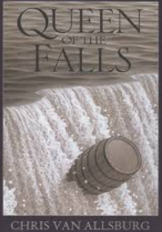 | 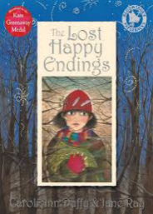 | 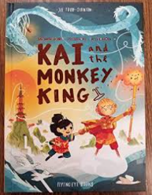 | 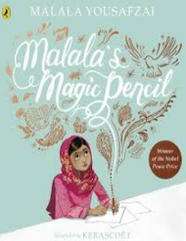 | 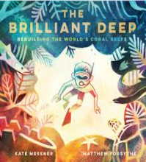 | 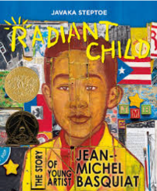
Reading | Goodnight Stories for Rebel Girls | Hansel and Gretel | Odd and the Frost Giants | You are awesome | Pollution a look behind the scenes and the Last Wild | African Tales
Maths Units | Place Value  Addition and subtraction | Multiplication and division  Fractions | Multiplication and Division  Fractions | Decimals and percentages  perimeter and area  Statistics | Shape  Position and Direction  Decimals | Negative Numbers  Converting Units  Volume
 | Please see White Rose and the Calculation Strategy for further details on the Maths page.
Science Kapow Unit | Materials: mixtures and separation | Materials: Properties and changes | Earth and space | Living Things | Forces | Human Timeline and Making Connections
Key People | Amedeo Avogadro | Amedeo Avogadro | John Tyler Bonner | John Tyler Bonner | Stephen Hawking | Stephen Hawking
Computing Unit | Create and search databases | Variables | Coding with Microbits | Stop Motion animation | The Internet and the World wide web | Modelling
DT  Projects on a Page Unit |  | Food & Nutrition  Seasonal Foods  Soup |  | Mechanical systems  Mechanical Systems  Automata Toys |  | Electrical Systems  Digital World  Wearable Technology
Key people |  | Henry Blair |  | Leonardo Da Vinci |  | George W Theiss
History KPOW Unit and significant person |  | Vikings-Were the Vikings raiders, traders or settlers? |  | Tudors-How was life in Tudor England? |  | Greeks-What did the Ancient reeks do for us?
History Key People |  | Alfred the Gt, Edward the Confessor, King Ethelred & Athelstan |  | King Henry VIII, Queen Elizabeth, Sir Francis Drake & Francis Bacon |  | Aristotle, Plato, Aspasia, Alexander the Great.
Geography KPOW  Unit | Why do oceans matter? |  | What is life like in the Alps? | . | Why does population change?
Geography Key Places | Local area |  | Peak District |  | Population records and maps of the locality
PSHE Unit | Family and Relationships  Marriage as a legal commitment  Safe and unsafe at home  Childline  Self-respect | Health & Well Being  Energy in food  Healthy eating  Failure and success  Relaxation and sleep  Sun safety | Family & Relationships  Friends and friendship issues  Bullying – what is it and how to deal with it. | Safety & the Changing Body  Online safety  Peer pressure  External sexual body parts  Puberty and body changes  First aid | Citizenship  The Law  Breaking the law  Parliament  Rights and responsibilities  Looking after the environment | Economic Wellbeing  Income and expenditure  Safeguarding money  Budgeting and loans  Career paths  Workplace stereotypes
Music  Charanga  Unit | Livin on a prayer  Rock Anthems | Classroom Jazz 1  Bossa Nova and Swing  Jazz improvisation | Make you feel my love  Pop Ballads | Fresh Prince of Bel-Air  Old School Hip-Hop | Dancing in The Street  Motown | Reflect, Rewind and Replay  Classical-The history of music
Art ‘Access Art’ Unit & Key Artist | Drawing, Typography & maps |  | Painting-Exploring Identity |  | Craft and Design-Set Design
Key Artists | Pauls Scher |  | Mike Barratt & Thandiwe Muriu |  | Rae Smith
PE Getset4PE  unit | Yoga  Swimming | Yoga  Swimming | Gymnastics  Basketball | Tennis  Hockey | Cricket  Fitness | Athletics  Rounders
MFL CulturetequeUnit | Basic and key words | Unit 1 | Unit 2 | Unit 3 | Unit 4+5 | Unit 6
Trips, visitors and enrichment experiences.

