
Year 6 - St Paul’s CE Primary Long Term Year Group Overview

 | Autumn 1 | Autumn 2 | Spring 1 | Spring 2 | Summer 1 | Summer 2
RE Unit | What can be done to reduce Racism? |  | Is it better to express your religion in art and architecture of in charity and generosity? |  | What matters more to Christians and Humanists? | What do religions say to us when life gets hard?
English | Star of fear, star of hope  (Fiction)  Outcome: flashback narrative | Can we save the tiger?  (Information hybrid)  Outcome: Report writing | The selfish Giant  (Fiction-Classic narrative)  Outcome: Fiction-Narrative | The Day war came  (Recount/ Persuasive)  Outcome: Letter | Manfish  (Biography)  Outcome: Recount -biography | Sky chasers  (Fiction-Adventure story)  Outcome: Adventure story
English texts | 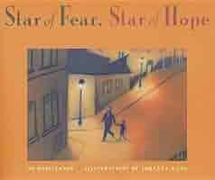 | 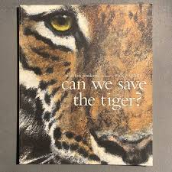 | 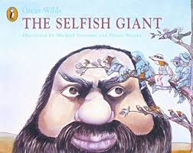 | 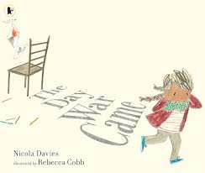 | 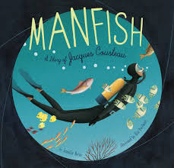 | 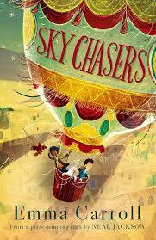
Reading | When we were Warriors.  By Emma Carroll | The Place for Me: Stories about Windrush.  By Floella Benjamin. | The Happy Prince and Other Tales.  By Oscar Wilde. | Goldfish Boy.  By Lisa Thompson. | Great Adventures.  By Alistair Humphreys. | Sky Chasers.  Emma Carroll.
Maths Units | Place Value  Addition, subtraction, Multiplication and division | Fractions, converting units | Ratio, algebra and decimals | Fractions, decimals and percentages  Area, perimeter and volume  Statistics | Shape  Position and direction | Themed projects  Consolidation and problem solving
 | Please see White Rose and the Calculation Strategy for further details on the Maths page.
Science Kapow Unit | The Heart and the Circulatory system | How light travels | Circuits | Microorganisms & classification | Inheritance | Evolution
Key People | William Havey | Christiaan Huygens | Benjamin Franklin | Carl Linnaeus | Gregor Mendel | Charles Darwin
Computing Unit | Creating formula in excel | Edublocks: Introduction to Python | Programming a game | Creating a Podcast | HTML | Social media and being safe online
DT  Projects on a Page Unit | Structures-Bird Box Shelters |  | Cooking & Nutrition-Savoury Muffins |  | Textiles-Leavers Bags to combine fabric shapes
Key people | Zaha Hadid |  | Jamie Oliver |  | Coco Channel
History KPOW Unit and significant person |  | Local Study-What was the impact of WW2 on the people of Britain? (1939 onwards) |  | British History Study Beyond 1066- What does the census tell us about our local area? |  | British History Study Beyond 1066- Unheard histories: Who should appear on the £10 note?
History Key People |  | Anne Frank, Alan Turing, Winston Churchill & Neville Chamberlin |  | Mary Bucktrout |  | Ellen Wilkinson, Betty Boothroyd, William Tuke, Alfred the Great, Lily Parr & Betty Snowball
Geography KPOW  Unit | Where does energy come from? -UK-Greenwich & 4 countries / cities of the UK -North America-Texas & USA |  | Would you live in the desert? -North America-Mojave Desert-California, Nevada, Utah & Arizona -Tropics of Capricorn / Cancer & Equator |  | How can we make out local area better for children & young people? UK-Stockport & Brinnington
Geography Key Places | Regions/counties of the UK and European/World cities. |  | Mojave Desert, California, Nevada, Utah & Arizona. |  | The continents, European countries/cities studied and UK places.
PSHE Unit | Family and Relationships  Respect  What is conflict?  Negotiation & Compromise.  Stereotypes.  Loss & grief. | Health and Wellbeing  Physical Health.  Illness, prevention and vaccination  Good habits  Technology and mental health  Relaxation & resilience | Economic wellbeing  Risks to money safety.  Gambling  Budgeting.  Career roles.  Teamwork. | Safety & the changing Body.  How reliable is online info?  Online relationships.  Alcohol.  Conception.  Puberty.  First Aid. | Citizenship  Education as a human right.  Areas of governance.  What is discrimination?  How food choices affect the environment. | Identity & KS3 Transition  What is identity?  Manipulation of images.  How do we see ourselves?  Strategies when feeling stressed or anxious.
Music  Charanga  Unit | Happy | Classroom Jazz 2 | A New Year Carol | You’ve got a friend | Music in me | Reflect, Rewind and Replay
Art ‘Access Art’ Unit & Key Artist |  | Drawing-2D drawing to 3D Making. |  | Painting-Landscapes. |  | Sculpture & 3D-Shadow Puppets.  Wayang Shadow Puppets
Art  Key people |  | Lubaina Himid |  | J.M.W Turner |  | Cai Guo-Qiang
PE Getset4PE  unit | Gymnastics  Tennis | Dance  Football | Yoga  Swimming | Yoga  Swimming | Cricket  Fitness | Mixed rounders  Athletics
MFL Cultureteque Unit | Niveau Rouge  Unit 1 | Niveau Rouge  Unit 2 | Niveau Rouge  Unit 3 | Niveau Rouge  Unit 4 | Niveau Rouge  Unit 5 | Niveau Rouge  Unit 6
Trips, visitors and enrichment experiences. | Brinnington Library. | St Mary’s Church in the Marketplace |  | The Whitworth Art Gallery | Lake District-  Two night residential. At the Lakeside Outdoor activity centre. | Brinnington Library.

