St Paul’s C of E Primary School Nursery Literacy and Topic Curriculum Overview B Year
 | Autumn One | Autumn Two | Spring One | Spring Two | Summer One | Summer Two
Topic | Me and my Family | Celebrations | Transport | Plants and Growing | Minibeasts | Under the Sea
Key Text | 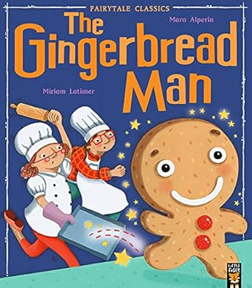  The Gingerbread Man by Mara Alperin  Outcomes: Oral retelling following a Story Mountain.  Sequence pictures on a Story Mountain. | 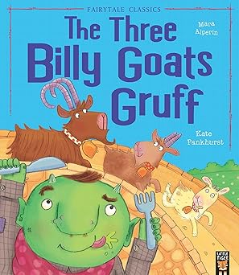  Three Billy Goats Gruff by Mara Alperin  Outcomes: Oral retelling following a Story Mountain.  Draw pictures showing beginning, middle and end in a Story Frame. | 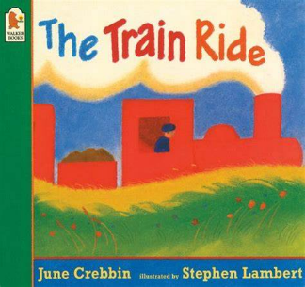  The Train Ride  Outcomes: Oral retelling following a Story Map.  Draw and sequence pictures on a Story Mountain.  Know who the characters are in a story. | 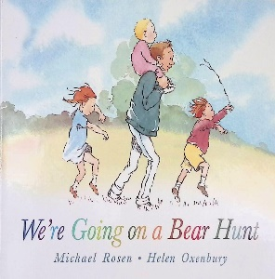  We’re going on A Bear Hunt  Outcome: Oral retelling following a Story Map.  Draw a simple Story Map.  Describe the setting of a story. | 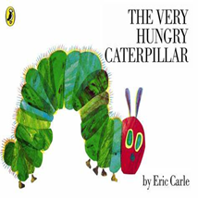The Very Hungry Caterpillar  Outcomes: Oral retelling following a Story Map.  Draw a simple story Map.  To talk about how a story can be changed. Teacher to model innovations of text. | 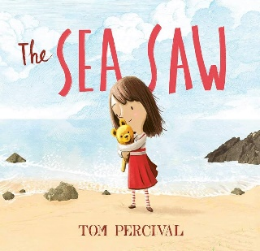  The Sea Saw  Outcomes: Oral retelling following a Story Map.  Draw a simple story Map.  Describe the characters in a story.
Additional and Supportive Texts | You Choose by Nick Sharratt  The Family Book and The Feelings Book by Todd Parr  Be Gentle, Play Nicely by Regina Miller  The Colour of Us, by Edward Miller  My Body, by Sue Barrowclough  Head to Toes, by Zita Newcome | The Three Billy Goats Fluff by Rachael Mortimer Festivals by Jane Bingham  The Leaf Thief by Alice Hemming  Tree: Seasons Come, Seasons Go by Patricia Hegarty  Dear Santa by Rod Campbell  The Christmas Story by DK | Whatever Next by Jill Murphy  Car, Car, Truck, Jeep by Katrina Charman  The Whales on the Bus by Nick Sharratt  Red Lorry, Yellow Lorry by Michelle Robinson  Naughty Bus by Jan and Jerry Oke  We catch the bus by Katie Abey | Errol’s Garden by Gillian Hibbs  Lola plants a garden by Anna McQuinn  We’re going on an Easter Egg Hunt by Laura Hughes  Ways into science: All about plants by Peter Riley  The Tiny seed by Eric Carle  Growing vegetable soup by Lois Ehlert | The Bad Tempered Ladybird by Eric Carle  Mad About Minibeasts! by Giles Andreae  Superworm by Julia Donaldson  Lulu meets the bees by Anna McQuinn  Bug Hotel by Libby Walden  Norman by Sue Hendra | Sharing a Shell by Julia Donaldson  Commotion in the Ocean by Giles Andreae  Tropical Terry by Jarvis  Hooray for fish by Lucy Cousins  A hole in the bottom of the sea by Jessica Law  First book of sea creatures by Zoe Ingram
Understanding the World  Geography | What type of home do we live in? |  | Using various construction equipment to recreate Brinnington. | Map making before sensory walk through grass, mud, snow etc. |  | Look at a map of the world and name the five oceans.
Understanding the World  Science | Naming facial and body features. | Autumn Walk – using our senses to explore the natural world and spot the signs of Autumn. | Pushes and Pulls (exploring forces through indoor and outdoor play).  Create a whole class Winter Weather Diary.  Make Bird Feeders. | Spring Walk – using our senses to explore the natural world and spots the signs of Spring.  Planting bean seeds.  Learn the names of baby animals born in the Spring. | Naming and describing different MiniBeasts. | Floating and sinking experiments.  Shadow drawings on the pavement using chalk.
Understanding the World  History | Who is in my family? | How have toys changed over time?
PSED | Routines and Feelings | Friendships and Relationships | Considering their feelings and others | Staying Safe | Managing care needs and Keeping Healthy | Independence and Resilience
Expressive Arts and Design  Art | Access Art  Paint Self-Portraits  Painting to Music  Footprints and handprints | Access Art  Wax crayon rubbings | Access Art  Clay Rockets | Access Art  Observational paintings of flowers | Access Art  Building bug hotels  Painting Minibeasts | Access Art  Playdough sea creatures
Expressive Arts and Design  DT | Design and bake a Gingerbread Man. |  | Junk Model Vehicles. |  | Make a split pin moving minibeast.
Expressive Arts and Design  Small World | Families and homes | Fairytales | Vehicles, train tracks and airports | Bears and woodland settings | Minibeasts | Sea creatures
Expressive Arts and Design  Music and Movement | Painting to Music  Singing Nursery Rhymes and Action Songs | Playing a steady beat and explore loud and quiet sounds on percussion instruments  Singing Christmas Songs | Snow is Dancing, by Debussy  (Listen and move to the music, add metallic instruments for snow and ice effects). | Singing, adding actions and accompanying with sound effects on musical instruments. | Play long and short beats on musical instruments to create simple rhythms. | Play steady beats and simple rhythms following a simple graphic score.
WOW! | Visit from a baby. | Christmas performance to parents.  Walk to a post-box to post Christmas cards/ letters to Santa. | Mother’s Day Afternoon Tea. | Easter Bonnet Parade.  Growing cress and eating egg and cress sandwiches. | Caring for caterpillars and observing their change into butterflies. | Rock pool visit.

