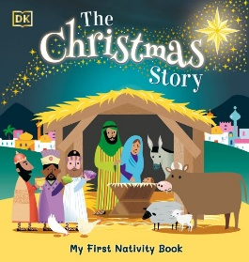
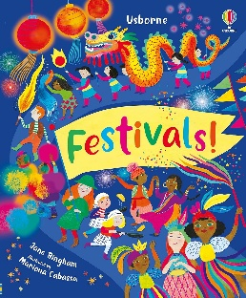
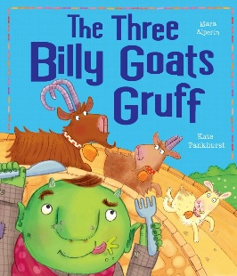
Activities
Sequence the key events from the story “The Three Billy Goats Gruff”. Paint the characters from the story “The Three Billy Goats Gruff”. Complete Autumn crafts and works of art. Go for an Autumn walk to look for signs of the season. Learn a range of Nursery rhymes during World Nursery Rhyme week. Practice forming letters to write our names. Learn a range of songs and take part in the Nativity performance. Make Christmas cards to give to people in the community. Write a letter to Father Christmas. Create Christmas cards and decorations to take home as gifts.

Key Vocabulary
Birthdays, celebrations, Diwali, Christmas, Eid, carnival, Hanukkah, Bonfire night, festivals, generosity, giving, family, together, party, fireworks, culture, religion, goats, troll, bridge, first, second, third.

Key Questions
What are the different celebrations that people take part in? Why do people celebrate different events? What are the key changes that happen in Autumn? What does it mean to be generous? How do we celebrate birthdays? How old are we? What is the Nativity story? How do people celebrate Christmas?

Parents as Partners
Encourage your child to play with malleable materials such as Playdoh to help strengthen the muscles in their hands. Help your child to recognise their first name. Count objects at home, e.g. fruit in the fruit bowl, pencils in a pot etc. Spot colours in the environment. Help your child to learn the songs for the Nativity performance. Attend Christmas craft morning with your child.
Focus Books

All about me Celebrations


