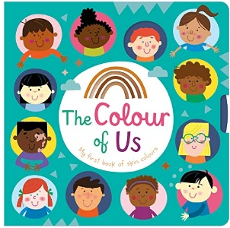
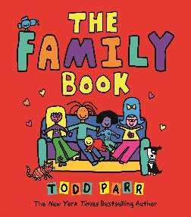
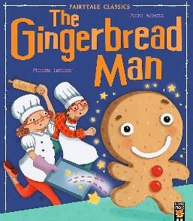

Key Vocabulary
Family, Me, Mum, Dad, Brother, Sister, Aunty, Uncle, Girl, Boy, Baby, Head, Shoulders, Knees, Toes, Arms. Legs, Eyes, Nose, Ears, Mouth, Smell, Taste, Touch, Feel, Hear, See, Happy, Sad, Angry, Excited, Colours, Rainbow, Home, House, Flat, School, Teacher, Birthday, Friend.
Activities
Settle into Nursery and learn the routine. Oral retell of ‘The Gingerbread Man’. Sequence events from ‘The Gingerbread Man’. Design and bake a gingerbread man. Look at different types of homes and build our homes with a range of construction equipment. Play matching and sorting games. Paint a rainbow. Draw pictures of our families and talk about who is important to us. Paint a self portrait. Painting to music. Explore our senses by smelling, tasting and touching different items.
. .
Key Questions
Who am I? Who is special to me? Who are the different members of my family? What are the different parts of my body? What are the five senses and what parts of my body do I use for each one? What are the seven colours of the rainbow? What type of home do I live in? What is my address?
Parents as Partners Sign up at the Library and share story books with your child on a regular basis. Share books and stories with your child two or three times every week. Help your child to recognise their first name. Go for a colour walk – what colours can you see in your environment? E.g. a red door, yellow bus etc. Talk to your child about different emotions, ask them how they are feeling each day. Sing a range of Nursery rhymes with your child.

Focus Books

All about me Autumn One

