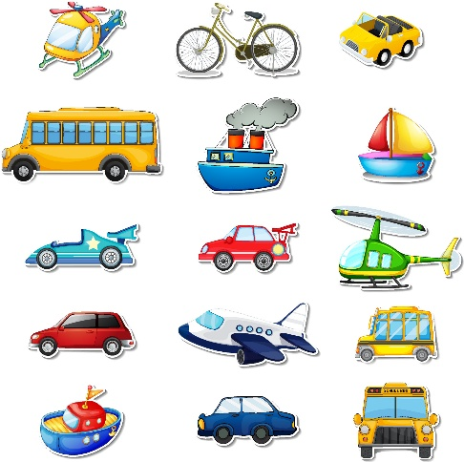
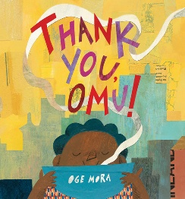
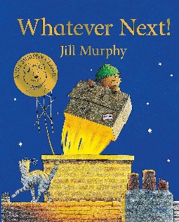
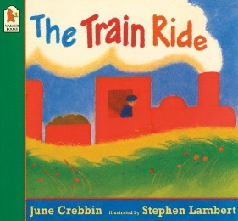
Parents as Partners
Practice crossing the road when out and about using stop, look and listen. Practice manipulating playdoh into different shapes to help to develop fine motor skills. Practice writing your child’s first name with them. Help your child to recognise and subitise numbers from 0-5. Practice counting from 0-10. Encourage your children to use their manners at home, saying please and thank you as part of our value this term of ‘thankfulness’.
Key Questions
What are the different types of transport and how do they move? How can we keep safe when travelling in a car? What must we think about before crossing a road? Can we investigate how fast or slow something can move? What are the different emergency vehicles and when are they used?

Key Vocabulary
Transport, vehicle, car, train, truck, rocket, bus, emergency vehicles, helicopter, plane, motorbike, bicycle, boat, submarine, wheels, track, fly, submerge, float, fast, slow, safety, crossing, seatbelt, traffic light.
Focus Books

Activities
Create a train book with drawings of what we could see on a journey. Sequence and orally retell the story of ‘The Train Ride’. Learn about the different forms of transport and what they are used for. Paint pictures of vehicles guided by an adult. Create a map of Brinnington and use different construction materials to build the different buildings. Make and paint rockets using clay. Create junk model vehicles. Explore what happens when we roll cars and trains in paint. Use 2D shapes to create vehicle pictures. Learn the letters of our first names by making name trains. Create number rockets.
Transport Spring One

