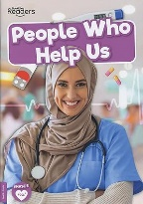
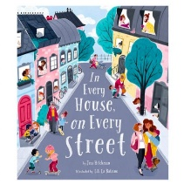
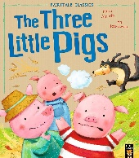
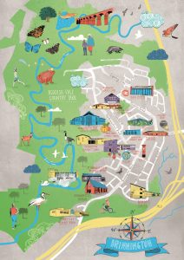
In Every House on Every Street By Jess Hitchman
People Who Help Us By William Anthony
The Three Little Pigs By Mara Alperin
Activities Trip to the Library Visit from a Police Sergeant Build a map of our local area using construction resources and junk materials. Learn about Road Safety using resources from ‘Think!’ government website. Read and write about people who help us. Look at pictures of Brinnington Hall (the building on our site before St Paul’s) Role-play road safety and community jobs, including builders with reference to our key writing text, ‘The Three Little Pigs.’
. .
Key Questions Where do I live? What is my address? How can I keep safe crossing the road? What are the key features of my town? What happens at a Library? Where is my school and what was here in the past? Who are the people who help me in my community? What job would I like to do when I grow up?
Focus Books

Our Town, Our Community Autumn Two
Key Vocabulary above, aerial, bird’s eye view, feature, find, identify, look, map, photograph, building, house, flat, church, school, car-park, shop, trees, road, pavement, traffic lights, pedestrian crossing, zebra crossing, car-wash, doctor’s surgery, chemist, post office, library, town, community, police officer, doctor, nurse, librarian, firefighter, dentist, teacher, builder
Parents as Partners When out with your child identify and name key features of our town. Teach your child their address. Sign up at the Library and share story books with your child on a regular basis. Listen to your child read two or three times every week. Help your child to learn to write their name. Carry out Learning with Parents activities.

