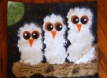
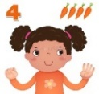
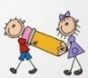
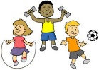
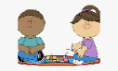
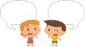

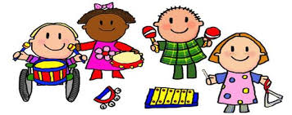

EXPRESSIVE ARTS AND DESIGN
Paint pictures of woodland animals
Collage owls
Sponge paint Owl Babies
Percy Park Keeper hut
Create stories with small world woodland animals
Make bats, squirrels and hedgehogs in the workshop
Sing songs about British Animals
Large scale weaving
Clay owls
Winter skies-pastels and blending

St Paul’s CE Primary School Reception Knowledge Organiser
Topics: British Woodland Animals and Winter
Spring One
LITERACY
Read Walk in the Woods. To create a non-fiction booklet.
Write facts and label pictures about British Woodland Animals
Read stories about Percy the Park Keeper and his animal friends.
Share the story, Owl Babies and learn by rote with Talk for Writing Actions
Draw Owl Babies Story Maps, write character descriptions and speech bubbles and retell in writing.
Share the story ‘The Gruffalo’

MATHS
Understand that one quantity can be more than, the same as or fewer than another quantity.
Explore capacity using different materials such as water, sand, rice and beads.
Represent 6, 7, and 8 in different ways and count out required number of objects from larger group.
Arrange 6, 7 or 8 items into small groups, subitise and see how the numbers are made up of smaller numbers
Make pairs and learn to count in twos
Combine two groups to and find the total
Order numbers to 10 and 20
Learn the names and properties of simple 3D shapes, make Bear Caves with Polydron cubes and cuboids

PSED
Think about the perspective of others whilst discussing the characters in our story – why does Bill ‘want his mummy’?Considering their feelings and others.
Explore value 'Thankfulness'

PHYSICAL DEVELOPMENT
Dough Disco – work on developing
strength in our fingers for fine motor work
Manipulate scissors independently to create models of animals from junk materials
Use our whole bodies to represent movements of bears and squirrels moving with control and co-ordination

COMMUNICATION AND LANGUAGE
Retell the story of Owl Babies, once they have developed a deep familiarity with the text; some as exact repetition and some in their own words
Engage in Non-Fiction Texts about British animals and seasons, developing new vocabulary
UNDERSTANDING THE WORLD
Use non-fiction books and the internet to find out about British Woodland Animals and the season of Winter
Find out which animals are ‘nocturnal’ and which ‘hibernate’ and explore what these terms mean.
Look for signs of winter on a winter welly walk.
Make a journey stick.
Parents as Partners in Learning
This half-term we will ask you to support your child to find out about a woodland animal. They will draw a picture and use their letters and sounds knowledge to write information about their animal.
Take your children on a Winter Walk and point out the signs of the season around them.
Listen to your children read every week and sign the reading record book
Help your child to practise their letter sounds and tricky words

Key Vocabulary: owl, squirrel, hedgehog, fox, badger, bat, deer, night, day, dark, light, hibernation, hibernate, nocturnal, prey, predator, sun, moon, sunset, sunrise

