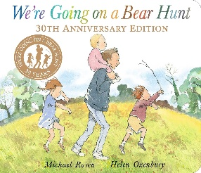
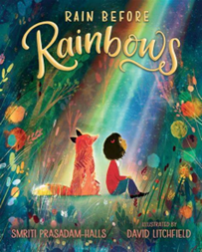
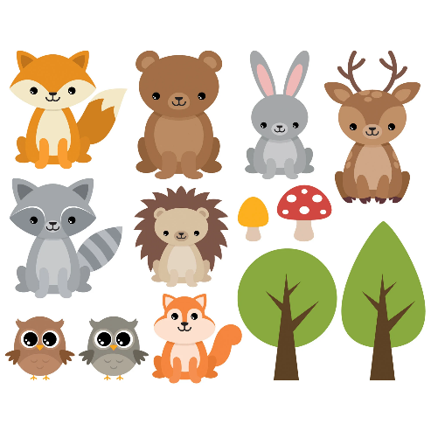
Key Vocabulary
Bears, British woodland animals, fox, badger, hedgehog, squirrel, owl, mud, grass, snow, cave, forest, river, water, light dark, night, day, touch, feel, flowers, plants, grow.
Activities
Sequence the events from ‘We’re going on a Bear Hunt’ and describe the settings. Sensory walk through mud, grass, water, snow. Use the dark tent to learn about light and dark/ night and day. Learn the names of British Woodland Animals and facts about some of them. Tummy time map making. Teddy bear collage pictures. Size ordering using bears. Paintings of teddy bears. Plant bean seeds and watch them grow. Observational paintings of flowers. Grow cress and eat egg and cress sandwiches. Talk about healthy food and make a healthy picnic plate. Teddy bears picnic.
Parents as Partners
Continue to help your child to recognise their first name and begin to write it. Support your children with number recognition, pointing out numbers in the environment such as on the bus, door numbers etc. Develop your child’s fine motor skills through activities such as playdoh, scissors and threading. Attend our Easter craft session which will be held on the 24th (Badger Class) and 26th (Hedgehog Class).
Key Questions
What are the names of some British Woodland animals? What does nocturnal mean? What does a plant need to help it grow? Can you sequence the events to retell the story of ‘We’re going on a Bear Hunt’? What does… feel like? What do we hope for? How can we help others to achieve their hopes and dreams?
Focus Books

Woodland animals Spring Two

