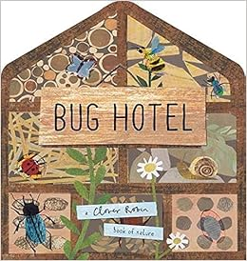
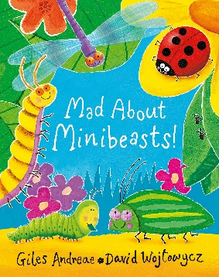
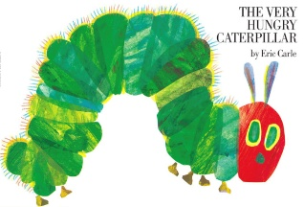
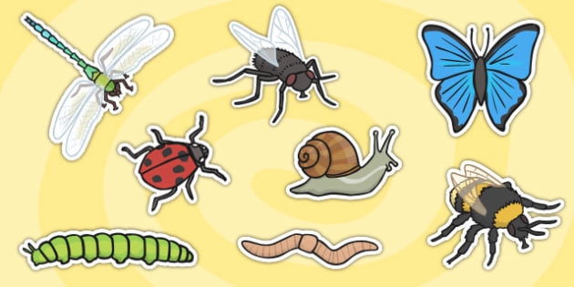
This Photo by Unknown Author is licensed under CC BY
Minibeasts Summer One

Key Vocabulary
Minibeast, bug, insect, caterpillar, butterfly, egg, chrysalis, metamorphosis, ant, worm, fly, bee, wasp, beetle, dragonfly, snail, ladybird, antennae, wings, legs, shell, exoskeleton, habitat, life cycle, camouflage, observe.
Activities
Create and innovate story maps to retell the story of ‘The Hungry Caterpillar’. Name and describe different minibeasts. Build bug hotels. Paint pictures of different minibeasts. Make a moving minibeast using split pins. Create butterfly paintings by folding paper and mixing colours. Observe caterpillars as they change into butterflies. Create a life cycle of a butterfly craft. Label the different parts of a plant and talk about what a plant needs to help it to grow. Discuss the importance of bees and how we can look after them to help them to survive. Go on a bug hunt outdoors and see what minibeasts we can find in the outdoor area.
Parents as Partners
Practice writing your child’s first name with them. Practice using scissors and cutting out simple shapes. Look for numbers in the environment, e,g, on doors, buses etc. Count out amounts from a larger group, e.g. count out three apples from a fruit bowl. Recognise and discuss the properties of 2D shapes. Observe and talk about the changes that are happening in spring.
Key Questions
Wha are the different types of minibeasts? What is the lifecycle of a butterfly? Why are minibeasts important for our environment? What bugs are in our outdoor area? How many legs does a spider have? Where do minibeasts live? Why do bees make honey? What do worms do for the soil? Why do spiders spin webs?
Focus Books

