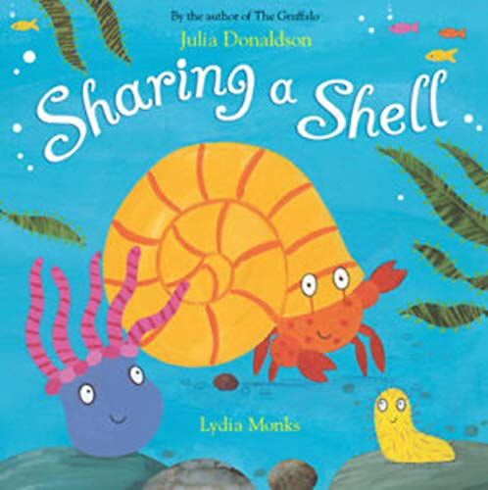
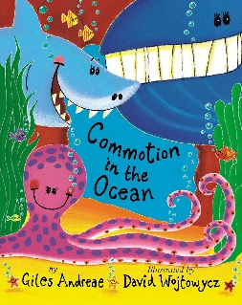
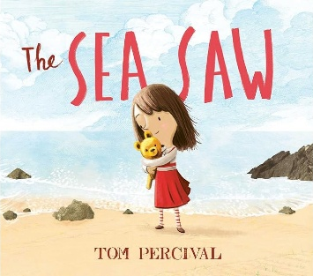
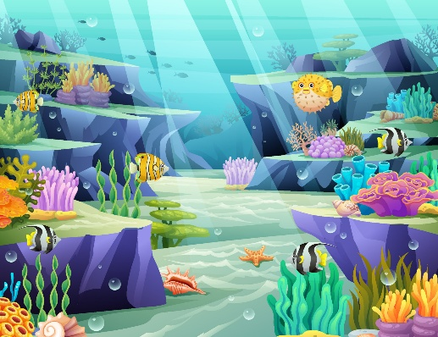
Focus Books

Under the Sea Summer Two

Key Vocabulary
Summer, season, beach, seaside, sea, ocean, bucket and spade, sandcastle, picnic, storm, thunder, lightning, seagull, shimmering, fish, whale, dolphin, octopus, starfish, turtle, jellyfish, shark, crab, shell, sand, coral, map.
Activities
Create alternative story maps for the story of “The Sea Saw”. Circle time discussion about emotions and how the characters in the story may be feeling. Learn facts about a range of different sea creatures. Sea creature crafts. Host a Teddy Bears picnic. Look at a map of the world and name the five oceans. Floating and sinking experiments. Shadow drawings on pavement using chalk. Small world sea creatures. Read a range of themed stories. Discuss the changes that happen during Summer and the weather that we might experience.
Parents as Partners
Continue to help your child with their name writing and recognition. Look for numbers in the environment, on doors, buses and signs and see if your child can recognise them. Encourage your child to practice some independence skills – can they get dressed by themselves, feed themselves, put their shoes on? Share stories with your child, talk about characters, settings, plot and make predictions.
Key Questions
What are the names of the five oceans? What activities can we do at the seaside? What happens to the weather during summer? Can you name five sea creatures? How can we look after and care for sea creatures? What do sea creatures eat and where do they live? How would it feel to swim under the sea?

