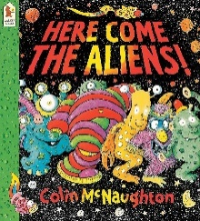
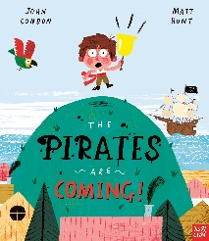
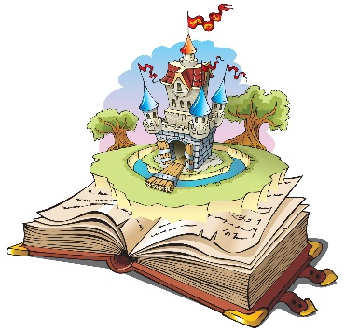
Winnie The Pooh
Meets the King
Jane Riordan
Here come the Aliens! Colin McNaughton
The Pirates are coming! John Condon

Key Vocabulary
King Charles III, Queen Elizabeth II, royal, queen, king, Buckingham Palace, London, royal, now, past, present, then, different, similar, photography, compare, difference, similarity, same castle, crown, king, prince, princess, queen, royal
float,sink,ship, Pirates, treasure, port , starboard, bow , stern,maps, riggin
Activities
Pirate Map Bingo
Floating and Sinking experiments using junk modelled pirate ships
Bake Fairy cakes
Fairy Tale Character dress up day
Observational drawings and paintings of shells using pencils, charcoal and watercolours
Planting and gardening in our outdoor area
Identify Kings & Queens in stories

Parents as Partners
Listen to your child read two or three times every week and practice the tricky words.
Share a range of stories with your child, discussing characters, setting and plot.

Key Questions
What do we know about the Royal Family?
What does the King do?
Can you describe significant events in the life of Queen Elizabeth & King Charles?
What items can float?
What items can sink?

Focus Books
Fantasy and Adventure Spring Two

