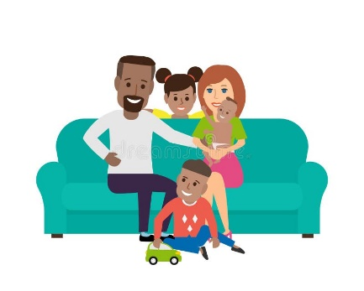
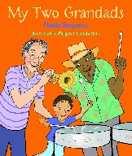
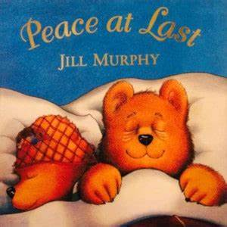
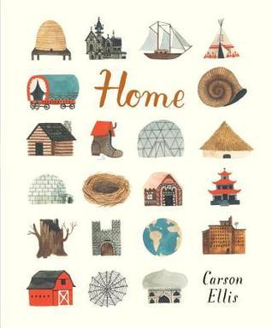
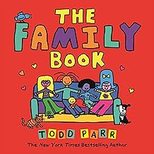
St Paul’s C of E Primary School Reception Knowledge Organiser
Parents as Partners Help your child to learn to read and write their name. Help your child to learn their birthday. Talk about your own families using some of the key vocabulary. Talk to your children about when you were a child and what toys you played with. Sing Nursery Rhymes and add actions. Carry out Learning with Parents activities.

Activities Find out about at different types of families. Talk about and draw our own families. Study facial features and draw self-portraits. Name, order and label stages of growing up. Name different body parts and discover how our body moves. Explore our 5 senses in investigations. Learn how to keep healthy and strong. Sing action songs and Nursery Rhymes. Move like toys in a Magic Toy Shop dance.
Me and my Family Autumn One
Key Vocabulary Mum, Dad, brother, sister, Grandma, Grandad, cousin, Aunt, Uncle, friend, baby, toddler, child, adult, teenager, elderly, past, present, change, now, then, history, historian, same, similar, different, grown, old, new, order, a long time ago, body, head, shoulder, arm, leg, knee, hip, toes, fingers, feet, hands, neck, nose, eyes, ears, tongue, back, stomach, sense, sight, touch, smell, taste, hear,
Focus Books

My Two Grandads By Floella Benjamin
Peace at Last By Jill Murphy
The Family Book By Todd Parr
Home By Carson Ellis
Key Questions What makes a family? Who is in my family? What makes me special? When is my birthday? What were birthdays like in the past? What could I do when I was a baby? What did I play with when I was a baby? What can I do now I am a child? What are my 5 senses and what can they do? What are the different parts of my body? How do I keep healthy?

